Step-by-step guide to
Sharing your QI project
Should I share my project?
The short answer is: yes!
- You have put a lot of hard work into your project, which deserves recognition – don’t be shy about your achievements.
- Sharing your project could help other teams in our Trust, other NHS organisations or even international healthcare providers who have similar problems.
- Let’s put Gloucestershire Hospitals NHS Foundation Trust on the map as the most innovative and improving NHS Trust!
Where can I share it?

- Journals: you can submit your project to a journal in the form of an article. Some journals specialise in QI, for example:
  - BMJ Open Quality https://bmjopenquality.bmj.com/ - publish for free if you a Q Community member
  - BMJ Quality and Safety https://qualitysafety.bmj.com/
- Locally: share with your colleagues, different teams or departments in our Trust or the wider Gloucestershire Health community, look for sharing opportunities at internal meetings and events.
- Within your profession or with peers
  - Share within your networks, Forums, Communities of Practice, email groups, professional bodies or via Twitter.
  - Sign up to the GSQIA mailing list to find out about potential events and conferences where you could share your project.
- Fab NHS Stuff: https://fabnhsstuff.net/ - a quick and easy way to share what you’ve done. Your short summary will be uploaded to the website and will reach a wide audience of readers.
How do I share?
- There may be rules or guidelines that a journal, conference or professional body requires you to follow. You can usually find these on their website
- For Fab NHS Stuff, you will need to register first, and complete a submission form.
- Sharing doesn’t have to be hard work! It might be as simple as submitting your already created poster to a conference.

Who can support me?

- Library & Knowledge Services
0300 422 6495
ghn-tr.libraryGHNHSFT@nhs.net
@GlosHospLib
Can provide
  - advice on suitable journals to publish in
  - referencing training
  - general advice on how to share knowledge
  - signpost and provide resources regarding writing styles and publishing
- GSQIA Team
ghn-tr.gsqia@nhs.net
@gsqia
Ask to be sent the mailing list of events including conferences and award ceremonies
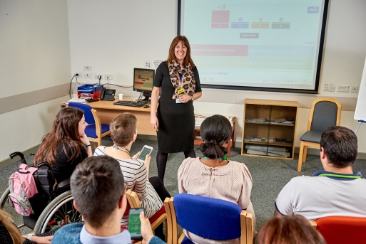

- Your Gold QI Coach

Good luck with sharing your hard work and achievements - please let us know if you are successful, so we can celebrate!

(Created by Library & Knowledge Services Jan 2021)

