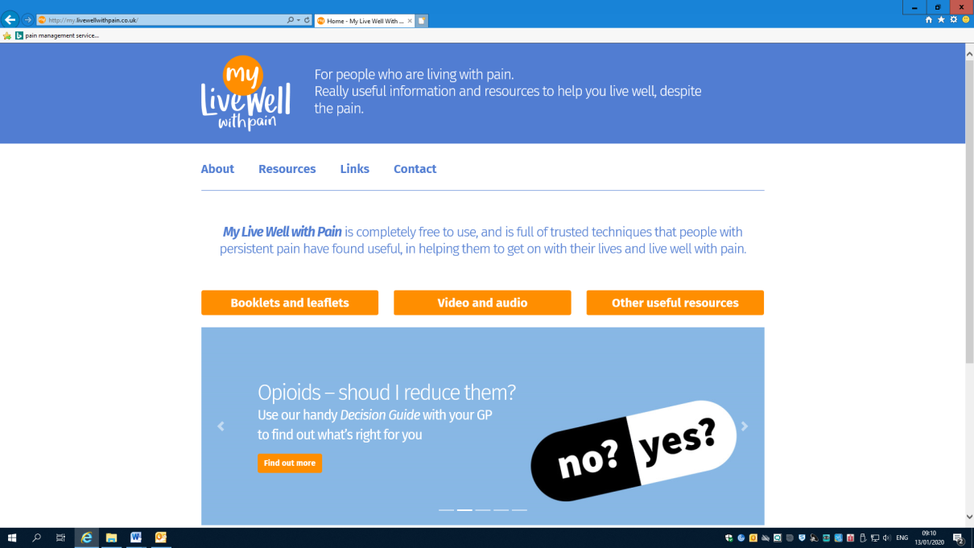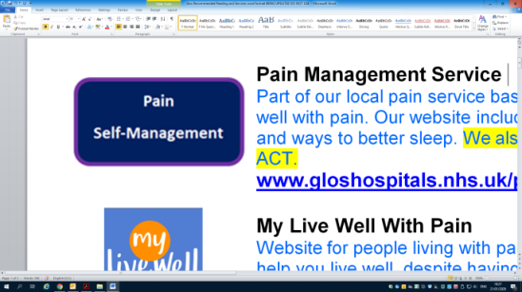S:\Shared Files\Student info 1415\Psychology Students\student projects 14\Pain Clinic Info\pictures\Yes\adult helpdesk.gif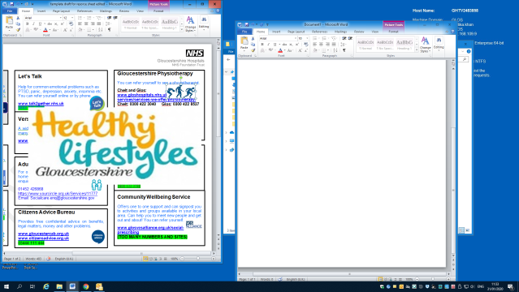[](https://www.talk2gether.nhs.uk/)

**Let’s Talk - Gloucestershire**

Help for common emotional problems

such as anxiety, depression, panic, PTSD, insomnia etc. You can refer yourself.

Website: [**www.letstalkglos.nhs.uk**](http://www.letstalkglos.nhs.uk/)

Tel no.: **0800 073 2200**

**Herefordshire Healthy Minds**

Previously known as ‘Let’s Talk’.

Provides support for people who are experiencing difficulties such as stress, anxiety, low mood and depression.

[**https://www.healthyminds.whct.nhs.uk/support**](https://www.healthyminds.whct.nhs.uk/support)

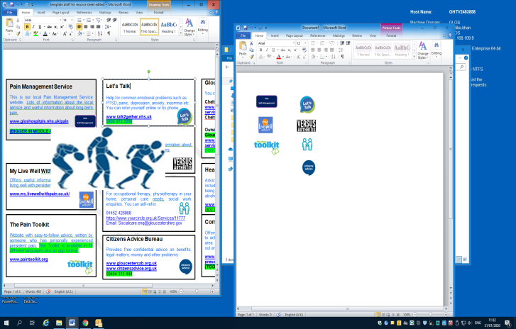



**Pain Management Service**

This is our local Pain

Management Service website. Information about the local service and about long-term pain.

Gloucestershire website: [**www.gloshospitals.nhs.uk/pain**](http://www.gloshospitals.nhs.uk/pain)

Herefordshire website: [**www.wyevalley.nhs.uk/services/community-services/pain-management-service.aspx**](http://www.wyevalley.nhs.uk/services/community-services/pain-management-service.aspx)

**Physiotherapy**

You can refer yourself to see a

physiotherapist.

If you live in Cheltenham or Gloucester: [**www.gloshospitals.nhs.uk/our-services/services-we-offer/physiotherapy/**](http://www.gloshospitals.nhs.uk/our-services/services-we-offer/physiotherapy/)

If you live outside Cheltenham or Gloucester:

[**www.ghc.nhs.uk/our-teams-and-services/adult-physiotherapy/**](http://www.ghc.nhs.uk/our-teams-and-services/adult-physiotherapy/)

If you live in Herefordshire:

[**www.wyevalley.nhs.uk/visitors-and-patients/county-hospital-(acute)/a-z-departments/physiotherapy.aspx**](http://www.wyevalley.nhs.uk/visitors-and-patients/county-hospital-(acute)/a-z-departments/physiotherapy.aspx)

Or ring your local hospital and ask for the Physiotherapy department

**My Live Well With Pain**

Offers useful information and resources

on living well with persistent pain.

Website: [**www.my.livewellwithpain.co.uk**](http://www.my.livewellwithpain.co.uk/)

**The Pain Toolkit**

Website with easy-to-follow advice,

written by someone who has personally experienced persistent pain.

Website: [**www.paintoolkit.org**](http://www.paintoolkit.org)

**Adult Helpdesk**

For occupational therapy, physiotherapy

in your home, personal care needs, social work enquiries. You can self-refer.

Gloucestershire website: [**www.yourcircle.org.uk/Services/11777**](https://www.yourcircle.org.uk/Services/11777)

Gloucestershire tel no.: **01452 426868**

Herefordshire website: [**www.herefordshire.gov.uk/info/200147/social_care_and_support/787/contact_adult_social_care**](http://www.herefordshire.gov.uk/info/200147/social_care_and_support/787/contact_adult_social_care)

Herefordshire tel no.: **01432 260101**

**Healthy Lifestyles**

Advice and support for

lifestyle changes including: losing weight, stopping smoking, being more active, and cutting down on alcohol. You can refer yourself.

Gloucestershire website: [**www. hlsglos.org**](http://www.hlsglos.org)

Gloucestershire tel no.: [**0800 122 3788**](tel:0800%20122%203788)

Herefordshire website: [**www.wisherefordshire.org/marketplace/cat/product/1095**](http://www.wisherefordshire.org/marketplace/cat/product/1095)

Herefordshire tel no.: **01432 383567**

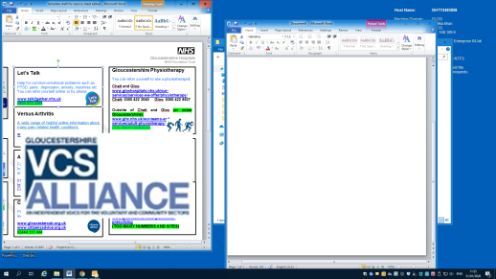

**Community Wellbeing**

Offers one to one support and can

signpost you to activities and groups available in your local area. Can help you to meet new people and get out and about! You can refer yourself.

Gloucestershire website: [**www.glosvcsalliance.org.uk/social-prescribing**](http://www.glosvcsalliance.org.uk/social-prescribing)

Herefordshire website: [**www.wisherefordshire.org**](http://www.wisherefordshire.org)

Artlift website: **www.artlift.org**



**Versus Arthritis**

A wide range of helpful online

information about many pain–related health conditions.

Website: [**www.versusarthritis.org**](http://www.versusarthritis.org)

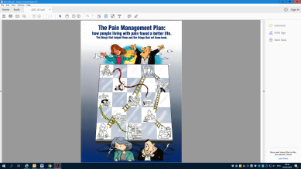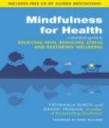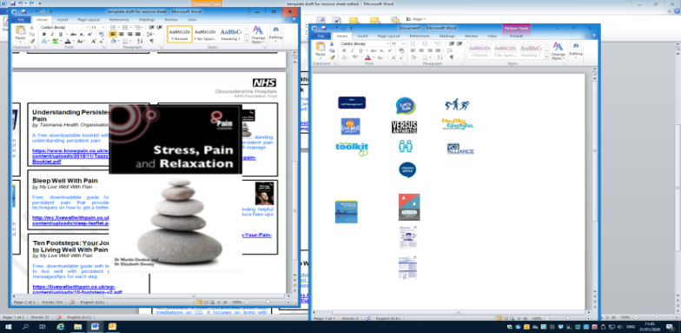

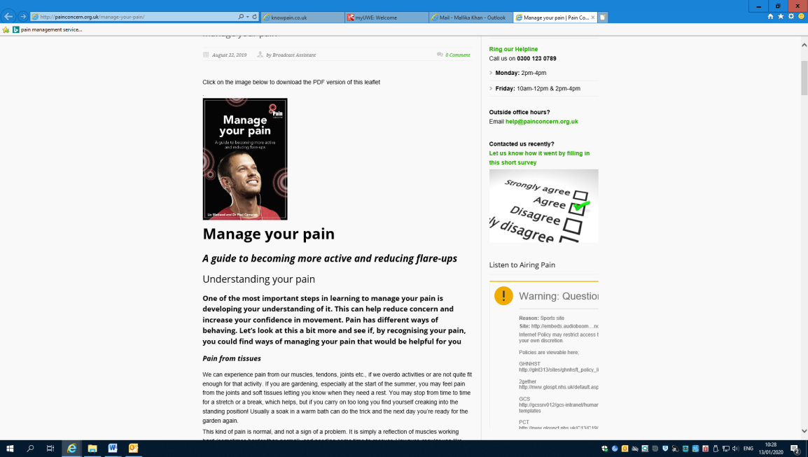

**Stress, Pain and Relaxation**

Guide to understanding stress and

pain. Includes relaxation exercises.

[**painconcern.org.uk/wp-content/uploads/2019/08/Stress-Pain-and-Relaxation-v.2.0-WEB-REFS.pdf**](http://painconcern.org.uk/wp-content/uploads/2019/08/Stress-Pain-and-Relaxation-v.2.0-WEB-REFS.pdf)

Also find relaxation exercises on our website:[**www.gloshospitals.nhs.uk/our-services/services-we-offer/pain/relaxation**](http://www.gloshospitals.nhs.uk/our-services/services-we-offer/pain/relaxation/)

**Mindfulness for Health:**

**Relieving Pain, Reducing**

**Stress and Restoring**

**Wellbeing**

*by Vidyamala Burch and Danny*

*Penman*

An excellent 8-week mindfulness book with meditations on CD. It focuses on living with physical health problems. You can get a copy from the local library.

**The Pain Management Plan:**

**How people living with pain**

**found a better life**

*by Robert Lewin*

Step by step guide to developing your own pain plan to help lead a better life with more control over your pain. You can get a copy from a local library or buy online.

[**www.pain-management-plan.co.uk**](http://www.pain-management-plan.co.uk)



**Manage Your Pain**

Guide on getting more active,

and ways to cope with flare-ups.

[**www.painconcern.org.uk/wp-content/uploads/2019/08/Manage-Your-Pain-English-v.2.pdf**](http://www.painconcern.org.uk/wp-content/uploads/2019/08/Manage-Your-Pain-English-v.2.pdf)

**Ten Footsteps: Your Journey**

**to Living Well With Pain**

Guide with ten steps on how to live well

with persistent pain.

[**www.livewellwithpain.co.uk/wp-content/uploads/10-footsteps-v2.pdf**](http://www.livewellwithpain.co.uk/wp-content/uploads/10-footsteps-v2.pdf)

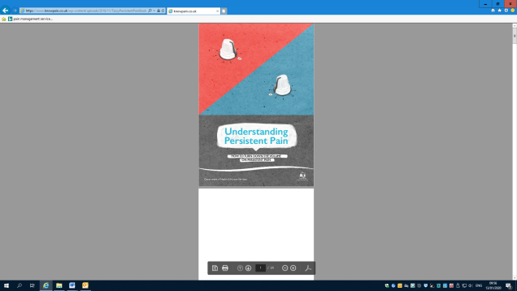

**Understanding Persistent**

**Pain**

Explains persistent pain.

[**www.knowpain.co.uk/wp-content/uploads/2018/11/TazzyPersistentPainBooklet.pdf**](http://www.knowpain.co.uk/wp-content/uploads/2018/11/TazzyPersistentPainBooklet.pdf)

**Active 10**

Records every minute of walking

you do. Tracks steps, helps you set

goals, shows your achievements

and gives you tips to boost your activity.

[**https://www.nhs.uk/better-health/get-active/**](https://www.nhs.uk/better-health/get-active/)

**‘Headspace’ and ‘Calm’**

Mindfulness and meditation apps for

your tablet or phone. Helps you to focus,

breathe, stay calm, and sleep better.

Headspace: [**www.headspace.com**](https://www.headspace.com/)

Calm: [**www.calm.com**](https://www.calm.com/)

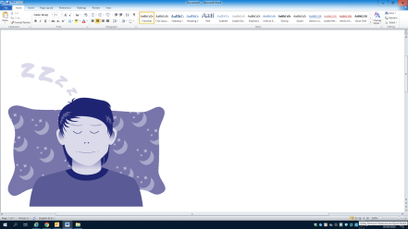

**Staying Alive**

An app full of useful information and

tools to keep you safe in a crisis.

[**https://people.nhs.uk/help/support-apps/stayalive/**](https://people.nhs.uk/help/support-apps/stayalive/)

**Sleep Well With Pain**

Guide for people with persistent pain.

Ideas on how to sleep better

despite pain.

[**www.my.livewellwithpain.co.uk/wp-content/uploads/sleep-leaflet.pdf**](http://www.my.livewellwithpain.co.uk/wp-content/uploads/sleep-leaflet.pdf)

**Citizens Advice Bureau**

Provides free confidential advice

onbenefits, legal matters, money

and other problems.

Website: [**www.citizensadvice.org.uk**](http://www.citizensadvice.org.uk)

Tel no.: **03444 111 444**





**Every Mind Matters**

Advice and practical tips to

help look after your mental health and wellbeing

**<https://www.nhs.uk/oneyou/every-mind-matters/>**