Fishbone Analysis
Patient factors:
Clinical condition
Social factors
Physical factors
Psychological/
mental factors
Interpersonal
relationships
Individual
(staff) factors:
Physical issues
Psychological
Personality
Social/domestic
Task factors:
Guidelines/
procedures/
protocols
Decision aids
Task design
Communication
factors:
Verbal
Non-verbal
Written
Electronic
Team + social
factors:
Role
congruence
Leadership
Support +
cultural factors
Problem
or issue
(CPD/SDP)
Education + Training
Factors:
Competence
Appropriateness
Availability
Accessibility
Supervision
Equipment +
resources:
Equipment
supplies
Visual display
Integrity
Positioning
Usability
Working condition
factors:
Environment
Design of physical
environment
Administrative
Staffing
Time/workload
Organisational +
strategic factors:
Organisational structure
Policy, standards, goals
Externally imported risks
Safety culture
Priorities

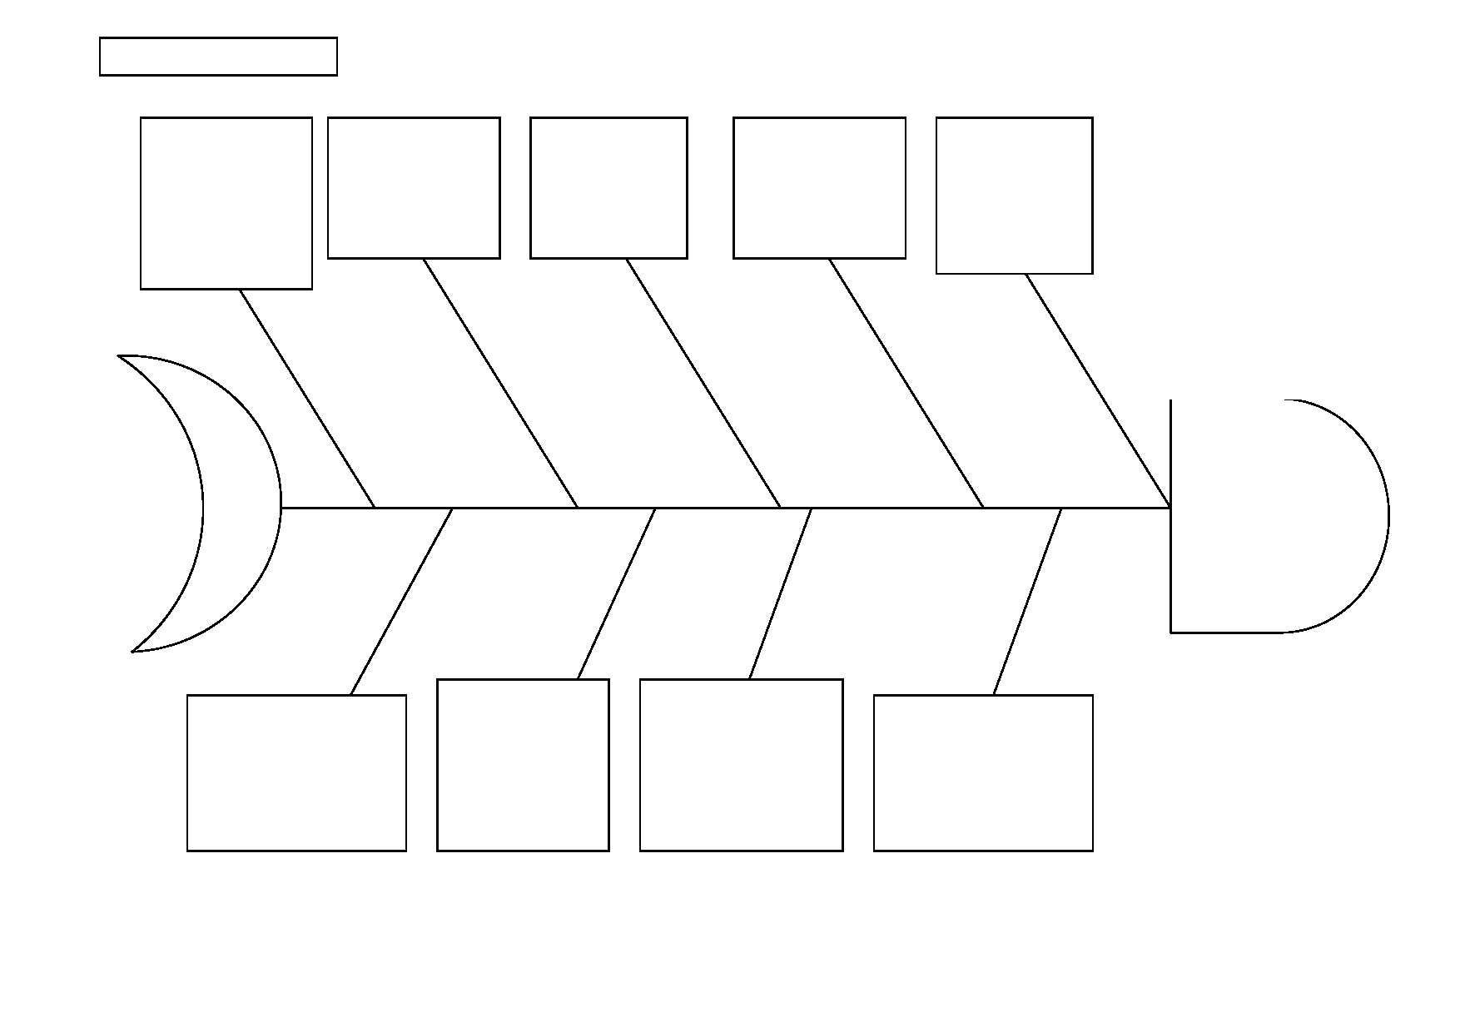Jan 11

