**SUSTAINABILITY REPORT 2022-23 GLOUCESTERSHIRE HOSPITALS NHS FOUNDATION TRUST**

**EXECUTIVE SUMMARY**

In November 2022 the Trust celebrated one year since the launch of our Green Plan (sustainability strategy). This commits the Trust to a range of actions, initially between 2021-2025, but also longer term, which will help move us forward on our pathway to net zero by 2040. Our Trust is keen to be a leader in climate action, helping and encouraging others to make a positive long-term shift towards sustainable behaviour. Our Green Plan provides a comprehensive and structured framework to show how we will work to embed sustainability into the organizational culture so that sustainability becomes part of how we think and everything we do.

In February 2023 the Trust was successful in obtaining a second multi-million pound grant from the Public Sector Decarbonisation Scheme (PSDS). This new fund will enable the replacement of the Tower Block façade together with the installation of triple glazed windows, provide an additional air source heat pump and upgrade some control systems. These works will contribute to energy efficiency and generate financial and carbon savings. The carbon reduction projects funded by the initial PSDS 2020 scheme are now complete and generating carbon reductions and savings. These developments are all vital if the Trust is to achieve carbon neutrality by 2040.

The Greener NHS has calculated an estimated carbon footprint for every hospital trust using a baseline of 2019/20. For GHT NHS Carbon Footprint Plus this is 112,364 tonnes CO2e.

Our declared carbon emissions for energy and water for 2022-23 are 18,071 tCO2e. These carbon emissions have decreased by 6.7% compared to previous year, despite the site gross internal area increasing by 5,457m2. Gas, electricity and oil consumption have decreased by 5.9% since 2021-22, however the global price rises have impacted with an overall increase of £1.91 million (59.5%) on energy expenditure.

**1.2 INTRODUCTION**

As an NHS organisation we have an obligation to work in a way that has a positive effect on the communities we serve. The three pillars of sustainability – society, environment, and economy are interconnected and reliant on each other. The Trust acknowledges the impact we have on the local economy, society and environment and are therefore committed to continually work to actively integrate sustainable development into our core business.

The links between health and climate change are clear and we have a responsibility to take action. The Climate Change Act (2008) and the NHS targets (Delivering a Net Zero NHS, 2020) oblige the Trust to reduce carbon emissions.

Acting now, by embedding sustainability into the organisational culture, making changes to how we operate, how, where and what we procure and upgrading our infrastructure, will be the only way to meet the NHS targets to reach net zero carbon emissions by 2040 on the emissions we directly control, and to reach net zero carbon by 2045 on those we influence.

**1.3 GREEN PLAN AND TARGETS**

In November 2022 the Trust marked the one-year anniversary since the launch of our Green Plan (sustainability strategy). We held an event for our Green Champions and launched our short animation “[Our Green Plan](https://www.gloshospitals.nhs.uk/documents/13933/1119Green-Plan-A4-DS-D7.pdf)” which outlines the steps we will take to reduce carbon emissions and improve sustainability over the next five years as we head toward net zero in 2040.

It includes details of how the Trust will support the NHS target to achieve net zero carbon emissions by 2040 ([NHS Net Zero report](https://www.england.nhs.uk/greenernhs/a-net-zero-nhs/) , October 2021) i.e.

* *for the emissions we control directly (the NHS Carbon Footprint), net zero by 2040, with an ambition to reach an 80% reduction by 2028 to 2032*
* *for the emissions we can influence (our NHS Carbon Footprint Plus), net zero by 2045, with an ambition to reach an 80% reduction by 2036 to 2039.*

Our vision is “to be a leader in sustainable healthcare, act sustainably and lead by example” and we have three green objectives – healthy environment, health for all and embedding sustainability.

GHT targets to 2040/2045

The Greener NHS has calculated an estimated carbon footprint for every hospital trust using a baseline of 2019/20. Much of their data is from expenditure-based estimates, with some data from our annual Estates Return Information Collection and this has all been used to generate an estimate of total carbon emissions. Their data does differ from ours in some areas, but their data is very useful in showing the scale and overall carbon emission reductions that we must achieve. The data in the table will be refined and we will publish data to show how we are progressing towards the interim targets especially on the NHS Carbon Footprint.

GHT NHS Carbon Footprint Plus = 112,364 tonnes CO2e



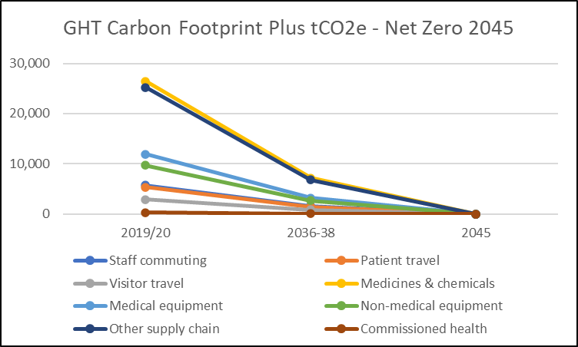

**1.4 ENGAGEMENT**

Working with staff, suppliers and local partners is essential action in reducing carbon emissions across the Trust. This year:

* we have over 120 Green Champions - staff members who are taking action in their work environments to help reduce carbon emissions
* we have an active Green Council which shares ideas, manages projects, and contributes to decision making and the development of sustainable development initiatives
* as a member of Climate Leadership Gloucestershire, we are leading on the Behaviour Change aspect (in collaboration with Gloucestershire Constabulary) and are a key stakeholder in the strategic planning and decisions for climate action
* our Head of Procurement is part of the national NHSE/I Sustainable Procurement Forum and able to influence and shape policy
* we contribute at regional level to the South West Greener NHS and to the South West Procurement Programme Transport Working Group.

**1.5 GOVERNANCE AND MONITORING**

Simon Lanceley (Director of Strategy and Transformation) is our lead executive director for sustainability. Deborah Evans (Trust Chair) is our lead non-executive director for sustainability. Our Climate Emergency Response Leadership group (CERL) monitors progress against the Green Plan and associated targets, provides assurance and is the key decision-making body for sustainability decisions, priorities and investments.

**1.6 ENERGY AND WATER**

GHNHSFT has spent £5.12 million on gas, electricity, oil and water in 2022/23.

|  |  |  |  |  |  |  |  |
| --- | --- | --- | --- | --- | --- | --- | --- |
| **Resource** | | **2017/18** | **2018/19** | **2019/20** | **2020/21** | **2021/22** | **2022/23** |
| Gas | Use  (kWh) | 56,854,097 | 85,965,330 | 87,932,803 | 90,503,442 | 98,521,058 | 93,954,862 |
| tCO2e | 10,471 | 15,814 | 16,176 | 16,641 | 18,045 | 17,151 |
| Oil | Use  (kWh) | 24,279 | No data | No data | No data | 587,947 | 585,325 |
| tCO2e | 6 | No data | No data | No data | 150 | 150 |
| Electricity | Use  (kWh) | 17,791,983 | 7,027,940 | 5,528,742 | 3,717,545 | 5,280,452 | 3,703,198 |
| tCO2e | 6,255 | 1,989 | 1,565 | 867 | 1,121 | 716 |
| Total Energy  tonnes CO2e | | 16,731 | 17,803 | 17,741 | 17,508 | 19,316 | 18,017 |  |

The combined heat and power plant at GRH came on line in 2018 triggering an increase in gas use (CGH CHP from 2014). Grid electricity has been increasingly decarbonized over the past few years with the increase in wind and solar into the national grid.

Overall carbon emissions have decreased by 6.7% compared to previous year.

Gas, electricity and oil consumption has decreased by 5.9% since 2021-22. The decrease in carbon emissions from electricity is partly due to reduced consumption and also reflects the reduction in the carbon emission factor for grid electricity. The carbon emission factor for electricity has been declining as more of the national grid electricity is generated from renewable sources and high carbon sources such as coal fired power stations have been turned off (note - if the carbon factor for 2021-22 had been used this would have given a figure showing an additional 147 tCO2e for electricity in 2022-23). The use of oil remains fairly constant, as this is oil for the back-up generators (most of which is used in the regular generator system checks) and heating for the estates building at GRH.

Unfortunately, the global energy price rises have had a big impact on the cost of energy. Compared to 2021-22 electricity costs are up by 30.7% and oil by 45.6%. Gas costs almost doubled, rising by 90.5%, from £1.926 million in 2021-22 to £3.670 million in 2022-23 and this is despite gas consumption in 2022-23 dropping by 4.6% on the previous year.

Site gross internal area has increased by 5,457m2 with the addition of new sites (5 and 9 Pullman Court and the Warehouse), the new Discharge Waiting Lounge and extensions to Gallery Wing and ED at GRH. The graph below shows a decrease in carbon emissions despite the large increase in site area. This demonstrates that the decarbonization works (solar PV, air source heat pumps and plate heat exchangers etc.), are beginning to impact on site consumption.

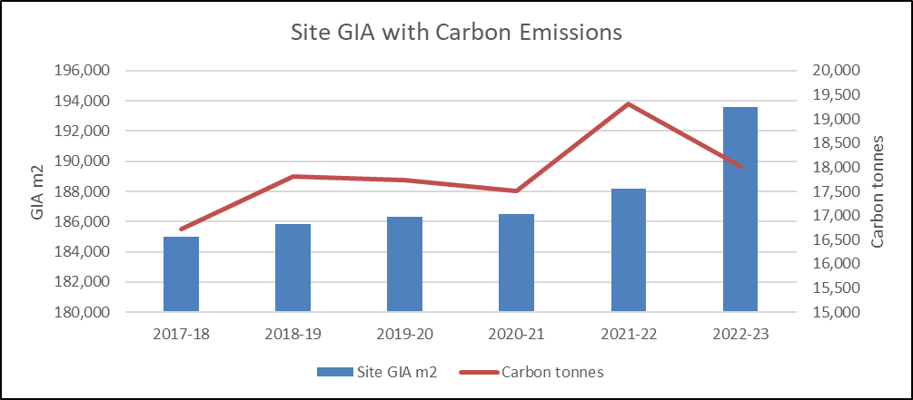

Salix Grant – Decarbonisation works

In February 2023 the Trust was successful in obtaining a grant of £10.9 million from the Public Sector Decarbonisation Scheme. The Trust has invested a further £1.2 million so that the projects will deliver 1,389 tCO2 saving per annum and achieve energy efficiency savings of £82,000 per annum at GRH. Work on the project has started and will transform the 1970s concrete Tower Block with a new façade and replace existing single glazed windows with tripled glazed ones. A 200kW air source heat pump will provide low carbon heat, there will be upgrades to the heating hot water control systems, roof insulation to the kitchen areas and improvements to the steam distribution systems. These developments will generate carbon and financial savings.

BREEAM

NHSEI estates criteria guidance recommends that all new construction projects should achieve BREEAM Excellent and all refurbishment projects over £2 million should achieve Very Good. BREEAM assessments provide a sustainability rating for non-domestic projects and covers aspects such as energy, water, transport, ecology and resilience. BREEAM will help us to ensure our future capital developments reduce the carbon associated with our buildings. This will start at the design stage, cover everything from construction materials used, to the energy systems within the building and conclude with post-occupancy analysis to ensure the building in use delivers the carbon efficiencies included the initial design.

**1.7 ACHIEVEMENTS IN 2022-23**

A £50,000 fund for sustainability projects has enabled a variety of projects including:

* Theatres and Maternity are piloting the Medclair mobile destruction unit. This captures the Entonox exhaled by women in labour and splits the gas back into harmless nitrogen and oxygen. As well as reducing this potent greenhouse gas, this technology also lessens maternity staff exposure to Entonox.
* Mobilisation of a new waste management partnership with The Green Block. This will enable the Trust to recycle far more of our waste, reduces carbon and will provide financial benefit as waste becomes a resource.
* Pathology have purchased reusable transport boxes as a replacement for single-use plastic bags.
* A chipper for the Grounds team, so garden prunings can be mulched or composted on site rather than transported to a municipal composting facility.

The Green Team Competition (run in conjunction with the Centre for Sustainable Healthcare) was a great success. Six teams ran projects aimed at reducing carbon within their areas. Endoscopy reduced use of paper and incontinence pads and have swapped a disposal product with a re-usable one. Haematology laboratories turned off equipment and considered unnecessary samples, Pharmacy swapped single-use plastic bags for reusable ones and Orthopaedic Theatres have swapped to a device that is not powered by single-use batteries. The Food Waste team were highly commended for their project on food waste measurement. Home Enteral Feeding Team were the winners with their introduction of a reusable feeding bottle and extended use of giving sets. In total, the projects should deliver savings of 11.4 tCO2 and £85,000.

There are a number of projects which have delivered sustainability benefits during the year.

|  |  |  |
| --- | --- | --- |
|  | Benefits include: | Impact on net zero carbon |
| TELEMEDICINE AND VIDEO CONFERENCING |  |  |
| * From April 2022-March 2023 there were 142,326 telephone and telemedicine appointments | Avoided travel, less traffic congestion & better air quality |  |
| TRAVEL – SHUTTLE BUS (SERVICE 99) |  |  |
| * From April 2022 to March 2023 there were a total of 194,335 passengers of which 140,146 were NHS staff and the other 54,189 public. Compared to 2021-22 figures this represents a 36% increase in overall passenger numbers. Additional early morning and evening services were added to enable shift workers to use the bus. * The shuttle bus covered 186,148 miles. | Active travel, less traffic congestion, better air quality and reduced pressure on car parks |  |
|  |
| TRAVEL |  |  |
| * Installation of bike repair stations at CGH and GRH * Linked with Stagecoach so staff can use P&R at Cheltenham race course to get to CGH * Staff travel surveyed conducted | Encourages cyclists.  Less traffic congestion, better air quality and reduces pressure on CGH car parks |  |
| TRAVEL – BUSINESS MILEAGE |  |  |
| * During 2022-23 the Trust fleet has covered 880,541 miles generating 181 tCO2. * The business mileage was *c*. 1,207,407 miles, with 329 tCO2 and associated expenses claims of £453,963. This is more than double the previous year. | NB: Fleet to be changed to EV |  |
| Claims for mileage travelled in electric cars increased |  |
| LINEN |  |  |
| * Posters reminding staff not to throw laundry in waste stream & to return scrubs * Need to ensure patient has clothing to go home in rather than Trust (rented) nightwear | Saves carbon associated with manufacture of new items |  |
| CATERING |  |  |
| * Meat based soups replaced with veg options * Discount on hot drinks if bring own mug * Extending lunch service by 30 minutes if there is lots of food leftover | Increasing plant-based options.  Reducing food waste and plastics. |  |
| GREEN SPACE AND BIODIVERSITY |  |  |
| * New grounds manager working on garden designs across Trust * Mowers, hedge cutters etc. all battery power * Wild flower areas seeded | Encourages wildlife, removal of petrol driven garden machinery, better green spaces for staff, visitors and patients |  |
| WASTE |  |  |
| * Establishing Warp It | Savings on waste, procurement and carbon emissions |  |
| THEATRES SUSTAINABILITY GROUP |  |  |
| * Nitrous oxide removed from manifolds at CGH & GRH reducing gas use * Stopped routinely flushing cannulas when patient moved from theatre to recovery | Reducing medical gas use and associated carbon. Reducing plastic saving energy and water |  |
| PROCUREMENT |  |  |
| * 10% weighting on net zero and social value included in tenders | Improve social value, promote supply chain resilience and address economic inequality |  |

**1.8 PROJECTS FOR 2023-24**

There are a large number of projects planned in 2023-24. These include:

|  |  |  |
| --- | --- | --- |
| Area of Focus | Project | Benefits include: |
| Reduction in carbon from fleet vehicles | * Establish scope and requirements to enable transition of GHT/GMS fleet to EV | Enable EV fleet introduction by 2025 |
| Staff travel | * New staff parking permit system in June. Needs-based allocation criteria e.g. shift, travel time / accessibility of public transport, on-call responsibility etc. | Promote active travel reduce congestion. System to be fair and equitable |
| Reduction in carbon emissions | * IT to introduce automatic monitor switch off | Reduce energy and carbon emissions |
| Sustainable catering and healthier eating | * Patient menus (especially Paediatrics) to increase plant-based content | Reduce carbon emissions from food |
| Reduce waste and improve recycling | * Introduce food waste recycling. Sorting of black bag waste to recover recyclables. | Meet target to recycle 100% non-clinical waste by 2025 |
| Reduce waste and improve recycling | * Introduce a re-usable sharps bin system across all Trust sites which also removes sharps from incineration process | Reduce plastic and carbon emissions from incineration |
| Green space and biodiversity | * Development of more gardens and planting for wildlife. Biodiversity Strategy to be written | Encourages wildlife. More green space for patients and staff |
| Reduction in carbon emissions | * Reduction of glove and apron use | Reduce plastic |
| Reduction in carbon emissions | * Continued work with ICS partners and countywide clinicians to switch patients away from meter-dose inhalers (where appropriate) | Reduction in carbon impact |

**1.9 ANAESTHETIC GASES**

|  |  |  |  |  |  |  |
| --- | --- | --- | --- | --- | --- | --- |
| **Year** | **Desflurane** | **Sevoflurane** | **Isoflurane** | **Nitrous Oxide** | **Entonox** | **Total**  **tCO2e** |
| **2018/19** | 479 | 97 | 6 | 1120 | 1541 | 3243 |
| **2019/20** | 68 | 105 | 2 | 1023 | 1421 | 2618 |
| **2020/21** | 17 | 61 | 0 | 611 | 1450 | 2138 |
| **2021/22** | 0 | 67 | 0 | 511 | 1465 | 2043 |
| **2022/23** | 0 | 61 | 0 | 354 | 1429 | 1844 |

The above anaesthetic gas figures are taken from purchasing data not returned cylinders. This year the focus has been on nitrous oxide. The CGH manifold was decommissioned and as a result CGH only generated 9 tCO2e (from nitrous) in the year. The GRH manifold was decommissioned in March, resulting in a purchase of only 5,400 litres nitrous oxide that month as opposed to a previous average of 70,000 litres per month. This should reduce nitrous oxide in 2023-24 to under 50 tCO2e.

The trial of a mobile destruction machine to render Entonox back to nitrogen and oxygen (and thereby remove the CO2e associated with it) is underway.

**1.10 SCOPE 1, 2 AND 3 EMISSIONS**

Our statutory declaration for our Scope 1, 2 and 3 emissions is:

|  |  |  |  |
| --- | --- | --- | --- |
| Area | Type | Unit | Cost £ |
| Greenhouse Gas Emissions | Scope 1 (gas consumption, fleet vehicles, oil and anaesthetic gases) | 19,325 tCO2e | Total Scope 1, 2 and 3 emissions (not including anaesthetic gas)  £5,716,452 |
| Scope 2 (electricity consumption) | 716 tCO2e |
|  | Scope 3 (business travel, water supply and treatment) | 458 tCO2e |
| Water | Water consumption | 305,887m3 |  |
| Waste minimisation and management | (a) total waste arising = 2,564 tonnes  (b) waste to energy = 948 tonnes  (c) waste recycled/reused = 547 tonnes  (d) waste incinerated = 244 tonnes  (e) waste sent to an AT plant = 825 tonnes  Overall waste tonnage increased by 3.5% compared to 2021/22, probably due to increased activity  No waste is sent to landfill – a fulfilment of a Green Plan aim. | | £855,114 |

Jen Cleary – Head of Sustainability, GMS

June 2023