

**Project - Plan On A Page**



**Title:**

**Team:**

**Sponsor:**

**Project lead:**

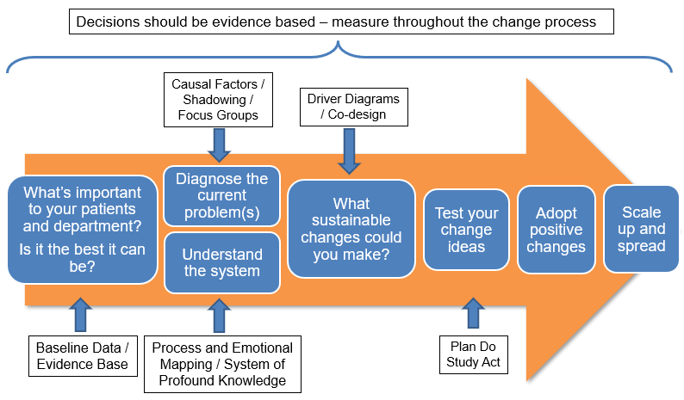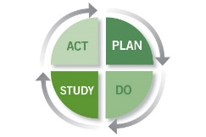

**Current Situation**

What is happening now and why is it a problem?

**Statement of the Problem**

**Scale Up and Spread**

What’s the plan for sharing learning?

**PDSA**

|  |  |  |  |  |
| --- | --- | --- | --- | --- |
|  | **1** | **2** | **3** | **4** |
| Plan -When / Where / Who? |  |  |  |  |
| Do - What is being tested? |  |  |  |  |
| Study - What happened? |  |  |  |  |
| Act - What now? Adopt / Adapt / Abandon |  |  |  |  |

**The #GSQIAWay**

**Project Focus:**  Patient Safety  Patient Experience  Staff Experience  Clinical Effectiveness  Sustainability (Green Agenda)  Sustainability (Financial)  Health and Safety

**Driver Diagram and Prioritisation of Change Ideas**

|  |  |  |  |
| --- | --- | --- | --- |
| **1O Driver** | **2O Driver** | **Change Idea** | **Priority No.** |
|  |  |  |  |
|  |  |
|  |  |  |
|  |  |
|  |  |  |  |
|  |  |
|  |  |  |
|  |  |
|  |  |  |  |
|  |  |
|  |  |  |
|  |  |
|  |  |  |  |
|  |  |
|  |  |  |
|  |  |

**Measures and Data Collection**

What data do you need to collect to evidence improvement?

**Breakdown of the problem (Diagnostics)**

Fishbone / Process Map / SEIPS / Baseline data

**SMART Aim**

**Containment of the Problem**

What needs to be done now to prevent the problem growing? Control of Special Causes