SDEC/AEC Echo Reference Guide
Echocardiography is a limited and labour-intensive resource.
Please carefully consider whether the investigation is truly required.
Please follow the following steps when requesting an echo:

URGENT echo requests that REQUIRE SDEC FOLLOW-UP AND REVIEW:

Indication | Additional Notes | Optimal timescale
Pericarditis with clinical suspicion of tamponade | Needs admission  Focused scan | 24hrs as IP
Ambulatory investigation of pyrexia/infection of unknown origin where IE suspected (e.g. presence of a murmur, known valve disease, embolic phenomena or typical organisms on BCs) | Please ensure heart sounds carefully documented.  Ensure 3 sets of blood cultures sent.  Patients with a high clinical suspicion or high-risk features* should be managed as an IP (please discuss with cardiology if unsure) | Within 24 – 48 hours
Assessment for structural heart disease and function in the context of VT or high degree heart block | Please ensure CXR done  Manage as IP | Within 24-48hrs
Malignant hypertension (>180/120mmHg) with clinical concern of acute left ventricular dysfunction | Please ensure CXR done  Manage as IP | Within 48hrs
Assessment of LV function in the context of suspected ACS | Please only as an IP or early OP | Within 72hrs
Pericarditis with suspicion of pericardial effusion but patient haemodynamically stable | Ensure CXR done  Focused scan | Within 72hrs
Myopericarditis but considered suitable for ambulatory pathway | Serial troponins < 50  Will need regular review in SDEC to ensure treatment response.  Admit if troponins rising or Sx worsening. | Within 72hrs
Suspected heart failure needing ambulatory IV diuretics/with NYHA class III or IV heart failure symptoms** / BNP >2000 | Ensure CXR and BNP have been done prior to request  Referral to heart failure team after echo | 1 week
Murmur in the presence of NYHA class III or IV heart failure symptoms** or syncope | Please ensure CXR done  Please ensure heart sounds carefully documented | 1 week
Suspected cardiomyopathy of pregnancy | Please ensure BNP is done prior to echo request | 1 week
NON-URGENT echo requests:
Indication | Additional Notes | Optimal timescale
Clinical signs & symptoms of HF with elevated NT-proBNP ≥400ng/l but <2000ng/l  Unexplained shortness of breath with abnormal ECG and/or  radiographic signs of HF and elevated NT-proBNP (>400ng/l) | Up to date BNP must be done prior to echo request  If BNP <400ng/l, echo is not indicated and alternative cause for symptoms should be considered  If in AF and rate not controlled, then needs targeted rate control therapy + reconsider need for echo when rate <100bpm | 6 weeks
Pre-existing heart failure/cardiomyopathy | Repeat echo where the result may change management or following procedures to improve cardiac function (e.g. guideline directed medical therapy, device therapy, cardioversion, or coronary  revascularisation)  Repeat echo where there has been a change in clinical status (e.g. worsening NYHA class) | 6 weeks
Hypertension and suspected left ventricular hypertrophy |  | 6 weeks
Pericarditis without suspicion of effusion | Ensure CXR done  Could be a focused scan  Not required if no effusion on CT scan | 6 weeks
Suspected valvular disease without high-risk clinical features*** | Please ensure CXR done  Please ensure heart sounds carefully documented | 6 weeks
Assessment for structural heart disease in the context of suspected SVT / AF / Flutter/ high ventricular ectopic burden >10% | Please ensure CXR done  Only request if this will change the patient’s management such as referral for DCCV or ablation | 6 weeks
Suspicion of aortopathy in a patient with susceptible genetic condition (e.g Marfan’s) |  | 6 weeks
Pulmonary disease (e.g. COPD/ OSA/fibrosis) with suspected right ventricular failure | Please ensure a BNP is done | 6 weeks
First presentation of symptomatic AF (in the absence of significant frailty) with suspicion of underlying structural cardiac abnormalities | Asymptomatic newly identified AF does not require an echo. | 6 weeks
Incidental radiological finding prompting suspicion of underlying structural cardiac abnormalities |  | 3 months
Abnormal ECG when ACS is not suspected prompting suspicion of underlying structural cardiac abnormalities |  | 3 months
Following large PE when clinical concern for right ventricular impairment and/or presence of developing pulmonary hypertension | Not an indication for OP echo in acute setting  Ensure they have been referred to PE clinic (through resp or acute medicine) for consideration of echo in 3 months to assess for pulmonary hypertension | N/A
Transient loss of consciousness with normal ECG and clinical examination | Please first request an extended period of OP cardiac monitoring and once complete, review if an echo is indicated.  If it is felt an echo is required at that point then the this would be routine within 3 months | N/A

* High risk features of infective endocarditis: prosthetic/metallic valve, Hx of IVDU, pre-existing valve disease, evidence of heart failure, HACEK organism, previous IE, poor response to antibiotic therapy
** NYHA classification for heart failure:
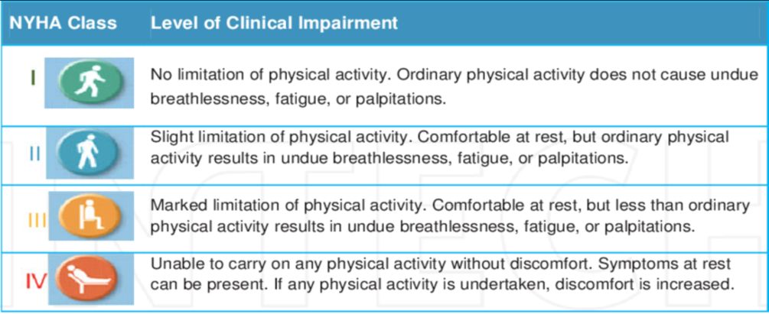
*** High risk clinical features in the context of suspected valvular disease include: syncope, recurring cardiac chest pain, clinical evidence of heart failure.

