Sustainability Quiz!

Last year the Trust spent £70,000 on buying what?

1. Paper
2. Gloves
3. Toner

What percentage of non-clinical waste do we recycle in the Trust?

1. 10%
2. 25%
3. 45%

How many tonnes of clinical waste did the Trust dispose of in 2014/15?

1. 502
2. 802
3. 1022

And how much did it cost to dispose of this waste?

1. £520,000
2. £740,000
3. £990,000

Leaving this item on overnight wastes enough energy to make 30 cups of tea. What is it?

1. A photocopier
2. A mobile phone
3. A desktop computer

How many litres of tap water does the average Britain use in a day?

1. 150 litres
2. 175 litres
3. 200 litres

How much money (approximately) did this Trust spend on water last year?

1. £500,000
2. £600,000
3. £700,000

How much money (approximately) did this Trust spend on electricity last year?

1. £1 million
2. £2 million
3. £3 million

If global emissions are not reduced, average summer temperatures in the south of England are projected to rise by how much?

1. 2°C
2. 3°C
3. 4°C

How many tonnes of cardboard did GRH recycle in 2014/15?

1. 29
2. 39
3. 49

Match the waste bag to the cost to dispose of per bag/box:

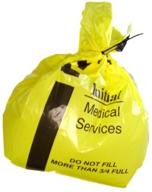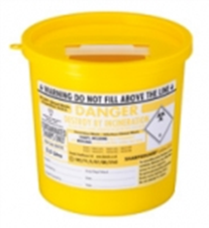

66p £2.70 49p

How many litres of water does it take to produce one beer?

1. 17 litres
2. 70 litres
3. 170 litres