
Martha’s Rule Children’s Leaflet

 | You know your child better than anyone.
 | If you’re worried about your child’s health getting worse, talk to us.
What is Martha's Rule? 
   | Martha’s Rule has been put in place to make sure that any concerns of children and their families are listened to and that something is done about it.  It will help to spot worrying health symptoms earlier and to stop them getting worse.

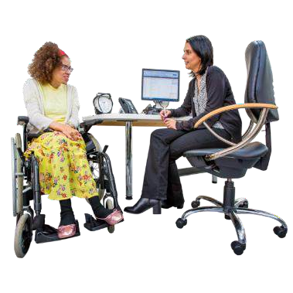
You can ask for a quick check if you are worried about changes in your child’s health.
 | You might see small changes before we do.
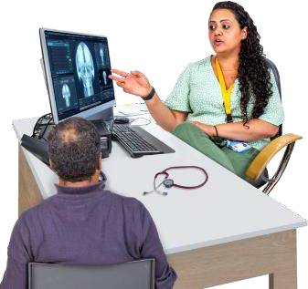 | Telling us about these changes can help us find problems early. This way, we can stop bigger health issues from happening.


How we monitor your child
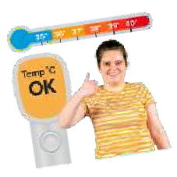 | When a child is in hospital, we often check their vital signs and other important health numbers.
 | How often we check depends on what your child needs. Sometimes we have to wake them up to do the checks.

 | We will ask you child every day if they feel better or worse. This helps us check for any changes in how they are doing.

Your role is very important
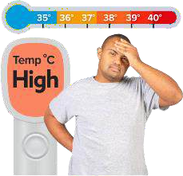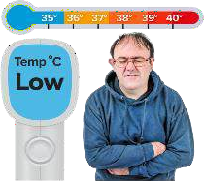     | Please let us know if you notice any changes in your child. Tell us if they:  - Feel too hot or too cold  - Have a high sounding or different cry  - Have any changes on their skin, like a rash

       | - Are hard to wake up or floppy  - Are grumpy, different from usual or will not relax  - Are not interested in drinking or eating  - Are breathing faster than normal, grunting with each breath or wheezing  - Are weeing less

   | - Have blood in their poo  - Is there anything else that makes you worried?
   | We want to help your child feel better. If you notice any changes, please share them with us.  Your child’s health is important to us. We are here to listen and support your child.

  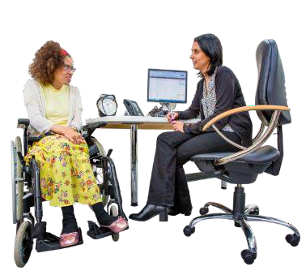  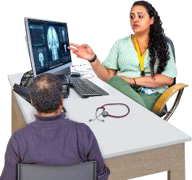 | Do not be anxious or worried about telling us if something is wrong.  If you see any changes, tell our staff.  This helps us find problems early and stop them from getting worse.

What to do if you're worried 
 | 1. First, speak to the team caring for your child

 | 2. If you still feel worried after talking to the care team and think they are not listening call for a quick review  Phone: 0300 422 2222
  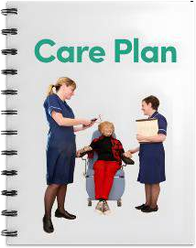  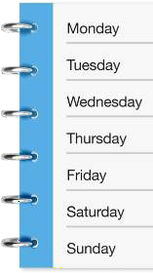 | Your call will go to a special team in our hospital. They help people who are very sick.  They will work with you and your child’s care team. They will help plan any treatment or check-ups you need.  The service is available:  - 24 hours a day  - seven days a week.

Our commitment 
 | We will often ask what you think and will listen to your worries.
 | We see you as a partner in your child’s care. We want to work together with you.  Please tell us if you have any worries.

