
Martha’s Rule Adult Leaflet


You and the people who support you know you better than anyone.
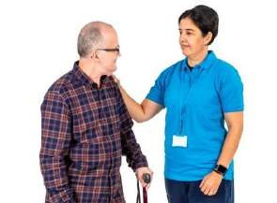 | If you’re worried about your health getting worse, talk to us.
What is Martha's Rule? 
   | Martha’s Rule has been put in place to make sure that any concerns of patients and their families are listened to and that something is done about it.  It will help to spot worrying health symptoms earlier and stop them getting worse

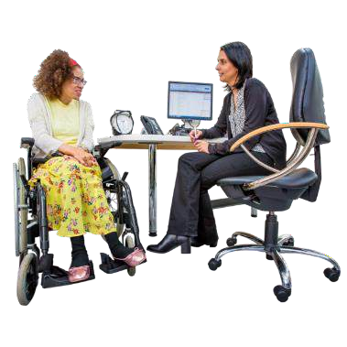
 | You can ask for a quick check if you are worried about changes in your or your loved one's health.
 | You might see small changes before we do.
 | Telling us about these changes can help us find problems early. This way, we can stop bigger health issues from happening.

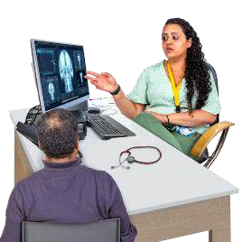

How we examine patients
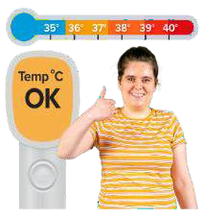 | When someone is in hospital, we often check their vital signs and other important health numbers.
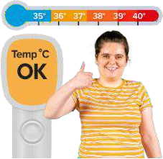 | How often we check depends on what the patient needs.  Sometimes we have to wake them up to do the checks.
 | We will ask patients every day if they feel better or worse. This helps us check for any changes in how they are doing.


Your role is very important
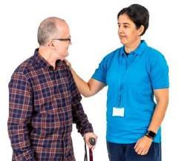  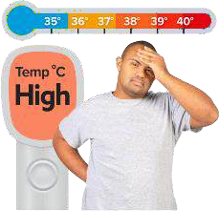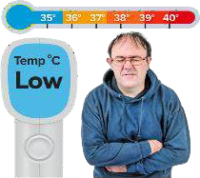       | Please let us know if you notice any changes. Tell us if you or your loved one:  - Feel too hot or too cold  - Have more pain than usual  - Spot any changes to the skin, like a rash  - Get very tired or sleepy

       | - Are not drinking enough water  - Are breathing different  - Are feeling confused  - Is there anything else that makes you worried?

        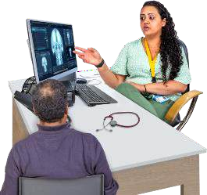 | We want to help you feel better. If you notice any changes, please share them with us.  It is important to talk about how you are feeling.  Your health is important to us. We are here to listen and support you.  Do not be anxious or worried about telling us if something is wrong.  We care about your well-being.  If you see any changes, tell our staff. This helps us find problems early and stop them from getting worse.

What to do if you're worried 
   | - First, speak to the team caring for you or your loved one  - If you still feel worried after talking to the care team and think they are not listening, ask for a quick check-up. Phone: 07976 071 450
  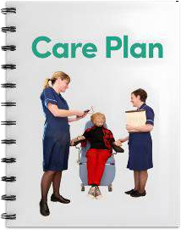  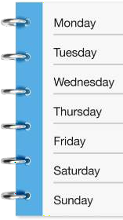 | Your call will go to a special team in our hospital. They help people who are very sick.  They will talk with you and your care team. They will help plan any treatment or check-ups you need.  The service is available:  - 24 hours a day  - seven days a week.

Our commitment 
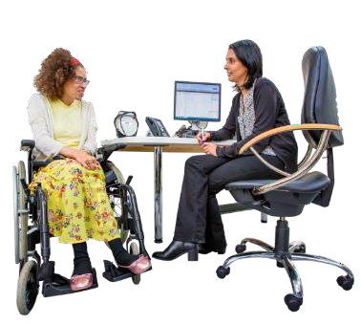 | We will often ask what you think and will listen to your worries.
 | We see you as a partner in your care. We want to work together with you.  Please tell us if you have any worries.

