**Welcome to the Gloucestershire enhance programme**

The **enhance** programme was inspired by key findings from the Future Doctor report and the NHS long term workforce plan, both of which recognized the need to improve the **generalist skills** of healthcare professionals in order to navigate our increasingly complex healthcare system.

By improving generalist skills **enhance** will help you to feel more confident managing care across multiple overlapping physical and mental health services. It will enable you to bridge organizational boundaries, work better in multi-professional teams, and provide more person-centred care.

On completion of an **enhance** programme you will be awarded a **Certificate in Contextual Leadership**.

***“We should celebrate being both specialists and generalists”***

***Professor Chris Witty***

**How does it work?**

In order to receive your Certificate in Contextual Leadership you will need to attend 3 **enhance** study days. You can then either write your reflections on the study days using the template provided, or do another piece of related work such as a poster, QI or research project. After your work is reviewed by the enhance team you will receive your certificate.

**When and where are the enhance study days?**

There are 5 or 6 **enhance** study days per year. These are held at either Cheltenham or Gloucester Postgraduate Centre, or at an external venue.

They are free events and include refreshments.

**What do the study days cover?**

Study days cover a variety of subjects which focus on the enhance learning domains and cross-cutting themes as detailed below:

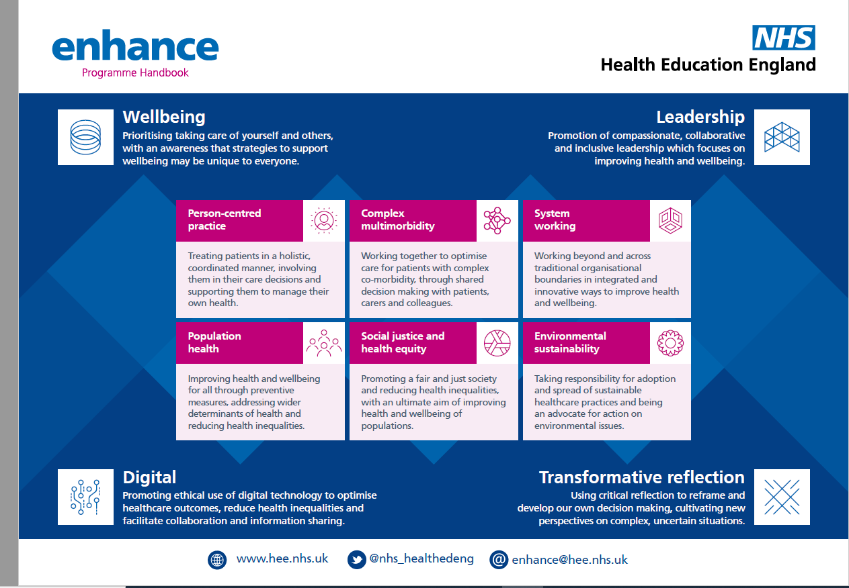

Previous study days have included:

* *“20-24” What is life like for young people who were coming of age during a global pandemic?*
* *Staff-centred care*
* *Homelessness*
* *Sexual misconduct*

Future study days include:

* *The Obesity Crisis (11/6/25)*
* *The Assisted Dying Dilemma : Compassionate conversations around End of Life care (24/9/25)*
* *Why are we all so anxious? (26/11/25)*

Study days are advertised across the Trust, GHC and Primary Care.

If you are completing your Certificate of Contextual Leadership, you will receive early notification of study days and priority booking.

Future events will be held in January and March 26 (TBC). Themes for these days will be confirmed nearer the time as they are planned according to current hot topics, local issues or requests from participants.

**Who is eligible?**

Any healthcare worker is welcome to take part in the **enhance** programme.

**Quality Improvement projects**

If you are inspired by any of the study days to do a QI project you will need to arrange appropriate QI training through your own organization.

**Educational Supervisors**

If your educational supervisor requires information about the enhance programme please signpost them to this page

**And finally**

We are keen for enhance to respond to local need, so if you have any ideas for future study days please let us know!

To register for the enhance programme, or if you have any questions, please email **[gtr.enhancesw@nhs.net](mailto:gtr.enhancesw@nhs.net%3e)**