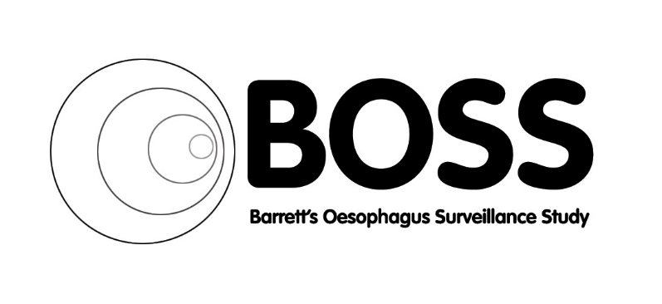

**BOSS FINAL RESULTS**

|  |
| --- |
| **BOSS RESULTS PARTICIPANT NEWSLETTER**  Welcome to the final newsletter from the BOSS trial team. We would like to give you a short summary of the results of the study.  We are contacting you because between 2009 - 2011 you kindly agreed to take part in a research project to find out whether people with a condition called Barrett’s Oesophagus would benefit from having an endoscopy every 2 years to monitor the development of the condition or whether having an endoscopy if symptoms worsened would be as good. You may also be receiving this as a relative of a loved one who was in the study but is no longer with us or able to read this for themselves.  We opened the BOSS trial in 2009 and recruited the final patient in 2011. We recruited 3,456 people into the study and each person including the last person to be recruited was followed up for 10 years. Unfortunately, the COVID pandemic in 2020 delayed the completion of the study, but the results of the BOSS trial have now been published.  The results of the BOSS project tell us that having a scheduled endoscopy every 2 years did not improve survival from oesophageal cancer or any other cause. We also found that having an endoscopy when symptoms worsen (an ‘At need’ endoscopy) may be a safe alternative for patients who have a low risk of their Barrett’s Oesophagus developing into cancer.  We would like to express our thanks and deep gratitude to all of you for participating in the BOSS trial and contributing to an important clinical study. It has been a long trial, but we are finally there, and we hope that the results will enable important changes in practice for all patients with a diagnosis of Barrett’s Oesophagus to be made in the future.  If you have any questions regarding the BOSS results, please contact:  [ghn-tr.researchgrants@nhs.net](mailto:ghn-tr.researchgrants@nhs.net)  **Website:** [**www.gloshospitals.nhs.uk/about-us/research-our-hospitals/research-trials/boss-trial/**](http://www.gloshospitals.nhs.uk/about-us/research-our-hospitals/research-trials/boss-trial/)  **Best wishes to you all from the BOSS team and**  **thank you once again for your support.** |