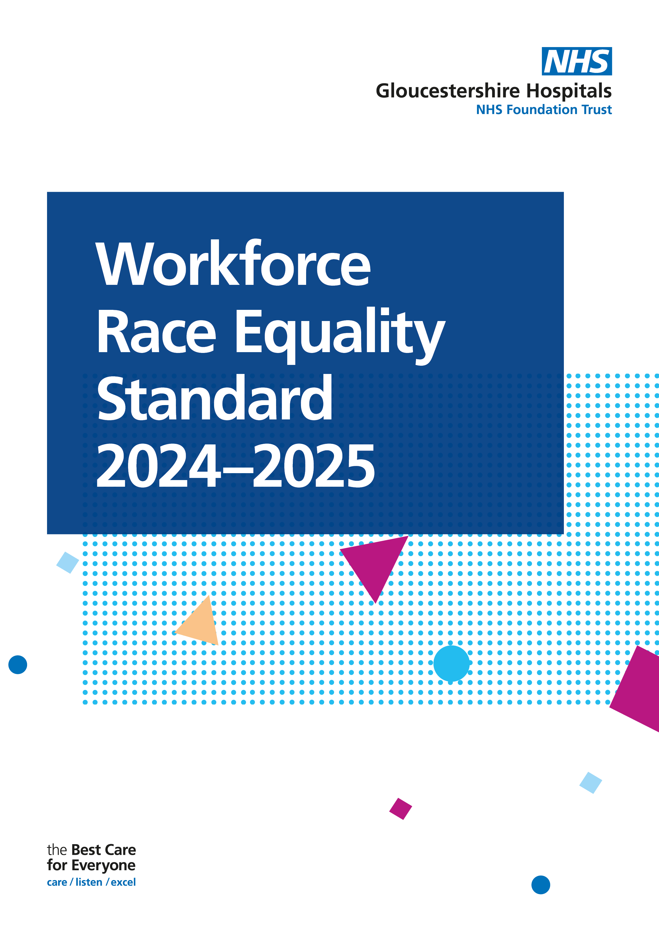

**Contents**

**Executive Summary 2**

**Introduction and Aims 3**

**Data and Summary of Progress**

**Workforce Indicators 4**

**Relative Likelihood Indicators 6**

**Staff Survey Indicators 7**

**3.4 Board Indicator 8**

**Executive Summary**

The Workforce Race Equality Standard (WRES) was introduced in 2015, with the first report published in 2016. It was developed to monitor progress across nine key indicators aimed at tackling inequality and unfair treatment experienced by Black and Minority Ethnic (BME) staff in the workplace. This enables the Trust to track progress over time, highlight areas requiring improvement, and implement necessary changes.

Over the past 12 months, the Trust has undertaken significant work to drive improvement across these indicators. As a result, we have seen positive progress since 2024 in six of the nine indicators (1, 5, 6, 7, 8, and 9), reflecting the impact of ongoing efforts and a positive trajectory in several areas.

However, while these improvements are encouraging, there remain areas where outcomes have worsened. In particular, indicators 2 and 3 have shown a decline, highlighting the continued need for focused action.

**Key findings include:**

22% of the Trusts staff are BME, which is an increase of 2% since 2024.

The number of BME senior leaders (Band 8a+) has increased from 41 to 43, which equates to an increase of 0.4%. The highest percentage representation is in Band 8c, at 15.6%.

The relative likelihood of White staff being appointed from shortlisting compared to BME staff has increased by 0.55 to 2.12.

BME staff remain more likely to enter the formal disciplinary process than White staff (relative likelihood of 1.07).

BME staff are more likely to access non-mandatory training and CPD than White staff (relative likelihood of 0.97). This has shifted marginally towards an equal figure, with White staff slightly more likely to access non-mandatory training than they were in 2024.

3.45% less BME staff reported experiencing harassment, bullying or abuse from patients, relatives or the public since the 2023 staff survey. White staff also report experiencing a reduction.

There has been a decrease in BME staff experiencing harassment, bullying or abuse from other staff members (27.98% in 2023 to now at 26.7%), however BME staff still experience this more than White staff.

There was an increase (of 1.45%) in both White and BME staff believing that the Trust provides equal opportunities for career progression and promotion.

BME staff are still more likely than White staff to experience discrimination at work from a manager/team leader or other colleague, although this has decreased to 16.95%. White staff have reported experiencing a small increase.

Numbers of BME Total Board members have increased from 2 to 3 in 2025, which is a 5.89% increase.

**2.0 Introduction**

Welcome to the 2024 Workforce Race Equality Standard (WRES) Report.

This report provides an overview of how the Trust is working to ensure equality of opportunity and fair treatment for our Black and Minority Ethnic (BME) staff. It presents data comparing the experiences of BME employees with those of their white colleagues, highlighting progress and areas for further improvement.

The WRES, introduced in 2015, was established to help NHS organisations demonstrate progress in creating a more equitable and inclusive workplace for staff from BME backgrounds. It is built around nine key metrics that allow for detailed comparison between BME and white staff experiences across areas such as recruitment, promotion, disciplinary processes, and workplace culture.

According to the 2021 Census, 15.1% of Gloucester’s population identify as from an ethnic minority background, compared to 6.9% across Gloucestershire. Comparing the Trust’s workforce data with these local population figures is important. It provides valuable context and helps assess whether the ethnic diversity of our staff reflects that of our community.

This 2024 report presents data for all nine WRES indicators, alongside a summary of actions taken throughout the year and plans for 2025/26. These actions have been informed by the WRES metrics, our annual action plan, and insights gathered from the 2024 staff survey. Notably, Metrics 5 to 8 are directly drawn from the survey results, offering a clear view of staff experiences and perceptions.

Through this report, the Trust reaffirms its commitment to equity, diversity, and inclusion, and to creating a working environment where all staff can thrive, regardless of their background

At Gloucestershire Hospitals NHS Foundation Trust (GHNHSFT), as of 31st March 2025, our Electronic Staff Records (ESR) data shows the following:

|  |  |  |  |  |  |
| --- | --- | --- | --- | --- | --- |
| Workforce Data | 2025  Headcount | 2025  % | 2024 Headcount | 2024  % | % Difference |
| Total Workforce | 8656 |  | 8699 |  |  |
| BME staff | 1930 | 22% | 1741 | 20% | Increase of 2% compared to the 2024 data. |
| White staff | 5805 | 67% | 5916 | 68% | Decrease of 1% compared to the 2024 data. |
| Ethnicity Unknown | 921 | 11% | 1042 | 12% | Decrease of 1% compared to the 2024 data. |

**Aims**

* Compare the workplace and career experiences of the Trust’s Ethnic Minority (EM) and white staff, using data drawn from the WRES reporting in 2024.
* Present high-level findings and analysis of the WRES metrics data.
* Highlight trends in NHS staff survey data published for the year 2024.
* Suggest actions to improve the experiences of Ethnic Minority staff for each metric.
* Raise awareness of race equality within the Trust's workforce and outline some of the challenges that EM staff collectively experience at work.

**WRES Metrics**

|  |  |
| --- | --- |
| **WRES Metric** | **White, BME & Ethnicity unknown or Null** |
| 1 | Percentage of staff in each of the AfC Bands 1-9 OR Medical and Dental subgroups and VSM (including executive Board members) compared with the percentage of staff in the overall workforce |
| 2 | Relative likelihood of staff being appointed from shortlisting across all posts |
| 3 | Relative likelihood of staff entering the formal disciplinary process, as measured by entry into a formal disciplinary investigation |
| 4 | Relative likelihood of staff accessing non-mandatory training and CPD |
| 9 | Percentage difference between the organisations’ Board voting membership and its overall workforce |

**3.0 Data and Summary of Progress**

**3.1 Workforce Indicators**

*Percentages presented are rounded to the nearest whole number.*

*Highlighted in green are where there have been percentage increases in disability representation, and red where there have been percentage decreases.*

|  |  |  |  |  |  |  |  |  |  |  |
| --- | --- | --- | --- | --- | --- | --- | --- | --- | --- | --- |
| **Indicator** | **2023/2024** | | | | | **2024/2025** | | | | |
| 1. Percentage of staffs in Bands | **Non-Clinical** | | | | | | | | | |
| **Band** | **White**  **2024** | **BME**  **2024** | | **Ethnicity Unknown/Null 2024** | **Band** | | **White 2025** | **BME**  **2025** | **Ethnicity Unknown/Null 2025** |
| Under Band 1 | 62% (8) | 8% (1) | | 31% (4) | Under Band 1 | | 44% (4) | 33% (3) | 22% (2) |
| Band 1 | 100% (2) | 0% (0) | | 0% (0) | Band 1 | | 100% (2) | 0% (0) | 0% (0) |
| Band 2 | 84% (373) | 9% (39) | | 8% (34) | Band 2 | | 86% (359) | 9% (36) | 5% (22) |
| Band 3 | 84% (482) | 9% (54) | | 7% (39) | Band 3 | | 83% (504) | 12% (71) | 5% (29) |
| Band 4 | 85% (252) | 9% (26) | | 6% (19) | Band 4 | | 84% (237) | 9% (25) | 7% (19) |
| Band 5 | 78% (141) | 13% (23) | | 9% (16) | Band 5 | | 79% (144) | 13% (24) | 8% (15) |
| Band 6 | 76% (145) | 16% (30) | | 8% (15) | Band 6 | | 78% (144) | 16% (30) | 5% (10) |
| Band 7 | 85% (83) | 7% (7) | | 8% (8) | Band 7 | | 78% (84) | 15% (16) | 7% (8) |
| Band 8a | 84% (58) | 7% (5) | | 9% (6) | Band 8a | | 84% (65) | 9% (7) | 7% (5) |
| Band 8b | 87% (40) | 9% (4) | | 4% (2) | Band 8b | | 88% (38) | 7% (3) | 5% (2) |
| Band 8c | 86% (19) | 5% (1) | | 9% (2) | Band 8c | | 85% (23) | 7% (2) | 7% (2) |
| Band 8d | 83% (10) | 8% (1) | | 8(1) | Band 8d | | 91% (10) | 0% (0) | 9% (1) |
| Band 9 | 75% (3) | 0% (0) | | 25% (1) | Band 9 | | 80% (8) | 0% (0) | 20% (2) |
| VSM | 63% (12) | 0% (0) | | 37% (7) | VSM | | 38% (3) | 0% (0) | 63% (5) |
|  | **Clinical** | | | | | | | | | |
| **Band** | **White**  **2024** | **BME**  **2024** | **Ethnicity Unknown/Null 2024** | | | **Band** | **White**  **2025** | **BME**  **2025** | **Ethnicity Unknown**  **/Null**  **2025** |
| Under Band 1 | 57% (8) | 14% (2) | 29% (4) | | | Under Band 1 | 92% (11) | 8% (1) | 0% (0) |
| Band 1 | 0% (0) | 0% (0) | 0% (0) | | | Band 1 | 0% (0) | 0% (0) | 0% (0) |
| Band 2 | 63% (616) | 25% (243) | 13% (126) | | | Band 2 | 74% (91) | 20% (24) | 7% (8) |
| Band 3 | 78% (251) | 15% (47) | 8% (25) | | | Band 3 | 62% (712) | 27% (315) | 11% (121) |
| Band 4 | 74% (220) | 10% (30) | 16% (47) | | | Band 4 | 88% (253) | 7% (21) | 5% (13) |
| Band 5 | 43% (780) | 33% (607) | 24% (431) | | | Band 5 | 41% (734) | 37% (667) | 23% (411) |
| Band 6 | 74% (890) | 21% (248) | 6% (71) | | | Band 6 | 73% (891) | 22% (267) | 6% (70) |
| Band 7 | 84% (559) | 11% (73) | 5% (34) | | | Band 7 | 81% (530) | 14% (91) | 5% (32) |
| Band 8a | 85% (183) | 12% (25) | 4% (8) | | | Band 8a | 86% (187) | 11% (24) | 3% (7) |
| Band 8b | 95% (58) | 2% (1) | 3% (2) | | | Band 8b | 92% (44) | 4% (2) | 4% (2) |
| Band 8c | 74% (14) | 21% (4) | 5% (1) | | | Band 8c | 67% (12) | 28% (5) | 6% (1) |
| Band 8d | 100% (7) | 0% (0) | 0% (0) | | | Band 8d | 100% (9) | 0% (0) | 0% (0) |
| Band 9 | 100% (4) | 0% (0) | 0% (0) | | | Band 9 | 100% (4) | 0% (0) | 0% (0) |
| VSM | 0% (0) | 0% (0) | 0% (0) | | | VSM | 100% (1) | 0% (0) | 0% (0) |
| **Of which Medical and Dental** | | | | | | | | | |
|  | Consultants | 72% (333) | 22% (100) | 7% (32) | | | Consultants | 71% (332) | 21% (96) | 9% (41) |
|  | Non-consultant Career Grades | 50% (56) | 44% (50%) | 6% (7) | | | Non-consultant Career Grade | 46% (57) | 42% (52) | 11% (14) |
| Trainee Grades | 58% (309) | 23% (120) | 19% (100) | | | Trainee Grades | 58% (312) | 28% (148) | 15% (79) |

**Non-Clinical**

BME representation has increased from 191 to 217, which equates to a 1.3% increase.

White representation has decreased in numbers from 1628 to 1625, however this equates to a 0.2% increase.

Colleagues declaring Unknown ethnicity/Null has decreased from 154 to 122, which equates to a decrease of 1.6%.

**Clinical**

BME representation has increased from 1280 to 1417, which equates to a 2.7% increase.

White representation decreased from 3590 to 3479, which equates to a 1.3% decrease.

Colleagues declaring Unknown ethnicity/Null has decreased from 749 to 665, which equates to a 1.3% decrease.

**Senior Leaders**

The number of BME senior leaders (8a+) (including both Clinical and non-clinical staff) has increased from 41 to 43, this equates to an increase of 0.4%. The highest percentage representation is in Band 8c (Clinical and Non-clinical staff combined gives a representation of 15.6%), which saw an increase of 2 in BME leaders, with an increase of 3.36%.

|  |  |  |
| --- | --- | --- |
| **Band** | **Total BME representation in Band 8a+** | |
| B8a | 31 | Increase of 1 since 2024, which equates to the percentage of representation in this band remaining the same. |
| B8b | 5 | Remained the same as 2024, which equates to a 0.8% increase in representation within this banding. |
| B8c | 7 | Increase of 2 since 2024, which is a representation increase of 3.4%. |
| 8d | 0 | Decrease of 1 since 2024, which equates to a percentage decrease of 5.3% within this banding. |
| B9 | 0 | Remained the same as 2024, |
| VSM | 0 | Remained the same as 2024 |

**3.2 Relative Likelihood Indicators**

|  |  |  |  |  |
| --- | --- | --- | --- | --- |
| **Indicator** | **Data Item** | **White** | **BME** | **Ethnicity Unknown/Null** |
| 2. Relative likelihood of staff being appointed from shortlisting across all posts | Number of shortlisted applicants | 3928 | 3833 | 310 |
| Number appointed from shortlisting | 906 | 416 | 143 |
| Percentage appointed from shortlisting | 23.1% | 10.9% | 0.46 |
| Relative likelihood of White staff being appointed from shortlisting compared to BME staff | 2.12 |  | |

A relative likelihood figure above 1 indicates that White staff are more likely to be appointed from shortlisting compared to BME staff.

The relative likelihood of White staff being appointed from shortlisting compared to BME staff has increased by 0.55 from the previous year.

|  |  |  |  |  |
| --- | --- | --- | --- | --- |
| **Indicator** | **Data Item** | **White** | **BME** | **Ethnicity Unknown/Null** |
| 1. Relative likelihood of staff entering the formal disciplinary process, as measured by entry into a formal disciplinary investigation | Number of staff entering the formal disciplinary process | 67 | 24 | 16 |
| Percentage of staff entering the formal disciplinary process | 1.09% | 1.07% | 1.13% |
| Relative likelihood of BME staff entering the formal disciplinary process compared to White staff | 1.07 |  | |

A relative likelihood figure above 1 indicates that BME staff are more likely than White staff to enter the formal disciplinary process.

BME staff are slightly more likely to enter the formal disciplinary process than White staff, and this has increased by 0.19 since 2024.

|  |  |  |  |  |
| --- | --- | --- | --- | --- |
| **Indicator** | **Data Item** | **White** | **BME** | **Ethnicity Unknown/Null** |
| 1. Relative likelihood of staff accessing non-mandatory training and CPD | Number of staff accessing non-mandatory training and CPD | 6205 | 2108 | 1042 |
| Likelihood of staff accessing non-mandatory training and CPD | 1.06 | 1.09 | 1.13 |
| Relative likelihood of White staff accessing non-mandatory training and CPD compared to BME staff | 0.97 |  | |

BME staff are more likely to access non–mandatory training and Continued Professional Development compared to White staff.

The relative likelihood of White staff accessing non-mandatory training and CPD compared to BME staff has marginally increased from 0.81 to 0.97.

**3.3 Staff Survey Indicators**

|  |  |  |  |
| --- | --- | --- | --- |
| **Indicator** |  | **2023** | **2024** |
| 1. Percentage of staff experiencing harassment, bullying or abuse from patients, relatives or the public in last 12 months | White | 24.89% | 22.29% |
| BME | 31.61% | 28.16% |

In 2024, 3.45% less BME staff have experienced harassment, bullying or abuse from patients, relatives or the public compared to 2023. Results decreased for White staff by 2.6%.

|  |  |  |  |
| --- | --- | --- | --- |
| **Indicator** |  | **2023** | **2024** |
| 1. Percentage of staff experiencing harassment, bullying or abuse from staff in last 12 months | White | 22.79% | 20.63% |
| BME | 27.98% | 26.70% |

Both BME staff and White staff experienced less harassment, bullying or abuse from staff compared to 2023 (-1.28% and -2.16% respectively).

|  |  |  |  |
| --- | --- | --- | --- |
| **Indicator** |  | **2023** | **2024** |
| 1. Percentage believing that trust provides equal opportunities for career progression or promotion | White | 52.45% | 53.62% |
| BME | 47.08% | 48.53% |

1.45% more BME staff believe that the Trust provides equal opportunities for career progression or promotion, along with a 1.17% increase in White staff, since 2023.

|  |  |  |  |
| --- | --- | --- | --- |
| **Indicator** |  | **2023** | **2024** |
| 1. Percentage of staff experiencing discrimination at work from manager/team leader or other colleagues in the last 12 months | White | 6.82% | 7.50% |
| BME | 19.01% | 16.95% |

BME staff are much more likely to experience discrimination from managers, team leaders or other colleagues, than White staff (by 9.45%). However, the number of BME staff experiencing this has decreased by 2.06% since 2023. There has been a 0.68% increase for White staff who report experiencing discrimination at work from a manager/team leader or other colleague.

**3.4 Board Indicator**

|  |  |  |  |  |
| --- | --- | --- | --- | --- |
| **Indicator** | **Data Item** | **White** | **BME** | **Ethnicity Unknown/Null** |
| 1. Percentage difference between the organisations’ Board voting membership and its overall workforce | Total Board Members: | 59% (10) | 18% (3) | 24% (4) |
| Of which: voting Board members | 50% (4) | 0% (0) | 50% (4) |

There has been an increase of 5.89% of BME Total Board members since 2024, with numbers increasing from 2 to 3.