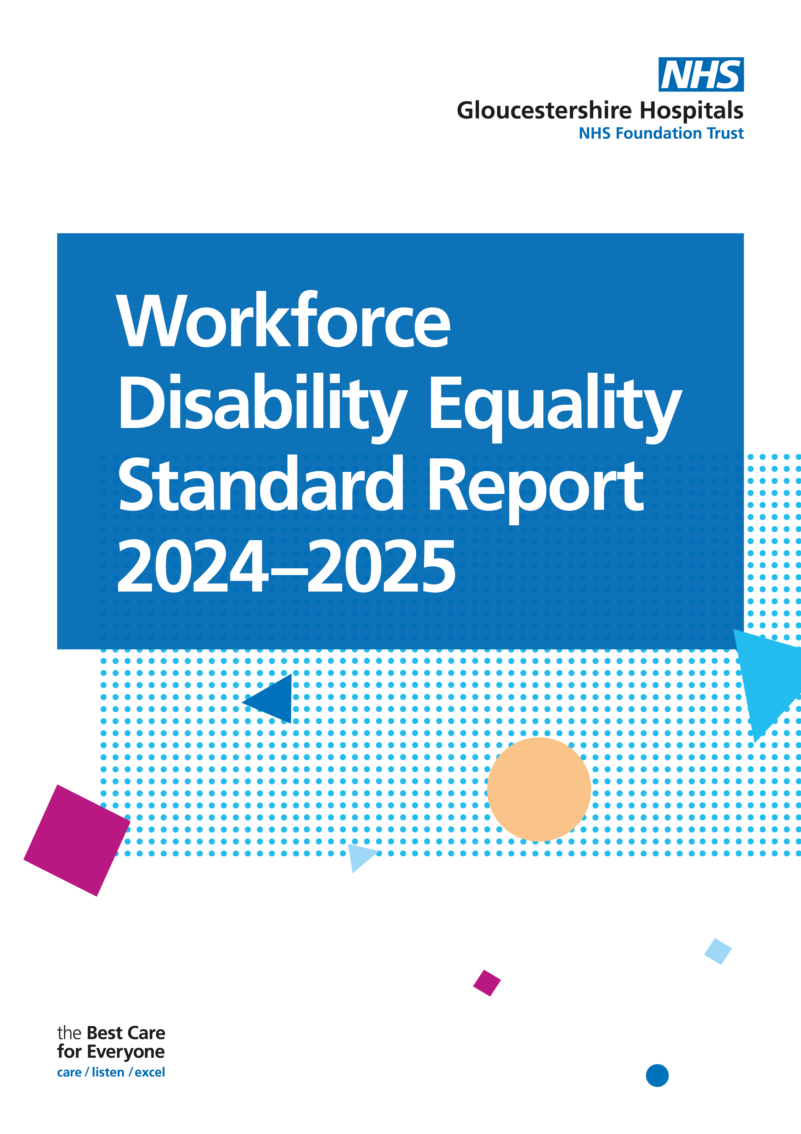

**Contents**

**Executive Summary 2**

**Introduction and Aims 3**

**Data and Summary of Progress**

**Workforce Indicators 4**

**Relative Likelihood Indicators 6**

**Staff Survey Indicators 7**

**3.4 Board Indicator 9**

1. **Executive Summary**

The Workforce Disability Equality Standard (WDES), introduced in 2019, is designed to help NHS organisations compare the workplace experiences of disabled and non-disabled staff across 10 key metrics. This comparison supports the development and ongoing monitoring of action plans aimed at demonstrating year-on-year progress, identifying areas for cultural improvement, and tackling inequality and unfair treatment in the workplace.

During the 2023–24 reporting year, Gloucestershire Hospitals NHS Foundation Trust has made significant strides through a range of initiatives and projects focused on improving performance across the WDES indicators. Encouragingly, we have seen improvements in 9 out of the 14 measured areas (indicators 1, 2, 4a, 4b, 4c, 4d, 7, 8, and 10). While some of these improvements are modest, they reflect positive momentum and a clear commitment to change.

However, despite our efforts, there remain areas requiring focused attention. The Trust continues to perform below the national average across all indicators, and further action is essential. Notably, indicators 3, 5, 6, and 9 highlight specific areas where improvement is still needed.

Key findings include:

* There has been a decrease of 25% of staff with an undeclared/unknown disability status. This demonstrates a large improvement in staff declaring their disability status.
* 4.92% of the Trusts staff have declared a disability, which is an increase of 1.35% since 2024.
* There has been an increase of 9 senior staff members (Band 8a+) declaring a disability, which is an increase of 1.91%. Band 9 has the highest representation of disabled staff at 14.29%.
* Non-disabled applicants are more likely to be appointed from shortlisting than disabled (relative likelihood of 1.37). This likelihood has shown a small decrease since 2024.
* Disabled staff are much more likely to enter the formal capability process than non-disabled (relative likelihood of 3.69), and this likelihood has shown a small increase since 2024.
* Disabled staff reported a decrease in experiencing harassment, bullying or abuse from patients (of 4.17%) since the 2023 staff survey.
* Both disabled and non-disabled staff reported a decrease in harassment, bullying or abuse from managers since 2023 (-1.44% and -0.77% respectively).
* There was a small reduction of 0.56% of disabled staff reporting experiences of harassment, bullying or abuse from colleagues.
* 50.8% of disabled colleagues said that the last time they experienced harassment, bullying or abuse at work they or a colleague reported it. This is a 6.87% increase.
* There was a decrease (of 2.25%) in disabled colleagues reporting that they feel the Trust provides equal opportunities for career progression or promotion.
* The percentages of staff who felt pressure from their manager to come to work despite not feeling well enough has remained largely the same for both disabled and non-disabled colleagues (with a small 0.16% increase for disabled staff).
* 70.99% of disabled staff felt that the organisation had made reasonable adjustments to enable them to carry out their work. This is a small increase on 2023 results.
* There has been an increase of 1 board member declaring a disability since 2024.

**2.0 Introduction**

Launched in 2019, the Workforce Disability Equality Standard (WDES) requires all NHS organisations to publish data and action plans based on ten indicators aimed at improving the working lives of disabled staff. These annual assessments enable Trusts to track progress, identify areas for improvement, and better understand the experiences of their disabled workforce. Ultimately, the goal is to foster a more inclusive and supportive working environment for everyone.

**Gloucestershire Population**

According to the 2021 Census, 17.4% of Gloucester’s population is disabled under the Equality Act 2010, closely aligned with the figure for Gloucestershire as a whole, at 16.8%. Comparing the Trust’s workforce data with these local population statistics is essential. It provides valuable context, highlighting whether the representation of disabled staff within the organisation reflects the communities it serves. This comparison not only supports accountability but also helps guide targeted, data-informed action to reduce disparities and promote equity.

|  |  |  |  |  |  |
| --- | --- | --- | --- | --- | --- |
| Workforce Data | 2025 | 2025% | 2024 | 2024% | % Difference |
| Total Workforce | 8656 |  | 8686 |  |  |
| Disabled Staff | 426 | 4.92% | 310 | 3.57% | Increase of 1.35% since 2024 |
| Non-Disabled Staff | 6794 | 78.49% | 4758 | 54.78% | Increase of 23.71% since 2024 |
| Disability Unknown | 1436 | 16.59% | 3618 | 41.65% | Decrease of 25.06% since 2024 |

**Aims**

* Compare the workplace and career experiences of the Trust’s disabled and non-disabled staff, using data drawn from the WDES reporting in 2024.
* Present high-level findings and analysis of the WDES metrics data.
* Highlight trends in the NHS staff survey data published for the year 2024.
* Suggest actions to improve the experiences of disabled staff for each metric.
* Raise awareness of disability equality within the Trusts workforce and outline some of the challenges that disabled staff collectively experience at work.

**WDES Metrics**

|  |  |
| --- | --- |
| **WDES Metric** | **Disabled, Non-disabled & Disability Unknown or Null** |
| 1 | Percentage of staff in each of the AfC Bands 1-9 OR Medical and Dental subgroups and VSM (including executive Board members) compared with the percentage of staff in the overall workforce |
| 2 | Relative likelihood of non-Disabled staff compared to Disabled staff being appointed from shortlisting across all posts |
| 3 | Relative likelihood of non-Disabled staff compared to Disabled staff entering the formal capability process, as measured by entry into the formal capability procedure  (Metric based on data from a two-year rolling average) |
| 4-9a | NHS Staff Survey data |
| 9b | Has your organisation taken action to facilitate the voices of your Disabled staff to be heard? |
| 10 | Percentage difference between the organisations’ Board voting membership and its overall workforce |

**3.0 Data and Summary of Progress**

**3.1 Workforce Indicators**

*Percentages presented are rounded to the nearest whole number.*

*Highlighted in green are where there have been percentage increases in disability representation, and red where there have been percentage decreases.*

|  |  |  |  |  |  |  |  |  |  |  |  |  |
| --- | --- | --- | --- | --- | --- | --- | --- | --- | --- | --- | --- | --- |
| **Indicator** | **2023/2024** | | | | | **2024/2025** | | | | | | |
| 1. Indicator | **Non-Clinical** | | | | | | | | | | | |
| **Band** | **Disabled 2024** | **Non-disabled 2024** | **Unknown/Null 2024** | | **Band** | | **Disabled 2025** | | **Non-disabled 2025** | | **Unknown/Null 2025** |
| Under Band 1 | 0% (0) | 7% (1) | 100% (13) | | Under Band 1 | | 0% (0) | | 67% (6) | | 33% (3) |
| Band 1 | 50% (1) | 25% (1) | 50% (1) | | Band 1 | | 50% (1) | | 0% (0) | | 50% (1) |
| Band 2 | 6% (28) | 38% (84) | 47% (209) | | Band 2 | | 8% (35) | | 77% (321) | | 15% (61) |
| Band 3 | 5% (26) | 52% (285) | 38% (219) | | Band 3 | | 7% (40) | | 80% (484) | | 13% (80) |
| Band 4 | 8% (24) | 48% (132) | 38% (114) | | Band 4 | | 9% (26) | | 77% (215) | | 14% (40) |
| Band 5 | 5% (9) | 53% (88) | 39% (71) | | Band 5 | | 4% (8) | | 78% (142) | | 18% (33) |
| Band 6 | 2% (4) | 58% (99) | 37% (70) | | Band 6 | | 3% (5) | | 82% (150) | | 16% (29) |
| Band 7 | 7% (7) | 49% (39) | 41% (40) | | Band 7 | | 6% (6) | | 82% (89) | | 12% (13) |
| Band 8a | 6% (4) | 44% (24) | 46% (32) | | Band 8a | | 9% (7) | | 73% (56) | | 18% (14) |
| Band 8b | 9% (4) | 47% (18) | 41% (19) | | Band 8b | | 2% (1) | | 86% (37) | | 12% (5) |
| Band 8c | 5% (1) | 52% (11) | 55% (12) | | Band 8c | | 7% (2) | | 78% (21) | | 15% (4) |
| Band 8d | 0% (0) | 50% (6) | 50% (6) | | Band 8d | | 9% (1) | | 64% (7) | | 27% (3) |
| Band 9 | 0% (0) | 50% (1) | 100% (4) | | Band 9 | | 20% (2) | | 80% (8) | | 0% (0) |
| VSM | 11% (2) | 83% (5) | 63% (12) | | VSM | | 0 | | 38% (3) | | 63% (5) |
|  | **Clinical** | | | | | | | | | | | |
| **Band** | **Disabled 2024** | **Non-disabled 2024** | | **Unknown/Null 2024** | | **Band** | **Disabled 2025** | | **Non-disabled 2025** | | **Unknown/Null 2025** |
| Under Band 1 | 0% (0) | 29% (4) | | 71% (10) | | Under Band 1 | 17% (2) | | 83% (10) | | 0% (0) |
| Band 1 | 0% (0) | 0% (0) | | 0% (0) | | Band 1 | 0% (0) | | 0% (0) | | 0% (0) |
| Band 2 | 3% (33) | 52% (509) | | 45% (443) | | Band 2 | 8% (10) | | 76% (93) | | 16% (20) |
| Band 3 | 3% (11) | 55% (179) | | 41% (133) | | Band 3 | 5% (57) | | 78% (890) | | 18% (201) |
| Band 4 | 5% (15) | 52% (153) | | 43% (129) | | Band 4 | 8% (22) | | 82% (235) | | 11% (30) |
| Band 5 | 2% (41) | 47% (862) | | 50% (915) | | Band 5 | 4% (76) | | 76% (1383) | | 20% (353) |
| Band 6 | 4% (51) | 59% (716) | | 37% (442) | | Band 6 | 5% (58) | | 82% (1007) | | 13% (163) |
| Band 7 | 2% (16) | 57% (382) | | 40% (268) | | Band 7 | 4% (23) | | 78% (506) | | 19% (124) |
| Band 8a | 2% (5) | 54% (116) | | 44% (95) | | Band 8a | 5% (11) | | 73% (158) | | 23% (49) |
| Band 8b | 5% (3) | 49% (30) | | 46% (28) | | Band 8b | 6% (3) | | 58% (28) | | 35% (17) |
| Band 8c | 0% (0) | 47% (9) | | 53% (10) | | Band 8c | 0% (0) | | 72% (13) | | 28% (5) |
| Band 8d | 0% (0) | 57% (4) | | 43% (1) | | Band 8d | 11% (1) | | 67% (6) | | 22% (2) |
| Band 9 | 0% (0) | 75% (3) | | 25% (1) | | Band 9 | 0% (0) | | 75% (3) | | 25% (1) |
| VSM | 0% (0) | 0% (0) | | 0% (0) | | VSM | 0% (0) | | 100% (1) | | 0% (0) |
|  | | | | | | | | | | | |
| Consultants | 3% (15) | 55% (244) | | 43% (190) | | Consultants | | 3% (13) | | 76% (356) | 21% (100) |
| Non-consultant Career Grades | 4% (5) | 61% (112) | | 38% (70) | | Non-consultant Career Grade | | 6% (7) | | 72% (88) | 23% (28) |
| Trainee Grades | 1% (5) | 70% (294) | | 29% (122) | | Trainee Grades | | 2% (9) | | 89% (478) | 10% (52) |

**Non-Clinical**

The number of staff declaring a disability has increased from 110 in 2024, to 134 in 2025. This equates to a 1.2% increase.

The number of non-disabled staff has also increased, from 1041 to 1539, which is a 25.6% increase.

The number of unknown/null staff has decreased from 822 in 2024 to 291 in 2025, which is a 26.9% decrease.

**Clinical**

The number of staff declaring a disability has increased from 175 in 2024 to 263 in 2025. This equates to a 1.6% increase.   
The number of non-disabled staff has increased from 2967 to 4333, which is a 25.1% increase.   
The number of unknown/null staff has decreased from 2477 in 2024, to 965 in 2025, which is a 26.7% decrease.

**Senior Leaders**

There has been an increase of 9 staff members in bands 8A+ declaring a disability, going from 19 to 28. This is an increase of 1.91%. The highest percentage representation is in band 9, at 14.29% (2 out of 14 declaring a disability).

**AfC Pay Bands**

The representation of staff declaring a disability in senior pay band grouping 8C, 8D, 9 and VSM has increased by 1 (3.1%). The highest representation is in pay band grouping 1, 2, 3 and 4, with 5.8% (91) of staff in these bands declaring a disability.

|  |  |  |
| --- | --- | --- |
| **Band** | **Total Disability representation in AfC Pay Band Grouping** | |
| AfC Bands 1, 2, 3 and 4 | 193 | Increase of 55 since 2024 (a 1.99% increase) |
| AfC Bands 5, 6 and 7 | 176 | Increase of 48 since 2024 (a 1.12% increase) |
| AfC Bands 8A and 8B | 22 | Increase of 6 since 2024 (a 1.60% increase) |
| AfC Bands 8C, 8D, 9 and VSM | 6 | Increase of 3 since 2024 (a 3.42% increase) |

**3.2 Relative Likelihood Indicators**

|  |  |  |  |  |
| --- | --- | --- | --- | --- |
| **Indicator** | **Data Item** | **Disabled** | **Non-disabled** | **Unknown/Null** |
| 2. Relative likelihood of staff being appointed from shortlisting across all posts | Number of shortlisted applicants | 758 | 6996 | 317 |
| Number appointed from shortlisting | 97 | 1226 | 142 |
| Percentage appointed from shortlisting | 12.8% | 17.5% | 44.8% |
| Relative likelihood of non-disabled staff being appointed from shortlisting compared to disabled staff | 1.37 |  | |

A figure above 1 indicates that non-disabled applicants are more likely to be appointed from shortlisting compared to non-disabled applicants.

The relative likelihood of non-disabled applicants being appointed from shortlisting compared to non-disabled has decreased very slightly by 0.04 from the previous year. Non-disabled applicants are still more likely to be appointed than disabled applicants.

|  |  |  |  |  |
| --- | --- | --- | --- | --- |
| **Indicator** | **Data Item** | **Disabled** | **Non-disabled** | **Unknown/Null** |
| 1. Relative likelihood of staff entering the formal capability process, as measured by entry into the formal capability procedure (two year rolling average) | Number of staff entering the formal capability process | 9.5 | 41 | 49.5 |
| Likelihood of staff entering the formal capability process | 0.02 | 0.01 | 0.03 |
| Relative likelihood of disabled staff entering the formal capability process compared to non-disabled staff | 3.69 |  | |

A figure above 1 indicates that disabled staff are more likely to enter the formal capability process than non-disabled.

Disabled staff are much more likely to enter the formal capability process than non-disabled staff. This has remained largely the same since 2024, however with a small 0.03 increase.

**3.3 Staff Survey Indicators**

|  |  |  |  |
| --- | --- | --- | --- |
| **Indicator** |  | **2023** | **2024** |
| 4a. Percentage of staff experiencing harassment, bullying or abuse from patients, relatives or the public in last 12 months | Disabled | 32.24% | 28.07% |
| Non-disabled | 24.51% | 22.64% |

In 2024, 4.17% less disabled staff reported experiencing harassment, bullying or abuse from patients, relatives or the public compared to 2023 staff survey results. Results for non-disabled staff decreased by 1.87%.

|  |  |  |  |
| --- | --- | --- | --- |
| **Indicator** |  | **2023** | **2024** |
| 4b. Percentage of staff experiencing harassment, bullying or abuse from managers in last 12 months | Disabled | 16.92% | 15.48% |
| Non-disabled | 8.56% | 7.79% |

Both disabled and non-disabled staff experienced less harassment, bullying or abuse from managers compared to 2023 (-1.44% and -0.77% respectively).

|  |  |  |  |
| --- | --- | --- | --- |
| **Indicator** |  | **2023** | **2024** |
| 4c. Percentage of staff experiencing harassment, bullying or abuse from other colleagues in the last 12 months | Disabled | 26.90% | 26.34% |
| Non-disabled | 17.82% | 16.37% |

The percentage of staff that reported experiencing harassment, bullying or abuse from other colleagues has slightly decreased since 2023, by 0.56% for disabled staff and by 1.45% for non-disabled staff.

|  |  |  |  |
| --- | --- | --- | --- |
| **Indicator** |  | **2023** | **2024** |
| 4d. Percentage of staff saying the last time they experienced harassment, bullying or abuse at work they or a colleague reported it | Disabled | 43.93% | 50.80% |
| Non-disabled | 49.17% | 48.40% |

There has been an increase in disabled staff saying that the last time they experienced harassment, bullying or abuse at work they or a colleague reported it (+6.87%). For non-disabled staff there was a small decrease of 0.77%.

|  |  |  |  |
| --- | --- | --- | --- |
| **Indicator** |  | **2023** | **2024** |
| 1. Percentage of staff who believe that the organisation provides equal opportunities for career progression or promotion | Disabled | 48.70% | 46.45% |
| Non-disabled | 51.99% | 53.92% |

There has been a 2.25% decrease in disabled staff saying that they believed the organisation provided equal opportunities for career progression or promotion, whereas non-disabled staff reported a 1.93% increase.

|  |  |  |  |
| --- | --- | --- | --- |
| **Indicator** |  | **2023** | **2024** |
| 1. Percentage of staff who have felt pressure to come to work, despite not feeling well enough | Disabled | 32.51% | 32.67% |
| Non-disabled | 20.97% | 20.96% |

The percentage of staff who felt pressure to come to work despite not feeling well enough has stayed largely the same (a 0.16% increase for disabled staff and a 0.01% decrease for non-disabled staff).

|  |  |  |  |
| --- | --- | --- | --- |
| **Indicator** |  | **2023** | **2024** |
| 1. Percentage of staff satisfied with the extent to which the organisation values their work | Disabled | 28.75% | 30.12% |
| Non-disabled | 38.82% | 41.76% |

There has been an increase in both disabled and non-disabled staff reporting that they are satisfied with the extent to which the organisation values their work (1.37% for disabled and 2.94% for non-disabled).

|  |  |  |  |
| --- | --- | --- | --- |
| **Indicator** |  | **2023** | **2024** |
| 1. Percentage of disabled staff saying their employer has made reasonable adjustments to enable them to carry out their work | Disabled | 70.53% | 70.99% |

There has been a small increase in disabled staff saying their employer has made reasonable adjustments for them to carry out their work (0.46%).

|  |  |  |
| --- | --- | --- |
| **Indicator** | **Disabled** | **Non-disabled** |
| 9a. The staff engagement score of disabled staff, compared to non-disabled staff (0-10) | 5.91 | 6.70 |

Disabled staff have a lower engagement score compared to non-disabled staff, and this has slightly decreased since 2023 by 0.1.

|  |  |
| --- | --- |
| **Indicator** | **Disabled** |
| 9b. Has the organisation taken action to facilitate the voices of the disabled staff to be heard | Yes |

The Trust is committed to amplifying the voices of disabled staff through a range of initiatives. These include the Staff Disability Network, the Disability Peer Support Group, drop-in sessions, dedicated conferences, awareness events, and staff spotlights that highlight the experiences of colleagues with disabilities. Stories from disabled staff are also shared at Board level to ensure their voices are heard in key decision-making spaces. An Executive Sponsor has also been appointed to support and champion the Disability Network.

As part of our ongoing commitment to improving disability inclusion and accessibility in the workplace, we are launching a research project aligned with the Access to Work scheme. This project will involve benchmarking our current practices against those of other organisations, enabling us to celebrate areas of strength and identify where further improvements are needed to better support our disabled staff and long term health condition.

**3.4 Board Indicator**

|  |  |  |  |  |
| --- | --- | --- | --- | --- |
| **Indicator** | **Data Item** | **Disabled** | **Non-disabled** | **Unknown/Null** |
| 1. Percentage difference between the organisations’ Board voting membership and its overall workforce | Total Board Members: | 5.88% (1) | 58.82% (10) | 35.29% (6) |
| Of which: voting Board members | 0.00% (0) | 33.33% (3) | 66.67% (6) |

There has been an increase of 1 disabled total board members from 2024 to 2025.

There has been a decrease in unknown/null disability status in both total board members (12.11%) and voting board members (11.07%).