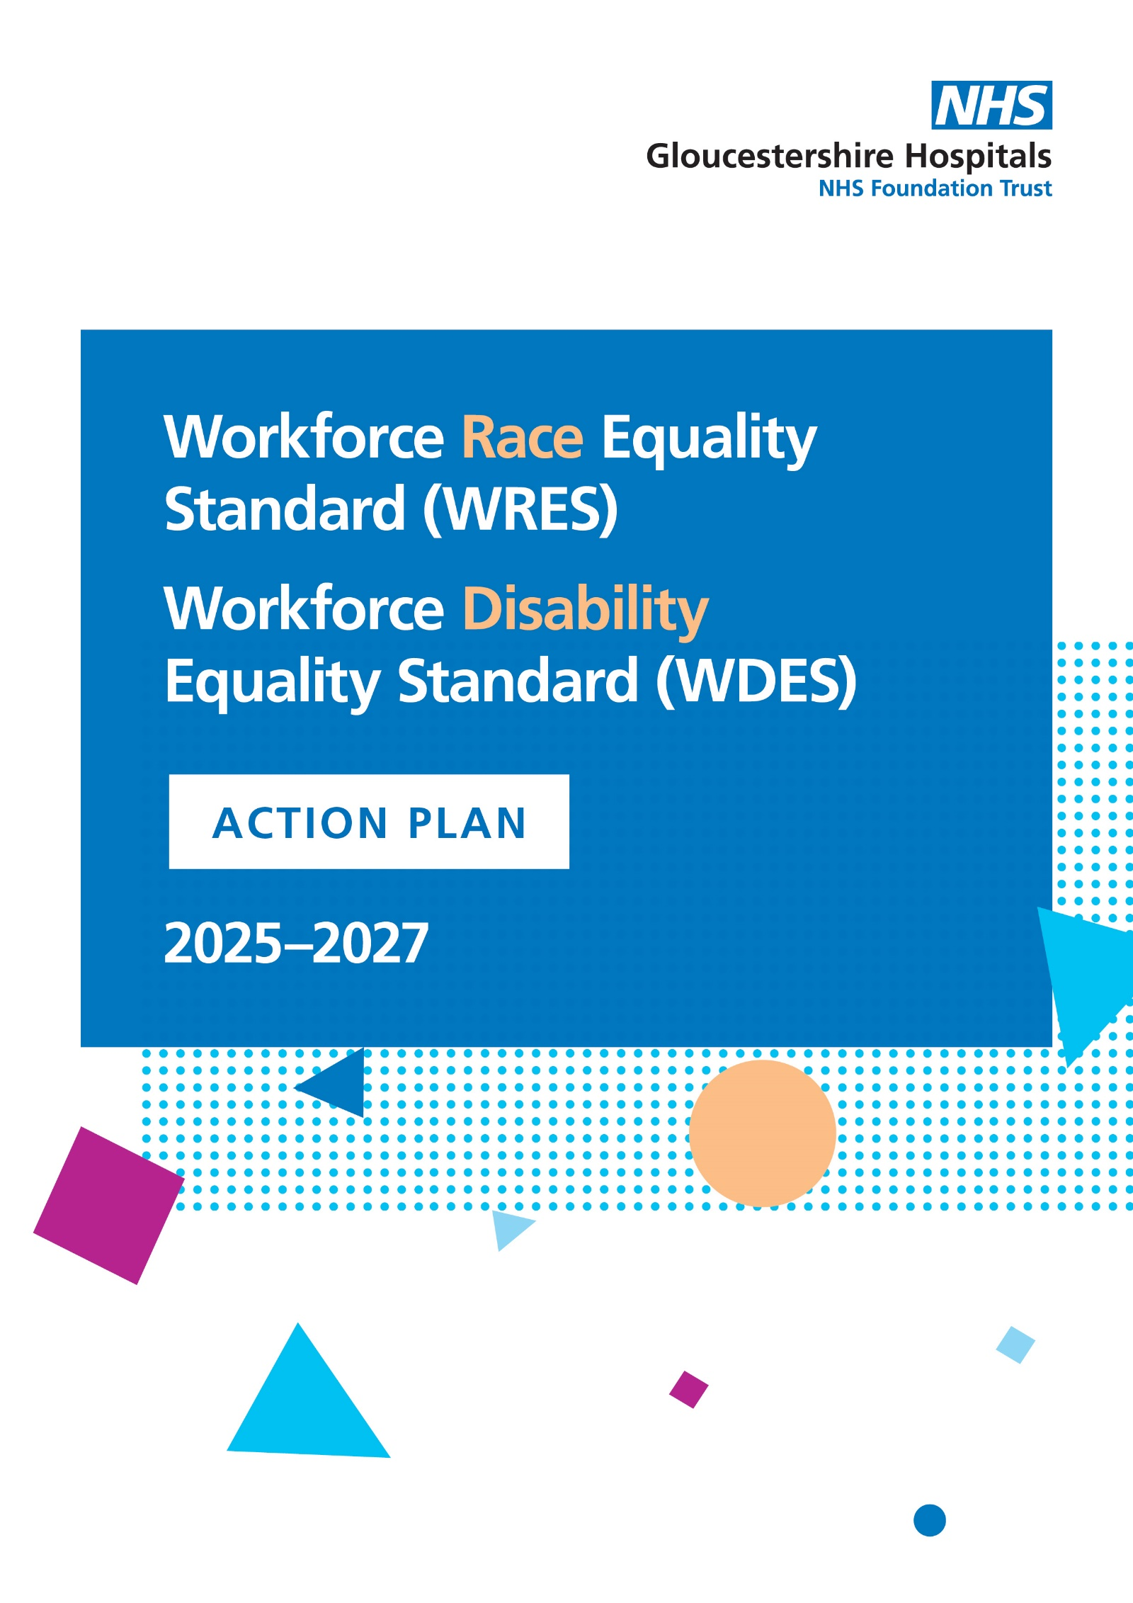

Workforce Race and Equality Standard Indicators
- Indicator 1: Percentage of staff in each of the AfC (Agenda for Change) pay bands (or medical and dental subgroups) compared with the overall workforce.
- Indicator 2: Relative likelihood of white applicants being appointed from shortlisting compared to BME applicants.
- Indicator 3: Relative likelihood of BME staff entering the formal disciplinary process compared to white staff.
- Indicator 4: Relative likelihood of BME staff accessing non-mandatory training and CPD compared to white staff.
Staff Survey Indicators
- Indicator 5: Percentage of staff experiencing harassment, bullying or abuse from patients, relatives or the public in the last 12 months.
- Indicator 6: Percentage of staff experiencing harassment, bullying or abuse from other staff in the last 12 months.
- Indicator 7: Percentage of staff believing that their organisation provides equal opportunities for career progression or promotion.
- Indicator 8: Percentage of staff personally experiencing discrimination at work from a manager, team leader or other colleagues.
Board Representation Indicator
- Indicator 9: Percentage difference between the organisation’s Board membership and its overall workforce with respect to BME representation

WDES Metrics Overview
Metric 1: Representation
Percentage of staff in each pay band (Agenda for Change, medical/dental, and very senior managers) who have declared a disability, compared to the overall workforce.

Metric 2: Recruitment
Relative likelihood of non-disabled applicants being appointed from shortlisting compared to disabled applicants.

Metric 3: Capability Process
Relative likelihood of disabled staff entering the formal capability process compared to non-disabled staff.

Metric 4: Harassment and Bullying
Percentage of disabled staff compared to non-disabled staff experiencing harassment, bullying or abuse from:
- Patients/service users/public
- Managers
- Other colleagues

Metric 5: Career Progression
Percentage of disabled staff compared to non-disabled staff believing that their organisation provides equal opportunities for career progression or promotion.

Metric 6: Presenteeism
Percentage of disabled staff feeling pressure from their manager to come to work despite not feeling well enough.

Metric 7: Feeling Valued
Percentage of disabled staff compared to non-disabled staff who are satisfied with the extent to which their organisation values their work.

Metric 8: Workplace Adjustments
Percentage of disabled staff reporting that their employer has made reasonable adjustments to enable them to carry out their work

Metric 9: Staff Engagement
Staff engagement scores for disabled staff compared to non-disabled staff, based on the NHS Staff Survey

Metric 10: Board Representation
Percentage of Board members who have declared a disability compared to the overall workforce.

WRES/WDES Indicator and Trust Action | Aligns with High Impact Actions 1, 2, 3, 4, 5 and 6
WRES/WDES Indicator and Trust Action | Current position | Objective | Action Planned for 25-27 | Outcome Measures
WRES Indicators 1, 2 and 7  WDES Indicators 1, 2 and 5  Aligns with EDI Trust Action 4 – EDI Team Actions | 22% of our workforce identify as being from Ethnic Minority backgrounds.  4.9% of our workforce identify as Disabled.  Despite this, there is a disproportionate underrepresentation of both EM and Disabled colleagues in senior clinical and non-clinical roles. | To improve the representation of Ethnic Minority and Disabled staff across senior levels of the organisation | Complete detailed WRES and WDES data analysis at divisional level to identify disparities in:  Divisional Workforce Analysis  - Applications, shortlisting and recruitment outcomes  - Promotion and career progression opportunities  - Access to secondment and acting up roles  Inclusive Recruitment & Selection  - Review and revise recruitment and selection processes to ensure equitable access and outcomes for EM and Disabled applicants  - Increase representation of EM and Disabled colleagues on selection panels  - Introduce targeted training for panel members to reduce bias and promote inclusive decision making  Career Development Support  - Develop tailored career development pathways for EM and Disabled staff, including mentoring, coaching and leadership programmes  - Ensure accessibility and reasonable adjustments are embedded in all development opportunities  - Monitor uptake and outcomes to ensure equitable access and progression  - Continue with Interviewing with Impact Workshops using our feedback to shape future workshops for our colleagues across the organisation. This will also include support with personal statements and job applications  Reciprocal Mentoring Programme  - Launch a reciprocal mentoring initiative for members of the Inclusion Network, pairing them with Senior Leaders to share lived experiences and perspectives related to varying members of the Inclusion Network  - Use insights from the programme to inform inclusive leadership practices and drive cultural change  Monitoring & Accountability  - Establish divisional accountability for progress against WRES and WDES indicators  - Report quarterly on progress and impact to the Trust Board and EDI Steering Group | - Increased percentage of EM and Disabled staff in senior roles  - Improved recruitment and promotion outcomes for EM and Disabled applicants  - Greater diversity and lived experience represented on selection panels  - Positive feedback from EM and Disabled staff on career development and progression opportunities  - Increased awareness and inclusive behaviours among senior leaders through reverse mentoring
WRES Indicator 1  WDES Indicator 1  Aligns with EDI Trust Action 4 – EDI Team Actions | 22% of staff as identify as being from Ethnic Minority backgrounds.  4.9% of staff identify as Disabled.  Declaration rates on EST remain lower than expecting, limiting the accuracy of workforce data and the ability to target support effectively. | Increase the number of staff completing their equality and diversity declarations on ESR, enabling more accurate workforce data and better-informed EDI interventions. | ESR Declaration Campaign  - Launch a Trust-wide campaign to encourage staff to update their personal data on ESR, focusing on ethnicity, disability, sexual orientation and other protected characteristics.  - Communicate the importance of declarations for improving inclusion, representation and access to support  EDI Team Support  - The EDI team will offer direct support to staff through drop-in sessions, guidance materials, team support in low declaration rate areas, and one-to-one assistance  - Collaborate with staff networks and divisional leads to promote the campaign and address concerns around confidentiality and data use  Monitoring and Reporting  - Track declaration rates monthly and report progress to the EDI Steering Group and Trust Board  - Use improved data to inform targeted actions across WRES and WDES indicators | - Increased declaration rates on ESR across all protected characteristics  - More accurate workforce data to support strategic planning and inclusive practice  - Greater staff confidence in data privacy and the purpose of declarations  - Enhanced ability to monitor and address disparities in recruitment, progression and experience
WRES Indicator 2, 3, 5, 6 and 8  WDES Indicator 4b, 4c, 4d, 6, 7, 8 and 9  Aligns to EDI Trust Action 6 – Staff Experience Improvement Programme | Staff Network Co-Chairs are often the voice for Ethnic Minority and Disabled staff, representing lived experiences and advocating for inclusion. However, many Co-Chairs have expressed the need for additional support to build confidence, leadership capability and strategic influence to effectively fulfil | Strengthen the leadership, visibility and strategic impact of Staff Network Co-Chairs by providing targeted development and support, enabling them to confidently represent their members and influence organisational change. | Co-Chair Development Programme  - Design and deliver a structured development programme tailored to the needs of Staff Network Co-Chairs to include modules on:  - Strategic influencing and leadership within the NHS  - Public speaking and presentation skills  - Navigating governance and decision-making structures  - Advocacy and allyship  Confidence Building and Peer Support  - Facilitate regular Co-Chair meetings for peer learning, reflection and shared problem-solving  - Provide access to coaching and mentoring, including reverse mentoring opportunities with senior leaders  Visibility and Voice  - Create opportunities for Co-Chairs to present at Trust Board, EDI Steering Group and divisional meetings  - Recognise and celebrate Co-chair contributions through internal communications and awards  - Embed Co-Chair input into policy development, service design and strategic planning  - Strengthen the connection between Executive Sponsors and their corresponding Network Co-chairs through regular meetings and involvement from Executive Sponsors in network activity  Monitoring and Feedback  - Collect feedback from Co-Chairs on the effectiveness of the programme  - Monitor impact through engagement levels, confidence ratings and visibility in decision-making spaces  Staff Networks  - Continually review and evaluate purpose and strength of all staff networks, establishing areas to increase engagement and amplify staff voice where possible.  - Review and strengthen purpose and process for Inclusion Council meetings | - Increased confidence and leadership capability amongst Staff Network Co-Chairs  - Greater visibility and influence in strategic decision making  - Positive feedback on development and support  - Enhanced staff voice aligned with WRES and WDES indicators  - Stronger advocacy for Ethnic Minority and Disabled staff across the Trust
WRES Indicator 1, 2, 3 and 7  WDES Indicator 1, 2, 3 and 5  Aligns to EDI Trust Action 5 – EDI Principles within Recruitment Process | There are currently 6 RCN Cultural Ambassadors within the Trust, with plans to increase this number. These individuals play a vital role in promoting inclusive practice, challenging bias and representing the lived experiences of Ethnic Minority and Disabled staff. Cultural  Inclusion Champions are currently used on some interview panels, however without consistency, definitive guidance on the role or adequate training. | To strengthen the role of Cultural Ambassadors and Inclusion Champions through training, increased visibility, and insight gathering, ensuring they are confidence and equipped to influence inclusive decision-making across the Trust.  Implementation of Inclusion Champion Feedback Pack for Senior Recruitment Panels. To Ensure fairness, transparency and equity in recruitment processes for Band 8A and above roles by collecting structured feedback from Inclusion Champions after each interview | Training and Development  - Deliver a structured training programme for Cultural Ambassadors and Inclusion Champions including modules on:  - Inclusive recruitment  - Unconscious bias  - Cultural competence  - Case review protocols  - Provide ongoing development opportunities and peer support forums  Deployment in key processes  - Include Cultural Ambassadors on all interview panels for senior roles and other key appointments  - Involve Cultural Ambassadors in case review meetings as needed, to provide an inclusion lens and challenge bias  - Identify and confirm differences in roles, responsibilities and uses of Inclusion Champions and Cultural Ambassadors  Insight Gathering  - Conduct regular surveys with Inclusion Champions and Cultural Ambassadors to identify emerging trends, themes and areas of concerns.  - Use findings to inform Trust-Wide EDI strategy and targeted interventions  Expansion and Visibility  - Increase the number of Cultural Ambassadors and trained Inclusion Champions across divisions  - Promote their role and impact through internal communications and staff engagement events  Inclusion Champion Pack  Develop and roll out a standardised Inclusion Champion Pack for use by panel members following each interview. This pack will include reflective questions, observations on inclusivity and space to record any concerns or good practices.  Collaborate with the Recruitment Team review, update and implement inclusive recruitment, in terms of:  - Diverse recruitment panels  - Positive Action  The data collected will be used to:  - Monitor and evaluate the fairness of recruitment practices  - Identify patterns or barriers affecting diverse candidates  - Inform continuous improvement in inclusive recruitment strategies  - Increase in positive feedback from candidates from underrepresented groups. | - Improved staff perception of fairness and inclusion in decision-making  - Insight reports from surveys informing strategic EDI actions  - Enhanced visibility and recognition of Cultural Ambassadors’ contributions  - Ambassadors will be involved in interview panels and case review meetings, contributing to fair and transparent processes.  - Increased accountability and transparency in senior recruitment  - Richer data to support equitable recruitment decisions  - Evidence-based improvements to recruitment policies and training
WRES Indicators 1, 2 and 5  WDES Indicators 1, 2 and 7  Aligns with EDI Trust Action 5 – EDI Principles within Recruitment Processes | Current recruitment processes do not consistently hold panel members accountable for ensuring fair and equitable recruitment processes.  There is also no process in place for monitoring and evaluating the fairness of recruitment practices.  We already undertake the gender Pay Gap reporting: the gap has reduced from 2024/25/ 25.7% to 23.3% (Mean average, in favour of males). 17.2% higher from 19.1% in 2024.  The Ethnicity Pay Gap was introduced this year. In 2024/25, the mean pay gap was 3.2% in favour of EM staff, and the median pay gap was 5.25% in favour of EM staff. | The improvement and standardisation of recruitment processes that hold those recruiting accountable, and ensure a fair and equitable recruitment process. | Review of Inclusion Champion Role  - Conduct a review of the Inclusion Champion role to assess whether the current process is effective.  - In conjunction with recruitment, develop diverse and inclusive recruitment and selection training for recruiting managers and interview panel members on conscious and unconscious bias, favouritism, and prejudice and create accountability  - Develop a training programme which will include positive action, unconscious bias and empowerment. This will be done in collaboration with the Recruitment team and discussed at the Equality, Diversity and Inclusion Steering Group (EDISG) to determine necessary actions for improvement  Interviewing with Impact Workshops  Continue with Interviewing with Impact Workshops using our feedback to shape future workshops for our colleagues across the organisation. This will also include support with personal statements and job applications  Pay Gap Reports  The continuation of reporting the Gender Pay Gap and the Ethnicity Pay Gap, plus the introduction of the Disability Pay Gap for 2025/2026.  Appraisal Review  In July 2025, a new appraisal pathway was introduced. It places greater emphasis on regular, meaningful conversations throughout the year, including Code of Conduct reviews, Wellbeing Conversations, and the Appraisal Conversation. The refreshed approach is fully aligned with the NHS People Promise.  Inclusive Recruitment Task and Finish Project  - Development of a recruiting manager toolkit with suggestions to include  - What is inclusive recruitment  - Introducing new policies and ways of working  - Short videos for managers to provide information  - Tips and advice for creating the best job adverts  - How to effectively use AI to support recruiting managers  - Understanding the audience and defining key USPs for department/division  - Recruiting manager training for all recruiting managers and all new management starters | - Standardisation of the Inclusion Champion role  - Implementation of a training programme to better equip inclusion champions to be successful in their role  - Colleagues feeling more equipped going into job applications and interviews thanks to improved workshops  - A more equitable and fair recruitment process  - The completion of the gender pay gap, ethnicity pay gap and disability pay gap reports  - Improved recruitment training for managers, increasing understanding around how to recruit in a fair and equitable way
WRES Indicator 6 and 8  WDES Indicator 4b, 4c and 4d  Aligns with EDI Trust Action 6 – Staff Improvement Programme Including Anti-Discrimination Workstream | We have held regular drop-in clinics for staff to share experiences and raise concerns.  In July 2025 we launched the Report Support and Learn platform for staff to raise concerns of inappropriate behaviour. | Staff have a clear understanding of how and where they can raise concerns of inappropriate behaviours and feel comfortable doing so.  Expectations around what consists of inappropriate behaviours are solidified, and the message of zero tolerance for these behaviours will be reinforced. | Inappropriate Behaviours  - We will continue to support staff through holding regular drop-in clinics, providing a confidential and safe setting for staff to raise their concerns and experiences.  - The embedding of the Report, Support and Learn Platform for Staff will enable colleagues to feel increasingly able to report inappropriate behaviours.  - Awareness posters on inappropriate behaviours will be developed and distributed to promote understanding and reinforce expected standards | - Improved staff confidence in reporting inappropriate behaviours  - Decrease in occurrences of inappropriate behaviours
WRES Indicator 9  WDES Indicator 10  Aligns with EDI Trust Action 1 – Board Requirements | Each board member is an executive sponsor for a specific protected characteristic within the Trust and have clear and measurable EDI objectives for which they are individually and collectively accountable. | Staff are given an amplified voice and are able to share their experiences working within the Trust via a reciprocal mentoring programme. | Reciprocal Mentoring Programme  A proposal has been written for us to take part in a reciprocal mentoring programme, pairing members of our Inclusion Network with Senior Leaders across the organisation. This programme will be facilitated by the Trust’s Organisational Development team. | - Increased understanding from Board members of the experiences of members of the Inclusion Network  - Increased visibility and amplified voice for the members of the Inclusion Network taking part in the scheme

WRES/WDES Action Plan, awaiting Board Approval

