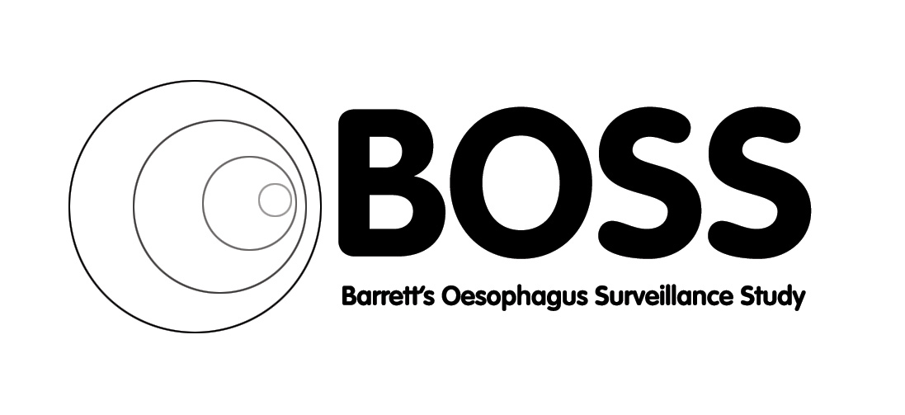



Newsletter
December 2017

Welcome to the 2017 Christmas Edition of the Barrett’s Oesophagus Surveillance Study newsletter

As we approach Christmas 2017 we would like to wish you all a merry Christmas and happy new year. Thank you all for your continued hard work and support of the BOSS trial.

Few bits of news:
Please remember that due to trust policy we no longer have a fax machine in our office, please scan and email or post all CRFs etc to the BOSS team. Any concerns please contact Clive or one of the data officers.

Cathryn Rasdell had a lovely baby boy who is now 3 and a bit months old, well according to my maths he is. We are hoping that Cathryn will return to the team in the Autumn.

As per a previous email the BOSS team have all gone over to nhs.net emails. Attached separately is an updated contact sheet for you all. Please be aware that if using the old email addresses after Christmas these may be returned to you as unknown.

The BOSS office will be manned except for the following dates:
20th, 22nd, 25th and 26th December.

A Christmas message from our Chief Investigator Professor Hugh Barr:

We at BOSS are extremely grateful for your huge and continued commitment to the BOSS trial.
There is no doubt that practice within the NHS and internationally will be impacted by the outcome of the trial.
Only a short time to go so please keep adhering to the protocol and continue to send in the data.
Thank you all for being so fantastic and Happy Christmas!

Take a few moments to relax with a mince pie and coffee …….Good luck with below, no prizes just a bit of seasonal fun from all at BOSS
Christmas Carols Word Search
O R S C W V A L N W V G S D R
J C E G K U W V S H D O L E A
H T H G N M B J D I S D L C T
S H M R N I B E J T J I E K S
I G C M I A K Q I E G S B T L
L I B S R S M E M C W L E H U
E N E Y X Y T A E H D O L E F
N Y U N X A Y M N R W V G H I
T L R L Q C K J A I H E N A T
N O C G O K N Q R S Y T I L U
I H O A U S A X J T T A J L A
G O I L M M S E Q M D R W S E
H M Z D B Z A S R A M U E A B
T V J I Q M F I R S T N O E L
T I S C H R I S T M A S D A Y

Away In A Manger  Beautiful Star  Deck The Halls  First Noel  God Is Love  Jingle Bells | O Christmas Tree  O Holy Night  Silent Night  Three Kings  Tis Christmas Day  White Christmas

