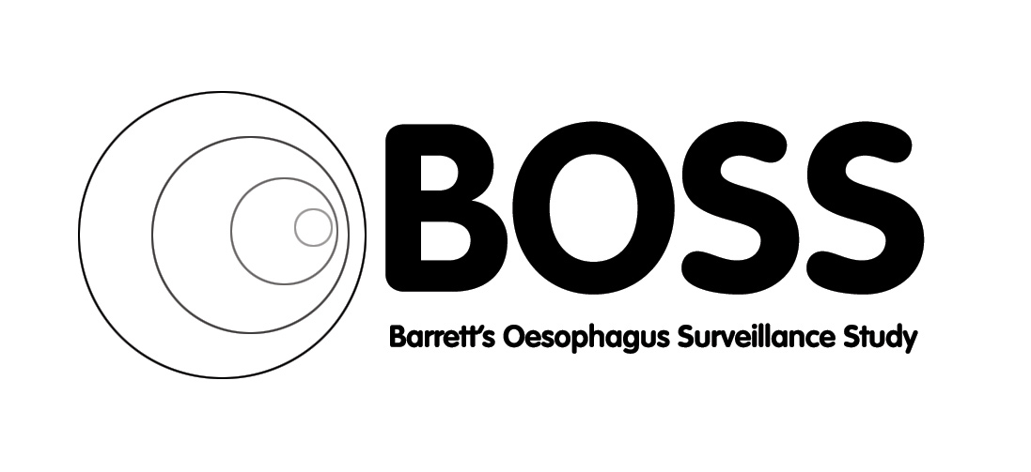


Newsletter
June 2017

Welcome to the June 2017 Barrett’s Oesophagus Surveillance Study newsletter

BOSS NEWS
Due to the recent computer virus which affected 99.9% of the NHS we have taken the decision to resend the May 2017 newsletter just in case the original did not reach you. We have taken this opportunity to add a few things following the recent BOSS Data and Safety Monitoring Committee meeting (DSMC).

We are aware that for BOSS we do not have an adverse events form. Could we remind you to use the comments section of the Endoscopy CRF for any information that you think we should know about please. This is useful for us to collate incidences that fall outside of hospital admissions / Serious adverse events.

When recording the number of biopsies taken please remember to use the local endoscopy report as your source data and NOT the pathology report. As you will agree sometimes these can give varying numbers of biopsies so to reduce confusion we have previously stated that the local endoscopy report should be used for this.

Please ensure that your endoscopy at need patients are removed from your hospital recall lists. Cathryn and Helen will soon be repeating the exercise undertaken last year asking sites to check whether at need patients have had any unscheduled endoscopies. Please look out for the e mail and respond to them as soon as you can.

It has been approximately 2 years since we reviewed the deceased archiving. A request to submit the original documents to Cathryn for the deceased participants was sent by email earlier this month. We have already received a great response – Thank you

We are aware that once patients reach the age of 70 – 75 that some trusts stop recalling these patients for endoscopy. Please remember that all patients consented and randomised to the 2 yearly arm should remain on a recall list

The recent DSMC meeting went very well. Overall the continuing data is good. The main concern still rests though with quality of life returns from those patients in the 2 yearly arm. Can we call on you to ensure that, where possible, you hand a QOL form to the patient in endoscopy and ask the patient to complete it there so that it can be returned directly to yourselves. Or if you do not see the patient when they attend please could you post them a QOL for completion.

During the DSMC we discussed the finish date for patients in the BOSS trial. The patient information sheet and consent form where historically, in retrospect, not clear in what was meant by 10 years within the trial. We have discussed options with the sponsor and Caldicott guardian and they are happy that the 10 years should be taken as 10 years of follow up since the last patient entered the trial and not 10 years from the time each patient entered the trial.

For example:

Patient recruited on 2009 was always thought of as ending participation in 2019 and so on for those recruited in 2010.
However, as the last patient was recruited in October 2011 all patients will be deemed as complete within BOSS as of October 2021.

Can we ask that as and when you see you patients that you discuss that the time for completion of the trial is 2021 and not, as some patients might think, 2019, 2020 etc.
Please do phone anyone of us in the BOSS trial office to clarify this or run through any questions that you may have.

We are pleased to inform you all that our BOSS website is once again up and running and fully up to date; this includes all current versions located under ‘investigators’ then documentation. If you get a chance please do look at it, all feedback gratefully received.

Website: www.bosstrial.glos.nhs.uk

BOSS team news

Professor Barr has now retired but…not from BOSS. He will do two sessions per week in endoscopy and see BOSS through to its conclusion as the Chief Investigator and fabulous leader that he has always been

Cathryn Rasdell will be leaving us in August but only for about 9-12 months due to a maternal condition…..umm, that’s called being pregnant. We shall miss her when she leaves us but are glad it’s on a temporary basis!

Sue Walton will be reducing her hours. She became a grandmother last year and is taking up the opportunity of spending a day a week looking after her beautiful granddaughter
We are also pleased to announce that we have two new staff members and an old face returning (she will love that expression)

Dr Catherine Kendall a scientist from Biophotonics here at Gloucester has taken over as the new BOSS trial manager and on a personal note is like a breath of fresh air

Mrs Allison Bates who works alongside Catherine has often stepped in to support the BOSS team on an ad-hock basis is now the new BOSS trial administrator

And the old face….for those of you who remember Angela Moulsdale, she will be returning to cover part of the maternity leave as is due to start around the 1st August

Best wishes from all at BOSS

TEAM CONTACT DETAILS:
BOSS Trial Team
Chestnut House
Gloucestershire Royal Hospital
Great Western Road
Gloucester GL1 3NN

Professor Hugh Barr - Chief Investigator Tel: 03004 226679
Mr Clive Stokes - Trial Coordinator Tel: 03004 225477
Mrs Cathryn Rasdell - Data Officer Tel: 03004 225475
Mrs Helen Sainsbury - Data Officer Tel: 03004 225482
Ms Sue Walton - Data Officer Tel: 03004 225474
Dr Catherine Kendall - Trial Manager Tel: 03004 225484
Mr Chris Foy - Data Manager Tel: 03004 225461
Mrs Allison Bates - Trial Administrator Tel: 03004 225484

Website: www.bosstrial.glos.nhs.uk

Fax: 03004 225486

