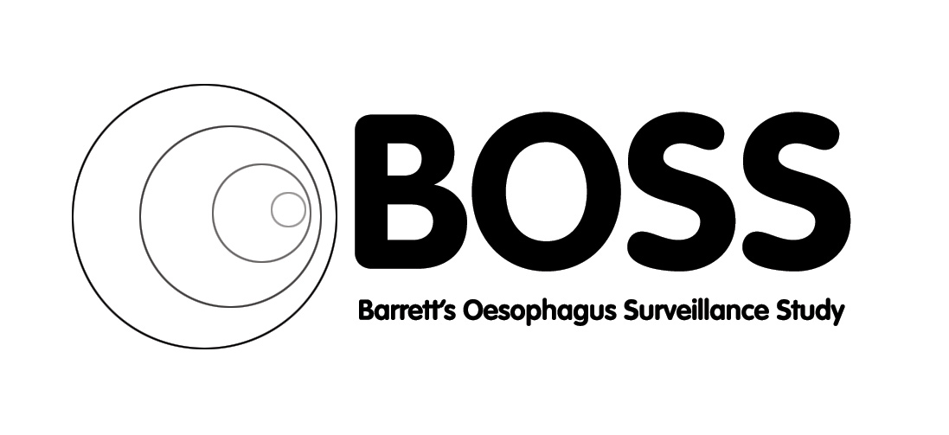


BOSS PARTICIPANT NEWSLETTER

Barrett’s Oesophagus Surveillance Study Newsletter

BOSS NEWS

Hello to you all and welcome to the second BOSS newsletter. We would like to take this opportunity to update you on the BOSS trial that you entered a few years ago and to thank you all for your continued involvement in this important study. BOSS remains a huge achievement for all our participants.

You may recall that the BOSS trial is hoping to determine whether 2 yearly routine endoscopy is more beneficial to patients than having an endoscopy when they report symptoms only. This is still a valid question for the endoscopy community across the UK.

We are now mid-way through the trial and the data is looking good but we will not be aware of the final outcome until the end of the trial. There are 4 years to go which means all patients recruited into the BOSS trial will end their participation as of November 2021. After this time you will all return to the endoscopy practice adopted for Barrett’s at your local hospital.

The quality of life questionnaires that are returned to the central office remain an important outcome of the trial. Please could we ask you to spare a few minutes to complete and return the questionnaires when you receive them, either from the hospital staff or through the post from the central trials office. Please do complete and return the questionnaires even if you have done one before, as we would like to build up a picture of any changes over the years.

If you experience any symptoms for example, unexplained weight loss, iron deficiency anaemia, recurrent vomiting, or worsening upper gastrointestinal symptoms please can you call your trials nurse. He or she can then review your symptoms and organise an endoscopy if required.

Could we also ask if you have had an endoscopy referred via your GP we would be grateful if you could let your trials nurse know. Unfortunately these scopes are not always picked up by the hospital research teams and the data is important to the trial. It is also worth reminding your GP that you are on the BOSS trial so they can highlight that in your referral to ensure you are seen by the appropriate clinical team.

Please remember if you are admitted to hospital, for any reason, we would like to know as this is one of the outcomes of the BOSS trial. To help with this please let your local trials nurse know so that they can complete the appropriate forms and return them to us.

Our website is updated regularly and holds a lot of key information in relation to the trial. Do take a look at:

http://www.gloshospitals.nhs.uk/en/About-Us/Research--Development/Barretts-Oesophagus-Surveillance-Study-BOSS/

Many thanks again for your involvement and continued support of the BOSS trial.

TEAM CONTACT DETAILS:
BOSS Trial Team
Chestnut House
Gloucestershire Royal Hospital
Great Western Road
Gloucester
GL1 3NN

Professor Hugh Barr | Chief Investigator | hugh.barr@nhs.net | 03004 22 6679
Clive Stokes | Trial Coordinator | clivestokes@nhs.net | 03004 22 5477
Helen Sainsbury | Data Officer | h.sainsbury@nhs.net | 03004 22 5482
Susan Walton | Data Officer | sue.walton6@nhs.net | 03004 22 5474
Cathryn Rasdell | Data Officer |  | 03004 22 5475
Angela Moulsdale | Data Officer | angela.moulsdale@nhs.net | 03004 22 5475

