Gloucestershire Education & Training Standards
for Managing Lower Limb Wounds

Introduction
This education and training standards aim to support the health and care workforce in developing the knowledge and skills required to enable appropriate lower limb wound (leg ulcer) care to be delivered to people in any setting in the Gloucestershire system.
People with lower limb leg wounds are cared for across a variety of health and care settings and services. There is currently variation in wound care for lower limb wounds related knowledge and skills across the health and care workforce in Gloucestershire, with pockets of expertise found in primary care, specialist and community services. To ensure that someone with a wound receives the care they need, it is necessary for all health and care practitioners to have wound care related knowledge and skills. To enable this, it is necessary to define the knowledge and skills needed by the multi-professional workforce at all levels.
The Core Capabilities are described in the Wound Care Workforce Framework which suggest three tiers for any practitioner working in a health or care setting, depending on their role. Fig 1 shows the definitions for each of these tiers.
Figure 1
The training at each tier should be in line with the Wound care framework www.skillsforhealth.org.uk/wp-content/uploads/2021/05/Wound-Care-Framework-2021.pdf
It is important to note that the Tiers do not relate to specific roles or pay grades. For example, it is possible that a consultant level doctor who has little involvement in lower limb care may only require knowledge and skills as defined in Tier 1. However, a healthcare support worker in a community setting working with people at high risk of pressure damage or co-morbidities that increase the risk of delayed healing may require some of the more in-depth knowledge and skills as defined in Tier 2.
Figure 2
Figure 2 shows the capabilities of the workforce for Leg Ulcer Best Practice Bundle elements and specialist services, mapped to the tiers of the National Wound Care Workforce Framework for England.
Below shows the domains to be covered and related capabilities (Table 1).

Table 1
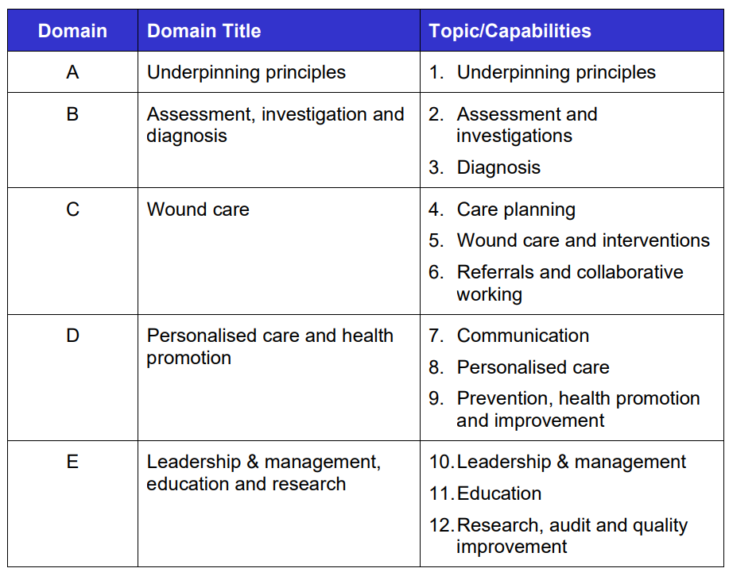

Table 2 shows the training requirements for health and care professionals to manage lower limb wounds and how they may be accessed. The e-Learning modules can be accessed through e-Learning for Health Care (ELfH) to register or if already registered through the e-Learning for health portal.
www.e-lfh.org.uk/programmes/wound-care-education-for-the-health-and-care-workforce/
Table 2

TIER 1
This is the minimum level of skill and knowledge required for practitioners with wound care responsibilities as part of their job role. All relevant members of the healthcare workforce who may come across a person with a wound should be trained to complete the activities under this element (e.g. community nurses, practice nurses, community pharmacists, allied health professional etc.).

Essential training | Desirable training | To be refreshed
ELfH Tier 1 essentials training  Modules as per below module list | ELfH Tier 1 essentials training Optional modules as per below list  ELfH Tier 2 training (as per below module list) | Every 2 years online
Red Flags and Pre–doppler (immediate and necessary care) training (PATH) |  | Every 2 years online on PATH Website or Bitesize Lunchtime Education Session (contact Essity rep to arrange for your team)
 | Wound Bed Preparation (PATH) | Every 2 years online on PATH Website or Bitesize Lunchtime Education Session (contact Essity rep to arrange for your team)
TIER 2
This is the minimum level of skill and knowledge that is required for practitioners assessing, diagnosing, developing treatment plans and reviewing healing for people with wounds as part of their job role.
Essential training | Desirable training | To be refreshed
ELfH Tier 1 and 2 training  Modules as per below module list | ELfH Tier 1 and 2 training  Optional Modules as per below list | Every 2 years online
Red Flags and Pre–doppler (immediate and necessary care) training (PATH) |  | Every 2 years online on PATH Website or Bitesize Lunchtime Education Session (contact Essity rep to arrange for your team)
2-day Leg Ulcer Management Course  Including:  1-day Doppler theory/practice  1-day compression therapy theory/practice |  | Every 2 years face to face
Doppler competency assessment |  | As necessary
Compression bandaging competency assessment |  | As necessary
 | Wound Bed Preparation (PATH) | Every 2 years online on PATH Website or Bitesize Lunchtime Education Session (contact Essity rep to arrange for your team)
 | Chronic Oedema Assessment (PATH) | Every 2 years online on PATH Website or Bitesize Lunchtime Education Session (contact Essity rep to arrange for your team)
TIER 3
Post-graduate course in wound care (or similar) level 6 or 7
ELfH Tier 1 Essential modules:
- Essentials of Skin Care – Skin anatomy, function and assessment.
- Essentials of Wound Assessment – Different types of wounds and undertaking a wound assessment.
- Essentials of Leg Ulceration – Causes of leg ulceration, types of leg ulceration and their management.
- Essentials of Digital Wound Imaging – The principles of taking a good quality digital image, including consent and data storage considerations.
- Essentials of the Foot at Risk – Anatomy of the foot, undertaking a simple foot assessment and making appropriate referrals. Please note – local referral guidelines will apply to this module.
- Essentials of Wound Infection – An infection occurs when microorganisms (germs) enter the body and multiply. Healthcare associated infections (HAIs) are infections that may affect people when they are receiving healthcare in places such as hospitals, care homes, health centres and in the person's home. This session will concentrate on wound infections.
- Nutrition and lifestyle considerations – The impact of nutrition and lifestyle behaviours on wound healing

OPTIONAL
- Essentials of surgical wounds – Recognise what a surgical wound is and differences in classification, identify the benefits and potential complications of various closure methods and the role of wound drains. Please note – local referral guidelines will apply to this module
- Pressure ulcer risk assessment - PURPOSE-T – Explains how to use the Pressure Ulcer Risk Primary or Secondary Evaluation Tool, PURPOSE-T (© Clinical Trials Research Unit, University of Leeds and Leeds Teaching Hospitals NHS Trust, 2017).
- Essentials of Pressure Ulcer Prevention - Using the aSSKINg framework to assess and manage identified risk of pressure area breakdown.

Tier 2 – Essential modules and 2-day Leg Ulcer Management Course

- The Foot at Risk – Assessment of the foot for peripheral vascular disease, including palpation and isonation of pulses, measuring toe pressure and ankle brachial pressure index, assessing for claudication, critical limb ischaemia and the WIfI classification system.
- An introduction to wound debridement – Developing understanding of what wound debridement is and when it should be offered as a therapeutic intervention.
- Choosing the right compression therapy – Reasons for compression, different compression therapy systems, measuring for and choosing maintenance hosiery.
- Dressing wounds – An introduction to the concept of using evidence to inform decisions about dressing wounds.
- Vascular disease – anatomy, physiology and assessment
- Diagnosing and managing wound infections – This session aims to provide learners with a thorough understanding of diagnosing and managing wound infection.

OPTIONAL
- Diagnosing and managing surgical wound complications - This session aims to provide learners with a thorough understanding of diagnosing and managing surgical wound complications
- Assessment and management of surgical wounds - This session aims to provide learners with a thorough understanding of the importance of assessing and managing surgical wounds.

2-day Leg Ulcer Management Course
Including:
1-day Doppler theory/practice
1-day Compression therapy theory/practice

To book, email Learning@ghc.nhs.uk or phone 0300 421 8104

Please note that tier 2 e-learning (shown in table 2) MUST be completed prior to attending the 2-day Leg Ulcer Management Course. Evidence of completed learning will be requested.

Tier 3

Health and care professionals who require Tier 3 capabilities should acquire this knowledge through post-graduate education provided or accredited by a Higher Education Institution (e.g., a university). A list of these can be found at: https://www.nationalwoundcarestrategy.net/wp-content/uploads/2023/04/NWCSP-Higher-Education-Courses-for-Wound-Care-2023-V2-1.pdf

Additional training
Additional free training can be accessed through the Professional Accredited Training for Healthcare (PATH) professionals. These have been mapped to the Tier 1 essential training – see Table 3 below. PATH is an education platform with a diverse selection of therapy areas and learning styles, to help you provide the best possible patient care. Register for access to the free e-learning modules here: PATH. Bitesize modules can be arranged through your organisation’s training and education lead.

Table 3 – PATH modules mapped to Tier 1 Essential Training
ELfH Tier 1 Essentials | PATH Equivalent modules – Option 1 | PATH Equivalent modules – Option 2
Essentials of Skin Care | e-learning Anatomy and physiology of the skin
Essentials of Wound Assessment | Bitesize Wound assessment - clinician delivered | Bitesize Assessment/wound bed preparation - clinician delivered
Essentials of Leg Ulceration | e-learning Anatomy and physiology of lower limb ulceration
Essentials of the Foot at Risk | Webinar The impact of diabetes – the diabetic foot  Webinar Diabetes and the effect on the lower limb managing and preventing | Bitesize Assessment and referral of a patient with diabetic foot ulceration - clinician delivered
Essentials of surgical wounds | e-learning Surgical site infection  Bitesize Surgical site infection – clinician delivered | Webcast Evidence in Maternity: SSI reduction with real world data  Webcast Challenges of managing surgical wounds post discharge  Webcast SSI: positive outcomes through continuity of care  Webcast SSI: Finding a simple solution for a complex problem
Essentials of wound infection | Webcast Taking the fear out of wound infection – conquering everyday issues | Bitesize Wound infection – Clinician delivered

(See Appendix 1 for module guide)

Competency sign off
Each provider needs to identify staff members who can sign off the competencies. Chosen staff should have the relevant skills, knowledge and experience and be competent themselves in this area of practice.

Appendices
Appendix 1 - Professional Accredited Training for Healthcare (PATH) professionals

Review Date | December 2028
Signed off by | Lower Limb Project Oversight Group  December 2025

Wound-Care-Workforce-Framework-FINAL-for-publication.pdf
https://www.nationalwoundcarestrategy.net/wp-content/uploads/2024/04/NWCSP-Best-Practice-Leg-Ulcer-Bundle-v1.0-04.04.24.pdf

