
Project - Plan On A Page


Title:

Team:
Sponsor:
Project lead:
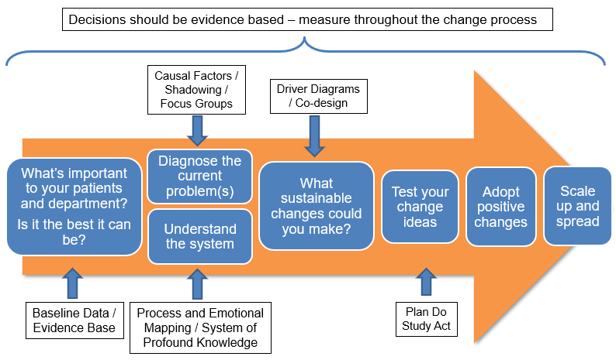
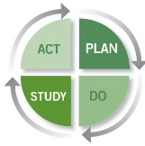
Current Situation
What is happening now and why is it a problem?

Statement of the Problem

Scale Up and Spread
What’s the plan for sharing learning?

PDSA

 | 1 | 2 | 3 | 4
Plan -When / Where / Who?
Do - What is being tested?
Study - What happened?
Act - What now? Adopt / Adapt / Abandon

The #GSQIAWay
Project Focus: ☐ Patient Safety ☐ Patient Experience ☐ Staff Experience ☐ Clinical Effectiveness ☐ Sustainability (Green Agenda) ☐ Sustainability (Financial) ☐ Health and Safety

Driver Diagram and Prioritisation of Change Ideas
1^{O} Driver | 2^{O} Driver | Change Idea | Priority No.

Measures and Data Collection
What data do you need to collect to evidence improvement?

Breakdown of the problem (Diagnostics)
Fishbone / Process Map / SEIPS / Baseline data

SMART Aim

Containment of the Problem
What needs to be done now to prevent the problem growing? Control of Special Causes

