‘Other’ Benefits of Your QI
The SMART aim of your project relates to the specific improvement opportunity you are working on, but are there any additional benefits related to what you are trying to achieve?

Will your improvement:
- Create a reduced length of stay for our patients? - Patient experience and the cost of that person’s admission…
- Create a better working environment? - Staff experience and wellbeing, sickness rates, recruitment, retention, joy at work…
- Reduce the number of contacts that a patient requires in hospital? Patient experience, carbon emissions from vehicle use…
- Reduce the waste in a procedure or process? Cost of items, staff time, waste disposal…
- Impact on health inequality or have you considered any social impacts of your changes? - Education level (patient information), access to transport (location of services), access to online facilities (video call vs in person), wealth differences (transport and parking costs)

Value and Waste in Healthcare (Ref 1)

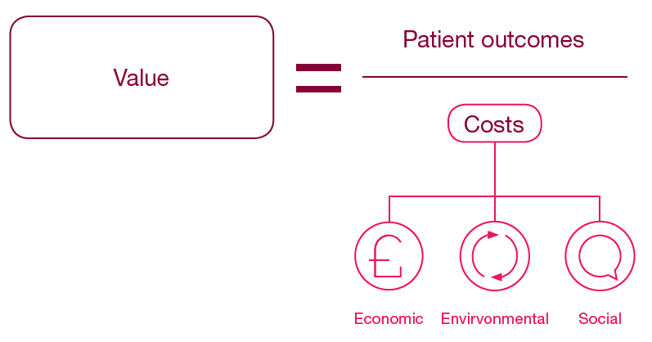
The NHS has a finite amount of resource, so ensuring good value is an important aspect of all our roles. Quality Improvement work can have a particular impact on value. Where waste in a system is high, value is low and vice versa.

In healthcare, ‘Value’ can be defined as meeting patient expectations (providing the desired outcome) for the least cost, where ‘Cost’ is associated not just with the Financial element, but also Environmental impact and the Social costs of a service or intervention.

‘Work done that does not meet need, is the opposite of Quality…’
(Don Berwick)
Categories of Waste (Ref 2)

Failure of Care Delivery | Unnecessary appointments, Unnecessary delays, Cancellations, Safety issues (e.g presence of pressure ulcers, Surgical Site Infections) - increased cost of treatment and length of stay, Time (cost) of investigating and responding to poor patient experience or outcomes
Failure of Care Co-ordination | Delays due to bottlenecks, DNAs due to late appointment letters, Duplication of tests due to inability to access systems, Poor discharge documentation for onward care, Lack of clarity of roles or role requirements, Lack of standardisation
Overtreatment | Unnecessary use of medications or diagnostic tests
Administrative Complexity | Duplication of time / effort / resource, Documentation that does not add value, Unnecessary steps, Difficulties with computer systems
Pricing Failures | Contracts for resources that are more costly than elsewhere (with the same quality)
Fraud / Abuse of the System | Hopefully not widespread, but does occur…
Waste of ‘Spirit’ | Poor staff wellbeing / motivation / engagement / incivility. Absence, productivity, recruitment.
Healthcare Inequalities (Ref 3)

Health inequalities are unfair and avoidable differences in health across the population, and between different groups within society. These include how long people are likely to live, the health conditions they may experience and the care that is available to them.
Wider determinants of health are often interlinked. For example, someone who is unemployed may be more likely to live in poorer quality housing with less access to green space and less access to fresh, healthy food. This means some groups and communities are more likely to experience poorer health than the general population. These groups are also more likely to experience challenges in accessing care.
The reasons for this are complex and may include:
- the availability of services in their local area

Is there flexibility in appointment times to allow for school drop off, or outside normal working hours?
Is Patient information/instruction overly complicated?
Are translators available for appointments?
Are services available in more than one location, and is there choice? Or patient transport available?
Does the service follow up on non-attendance to understand why?

- service opening times
- access to transport
- access to childcare
- language (spoken and written)
- literacy
- poor experiences in the past
- misinformation
- fear

Environmental Impact (Ref 4)

The Carbon Footprint can be defined as the sum of greenhouse gas (GHG) emissions attributable to any given process.
There are different types of gases that contribute to global warming, To allow standardisation of calculations, these are expressed as ‘Carbon Dioxide Equivalents’ (CO₂e) and converted into kilograms of CO₂e.
Carbon footprint (kg CO₂e) = activity or resource use* x GHG emissions factors
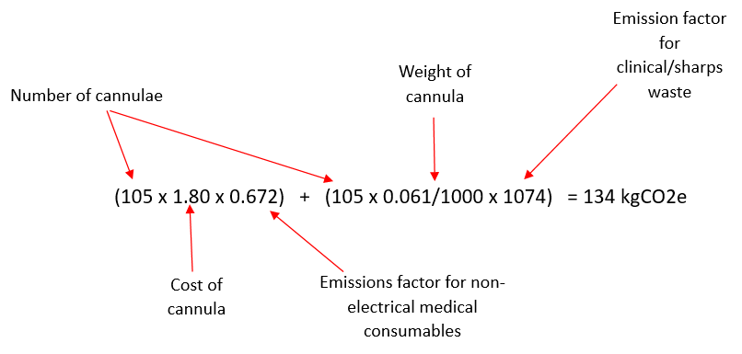
*Activity or resource = energy, waste, water, fuel, spend etc. as kWh, litres, tonnes, kilometres, £ etc.
In this example the emissions of creation of the physical resource (cannula) and the emissions associated with disposal have been calculated:

e.g. Reduction in Cannula Use

In one week a hospital reduced the number of cannulas used by 105.

- The cost of one cannula = £1.80
- The weight of one cannula = 0.061kg
- The emission factor for non-electrical medical consumable = 0.672 kgCO₂e/£
- The emission factor for Clinical/sharps waste incineration: 1074 kgCO₂e/tonne

Where to find GHG emission factors and unit costs:

Unit Costs of Health and Social Care: (2022 – 2027) | (https://www.pssru.ac.uk/unitcostsreport/)

Travel, Energy and Water use: Government emission conversion factors for greenhouse gas reporting 2024 https://www.gov.uk/government/publications/greenhouse-gas-reporting-conversion-factors-2024

Medical Supplies etc: eclass mapping, GNHS Knowledge Hub (requires sign up to the FutureNHS Platform)
eClass to SIC mapping - Greener NHS Knowledge Hub - FutureNHS Collaboration Platform

What wasteful clinical processes relate to your QI? (Ref 4)
Relevance to your service?
Patient record not available /consulted, leading to duplications/omissions
Insufficient time invested to allow patients to participate in decision making
Clinical tasks not designed around patient need
Inefficient use of staff time
Inefficient use of patient/carer time
Information not available for decision-making
Unnecessary delays to referral
Unnecessary delays to treatment
Unnecessary delays to discharge
Patient and carer travel
Duplications in information or tests
Anything else?

Understanding What ‘Other’ Impacts There Are… (Ref 4)

Resource |  | Does your project impact? | Impact  ↑ or ↓ | Details – By how much? Costs? Carbon emissions?
Medical supplies | Medications
Medical supplies | Anaesthetic gases/ nitrous oxide
Medical supplies | Medical & surgical equipment
Medical supplies | Dressings
Medical supplies | Diagnostic equipment & services
Medical supplies | Other, specify…
Non-medical Supplies | Office equipment
Non-medical Supplies | Furniture fittings
Non-medical Supplies | Provisions (food)
Non-medical Supplies | Other, specify…
Other  Resources | Staff time
Other  Resources | Waste disposal
Other  Resources | Energy use
Other  Resources | Water use
Travel | Staff travel
Travel | Patient and carer travel
Units of Healthcare activity | Inpatient bed-days
Units of Healthcare activity | Outpatient appointments
Units of Healthcare activity | GP appointments
Units of Healthcare activity | Surgical or other procedure
Units of Healthcare activity | Ventilator days

