Annual Complaints Report
2024/2025

Author/Presenter:
Jo Mason-Higgins,
Acting Associate Director of Safety (Investigation and Family Support)

Contents

Section | Page
Executive summary | 2
- Accountability for complaints management | 3
- Complaints reporting | 3
- Total complaints received in 2024-2025 | 4
- Outcomes | 5
- Complaint themes | 8
- Performance in responding to complaints | 10
- Complaint Improvement Programme | 11
- Complaint Satisfaction with Complaint Response | 12
- Parliamentary and Health Service Ombudsman | 13
- Learning from Complaints | 13
11. Looking Forward | 16

Executive summary

In accordance with the NHS Complaints Regulations (2009) this report sets out a detailed analysis of the number and nature of complaints received by Gloucestershire Hospitals NHS Foundation Trust during the 2024/2025 financial year.

In summary:

- 1075 complaints were received by the Trust during 2024/2025 giving an average of 89.5 complaints per month. This number compares to 1087 during 2023/2024; an average increase of 1 complaint per month.

- 94% of the time, acknowledgements were sent within the national target of 3 days. 100% was not achieved due to administrative pressures within the complaints team. A generic automatic email response is in place.

- 13% of responses were sent within agreed timescales. This represents a decrease of 5% on the previous year (18%). The work to improve response rates, commenced in 2023/2024 continued into 2024/2025, with the development of a Complaint Improvement Programme in August 2024. The objective of the programme has been to improve how the Trust respond to complaints, the quality of the response provided, the timeframes within which responses are provided and how the Trust learns from complaints. Initial focus has been on ensuring that responses have been provided to all complaints due within the 2024/2025, financial year. The backlog of some 500+ complaints has been cleared. At the time of writing this report, there are less than 10 complaints, more than six months overdue and 45% of responses are being sent within required timescales.

- During 2024/2025 9 complaints were referred to the PHSO. A decision has been received during the year on 5 cases (decisions may relate to cases referred in the previous year). 1 was upheld, 3 were not upheld and 1 was partially upheld. The PHSO do not inform us of complaint referrals that do not meet their threshold and are, therefore, not formally investigated through the second stage resolution process.

- Improving how the Trust learn from complaints remains a focus of the Complaint Improvement Group. Having cleared a significant backlog of overdue complaints and increased Divisional Leadership teams oversight and responsibility for complaints, there is improved visibility of issues, concerns, themes and trends, enabling Divisional and Service line, leadership teams to initiate service improvements, in real time.

- There is good evidence of learning from complaints, specifically in the Women’s & Children’s and Surgical Division. Communication remains a common theme running through many of the concerns and complaints raised. In recognition of the challenges faced with communication with service users, the Digital team have introduced the Patient Engagement Portal. Martha’s Rule is also helping to empower patients, families, carers and staff to ensure that their concerns are listened to and acted upon. The introduction of a monthly Experience of Care Meeting in April 2025 will further improve learning from complaints, by the provision of a forum to consider real time issues, concerns, themes and trends across both the PALs and Complaints teams. Though the work of this group, Divisional and Service line leaders will be supported with designing and developing actions to improve service user experience.

- Action Plans arising from Complex Complaints are monitored and assured through to closure by the Safety, Experience and Review Group. The Complaint Improvement Group have identified the need for an improved approach to monitoring and closing actions arising from standard complaints. Through the work of the Complaint Improvement Group, the feedback module of Datix Cloud will be utilised to record all outstanding actions; providing a mechanism for Divisional leadership teams to have improved visibility and support staff, with closure.

- The Trust’s Complaint Handling Policy has been updated and published.

- This Annual Complaints report will be published on the Trust website as required to meet our quality reporting requirements for the Quality Account.

- Accountability for complaints management

The Board of Directors has corporate responsibility for the quality of care and the management and monitoring of complaints received by our Trust. The Chief Executive has delegated the responsibility for the management of complaints to the Medical Director and Director for Safety.

The Complaints Department sits within the Patient Investigation and Learning Team and is managed by the Head Complaints, reporting to the Associate Director of Safety (Investigation and Family Support). The Head of Complaints is responsible for ensuring that:

- All complaints are fully investigated appropriate to the complaint
- All complaints receive a comprehensive written response from the Chief Executive or their nominated deputy in their absence
- Complaints are responded to within local standard response times of 35 or 65 days
- Where the timescale cannot be met, an explanation is provided and an extension agreed
- When a complaint is referred to the PHSO, all enquiries are responded to promptly and openly

The complaints team consists of 0.3 WTE Head of Complaints, a 1WTE Band 7 Patient Safety Investigation Manager (Complaints), 2.8 WTE Band 6 Complaints Managers; who are responsible for the coordination of staff investigating and the final response to the complainant, supported by 1WTE band 4 and 2WTE band 3 administrators.

- Complaints reporting

In 2024/2025, the Associate Director of Safety (Investigation and Family Support) reported the following information to the Quality and Performance Committee monthly:

- Number of written complaints received per 1000 episodes of care and broken down by division
- Number of PHSO cases received during the quarter and the resolution during that quarter of any existing cases
The Annual Complaints Report will be received by the Quality and Performance Committee and this report will be published in the public domain via the Trust website.
The Safety and Experience Review Group will continue to monitor action plans arising from complex complaints and those reported to the PHSO on a monthly basis. Action plans are developed in collaboration with the Division\Specialty.

- Total Complaints Received in 2024/25

1075 complaints were received by the Trust during 2024/2025 giving an average of 89.5 complaints per month. This number compares to 1087 during 2023/2024; an average increase of 1 complaint per month.

Figure 1 below provides a breakdown of the number of complaints received per quarter over the last three financial years.

Figure 1

Complaints per 10,000 Contacts
 | Apr-24 | May-24 | Jun-24 | Jul-24 | Aug-24 | Sep-24 | Oct-24 | Nov-24 | Dec-24 | Jan-25 | Feb-25 | Mar-25
Diagnostic & Specialist | 4.04 | 4.50 | 1.92 | 2.55 | 1.43 | 2.32 | 1.66 | 3.09 | 0.97 | 1.67 | 0.47 | 2.71
Medical | 11.61 | 11.75 | 9.53 | 13.82 | 10.88 | 8.36 | 12.77 | 13.58 | 6.83 | 9.57 | 11.20 | 10.49
Surgical | 11.79 | 11.62 | 9.16 | 13.08 | 15.73 | 10.21 | 6.69 | 10.13 | 9.54 | 9.62 | 10.25 | 11.73
Women & Children | 15.58 | 24.78 | 8.69 | 19.47 | 18.08 | 13.75 | 13.93 | 16.42 | 18.47 | 6.36 | 14.33 | 15.19
Grand Total | 10.52 | 12.13 | 7.93 | 12.23 | 11.64 | 8.50 | 8.91 | 10.76 | 7.93 | 7.69 | 8.99 | 9.86

Table 1
3.1 Complaints by Division

Table 2 below shows the number of complaints received by each of the Trust’s divisions compared with the previous year. Directional arrows indicate change compared to the previous fiscal year.

Division | Complaints 2023/2024 | Complaints 2024/2025
Corporate | 38 | 33↓
Diagnostics & Specialties | 97 | 68↓
Estates & Facilities (GMS) | 16 | 9↓
Medicine | 449 | 434↓
Surgery | 334 | 368↑
Women & Children | 153 | 163↑
TOTAL | 1087 | 1075

Table 2
The data demonstrates, complaint numbers increased in the Women’s & Children’s and Surgical Divisions. Complaint numbers decreased across all other Divisions, with the most significant decrease in the Diagnostics & Specialties Division.
In order to support the processes in place for medical staff and junior doctors our complaints are broken down by staff group. The three groups receiving the majority of complaints during 2024/2025 were Medical (702, Nursing (349) and Clinical Support (115). The numbers of each complaint recorded against these staff groups have however decreased when compared to 2023/2024.
2023/2024 saw an increase in the number complaints relating to midwifery care (72 to 107). This has decreased significantly in 2024/2025, with 57 recorded against this staff group.
Complaints involving senior medical staff are recorded and doctors must submit this information for review and discussion at their appraisal. Complaints involving junior doctors are highlighted to the Deanery for further consideration with the doctor’s educational supervisor.

4. Outcomes

Table 3 below demonstrates the breakdown, by quarter, of complaint outcomes during 2024/2025.

Outcome 24/25 | Q1 | Q2 | Q3 | Q4 | YTD Total
Upheld | 76 | 82 | 106 | 79 | 343
Partially | 49 | 80 | 78 | 85 | 292
Not Upheld | 80 | 98 | 91 | 71 | 340
Total | 205 | 260 | 275 | 235 | 975

Table 3
The outcome is determined by the division indicating if the complaint is considered to be:
Upheld: If a complaint is received which relates to one specific issue, and substantive evidence is found to support the complaint, then the complaint should be recorded as upheld.
Not upheld: Where there is no evidence to support any aspects of a complaint made, the complaint should be recorded as not upheld.
Partially upheld: Where a complaint is made about several issues, if one or more of these, (but not all), are upheld then the complaint should be recorded as partially upheld.
31% of closed complaints were upheld in 2024/205. This represents a 6.2% decrease in the percentage number of upheld complaints in 2023/2024. 27% of complaints were considered to have been partially upheld in 2024/2025 which is comparable to the % of partially upheld complaints in 2023/2024. 31% of complaints were considered not upheld in 2024/2025. This represents a decrease of 5% when compared to the percentage of complaints not upheld in 2023/2024.

4.1 Upheld Complaints by Specialty

Figures 2,3,4 and 5 below demonstrate the breakdown of upheld complaints by specialty. These demonstrate that complaints are most commonly upheld within the Maternity, Emergency Medicine, Radiology and Trauma & Orthopaedic specialties.

Figure 2

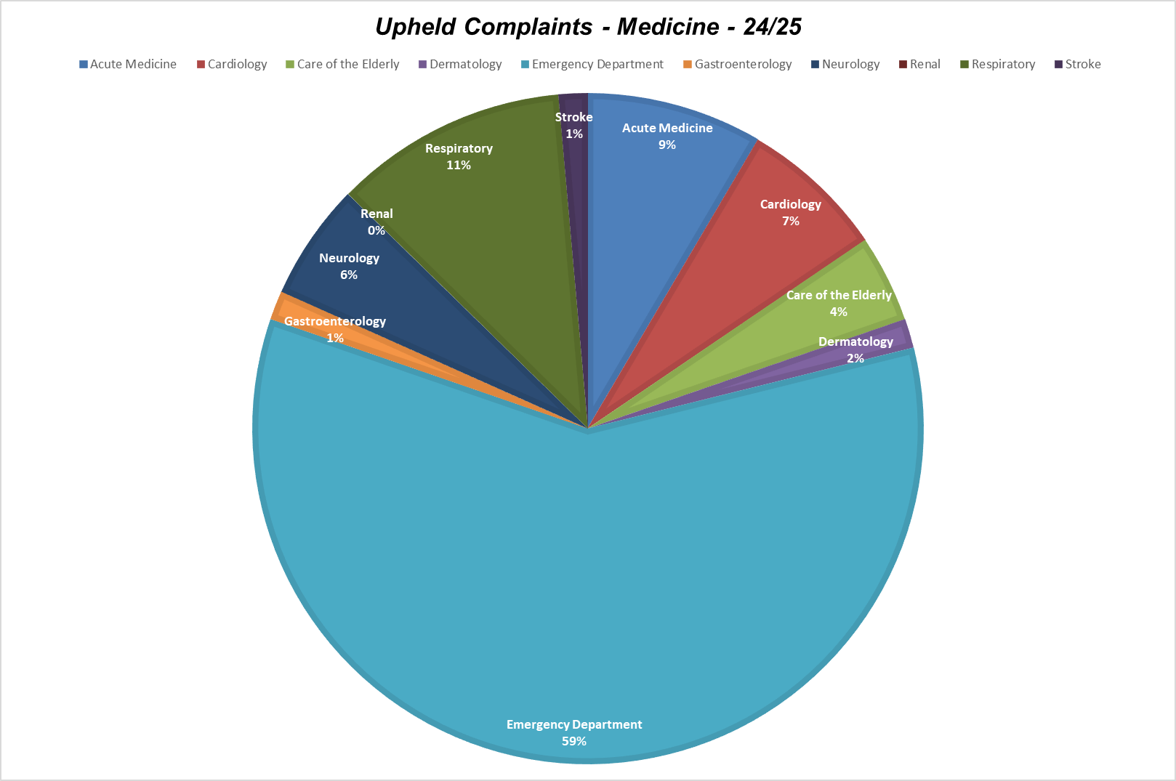

Figure 3

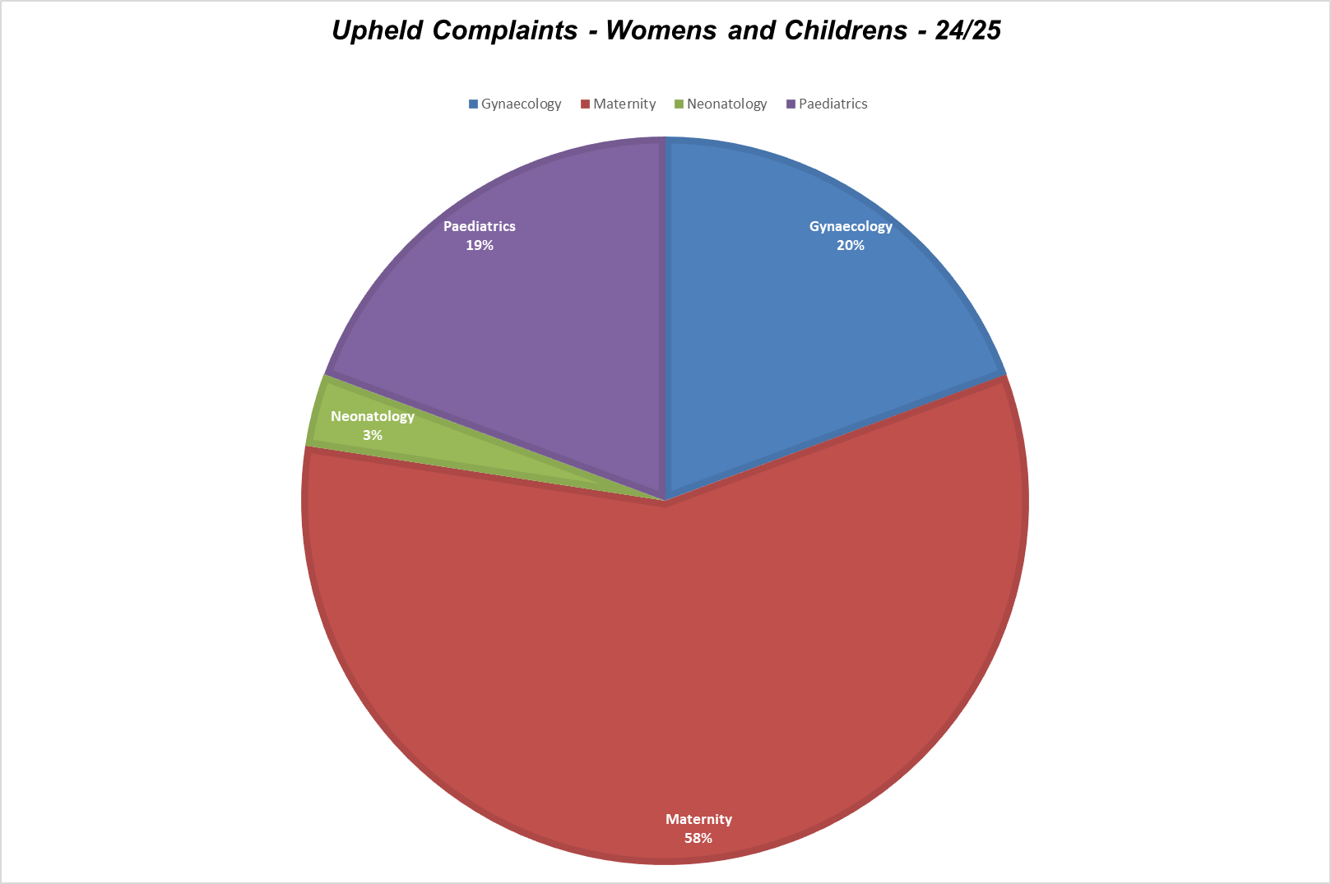
Figure 4

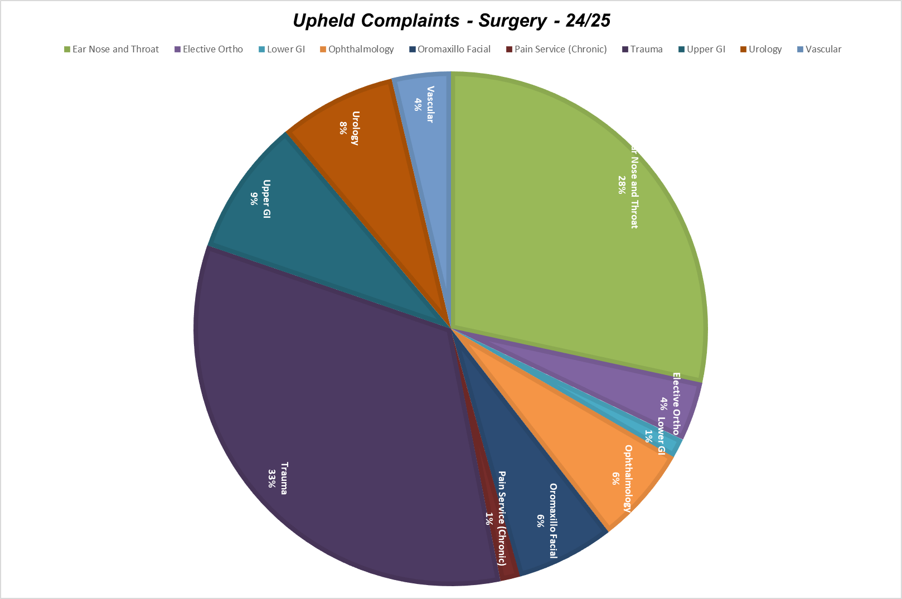

Figure 5
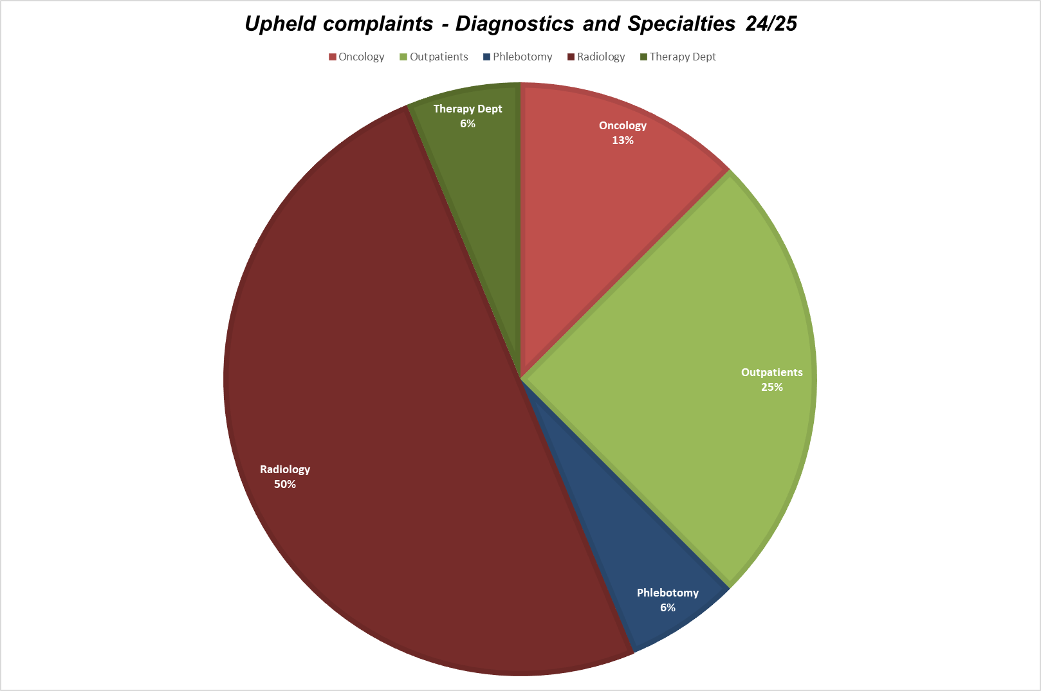

- Complaint Themes
Table 4 below identifies the themes and trends from our complaints; the top 5 themes are highlighted in blue.

Complaint Theme | Total complaints 2024/2025 | Total complaints 2023/2024 | Total complaints 2022/2023
Clinical Treatment (Medical) | 468 | 624 | 631
Access to Treatment or drugs | 15 | 25 | 33
Admissions, Discharge and Transfers | 89 | 126 | 168
Appointments | 166 | 172 | 176
Communications | 444 | 444 | 451
Consent to treatment | 7 | 8 | 5
End of Life care | 12 | 9 | 14
Facilities | 49 | 67 | 62
Integrated care | 0 | 3 | 1
Patient Care (including nutrition and hydration) | 203 | 309 | 379
Prescribing errors | 13 | 32 | 43
Privacy, Dignity and Wellbeing | 41 | 55 | 77
Restraint | 1 | 8 | 2
Staffing Numbers | 7 | 14 | 30
Trust Administration | 47 | 49 | 79
Values and Behaviour | 225 | 298 | 285
Waiting Times | 50 | 52 | 53
Other | 8 | 23 | 15

Table 4

Please note complaints can involve multiple themes, hence the disparity between issues and numbers of complaints.

5.1 Top Five Themes

- Clinical treatment (medical)
- Communications
- Values & Behaviour
- Patient Care (including nutrition and hydration)
- Appointments

The top five themes (set out above) are largely consistent with the top five themes in 2023/2024. Clinical treatment and communications remain the top two categories of complaint received. We received an increased number of complaints relating to values and behaviour in 2024/2025; this becoming the third rather than fourth top category of complaint.

5.2 Analysis - Categories

There has been a decrease in all categories of complaint, (with the exception of End of Life Care) in 2024/2025 when compared with 2023/2024. One complaint may involve multiple categories and this notable decrease is not comparable to the marginal decrease in complaint numbers. The data therefore suggests there to have been a decrease in the number of complaints with multiple issues. However, caution is exercised with analysis as the accuracy of the data is dependant upon complaints administrators ensuring that all issues are recorded within the complaint case management system.

The “Clinical Treatment” category relates to service user concern with diagnosis, access to and timeliness of treatment and complications following surgery. 2024/2025 has seen a notable decrease in the number of complaints within this category. 2023/2024 saw a marginal decrease against a minor increase in 2022/2023

Complaints in relation to “Restraint” have decreased considerably in 2024/2025. It is of note that there was a notable increase in this category in 2023/2024. The Trust undertook a review of its security services and rolled out training in restraint. The improvement noted in this category of complaint has likely been positively impacted by this review and additional training.

The “Patient Care” category covers much of the general nursing care, including providing help to eat meals if needed, answering the call bell, responding to the needs of the patient, providing help with washing and personal hygiene. The moderate decreased in concerns within this category noted in 2023/2024 has continued into 2024/2025.

The moderate decrease in complaints relating to “Appointment times” seen in 2023/2024 has continued into 2024/2025. This category of complaint had increased considerably in 2022/2023. Whist complaints relating to appointments, remain in the top five, the continuing decrease can likely be attributed to the supported provided by the Patient Advice and Liaison team in chasing and arranging appointments, alongside the introduction of the electronic patient portal. This category of complaint commonly relates to administration of appointment letters, including not being sent/ received or not sent in a timely way.

Concerns reported in the “Communications” category generally relate to communication between staff and patients or staff and relatives/ carers/ visitors. This can include a lack of communication, incorrect method of communication, and timeliness of communications. The number of complaints recorded against this category in 2024/2025 is consistent with the number reported in 2023/2024.

Concerns relating to End of Life Care increased in 2024/2025. This category of complaint had seen a decrease in 2023/2024. The complaints relating to this category will be shared with the Trust’s End of Life Improvement Group.

6. Performance in Responding to Complaints

In addition to monitoring the number of complaints received by our Trust we also monitor our performance against nationally and locally set timescales (3 working days for an acknowledgement – nationally set and 35 or 65 working days for a response – locally set).

Guidance from the Parliamentary and Health Service Ombudsman recommends that a Trust must investigate a complaint ‘in a manner appropriate to resolve it speedily and efficiently and keep the complainant informed’. Therefore when a response is not going to be completed in the set timeframe then an explanation must be given, by the Trust, to the complainant and a new timeframe agreed.

Table 5 below shows the percentage of responses sent within 35 or 65 working days by Division and demonstrated by quarter through 2024/2025

 | Q1 | Q2 | Q3 | Q4 | YTD Rate
Corporate | 33 | 25 | 33 | 25 | 29
D&S | 15 | 26 | 22 | 12 | 19
E&F | 0 | 50 | 25 | 0 | 20
Medicine | 9 | 12 | 14 | 7 | 11
Surgery | 9 | 20 | 15 | 5 | 13
W&C | 10 | 11 | 7 | 16 | 12
Total | 11 | 17 | 15 | 9 | 13

Table 5

The annual response rate of 13% in 2024/2025 has decreased by 5% when compared to the 18% in 2024/2025.

Reasons for delay are tracked by the Complaint Department. Those reasons remain consistent across previous years; 50% relating to delayed responses from clinical/nursing leads, 25% relating to delays within the review/approval (by Divisional/Specialty leaders) stage and 25% being due to delays in the Complaint Department, with drafting responses.

Measurement of performance in respect of response rates is strict; if a response is not provided at the 35 or 65 day point, then it is considered to have breached. The extent of the breach can range between minimal (one to two days) and significant, many months. Response dates are not, typically amended to reflect any mutual agreement (between the Trust and service user) to extend response time frames.

7. Complaint Improvement Programme

- In recognition of the increasing number of complaints not meeting response timeframes a number of improvements were introduced in Q4 of 2023/2024. These are described in the 2023-2024 annual report. In summary, these included improving Divisional Leadership teams involvement, oversight and accountability for complaints. Save for specific cohorts of complaint requiring Medical Director, Chief Nurse or Chief Executive oversight, review/approval and signature of complaints was delegated to Divisional Leadership teams. Monthly reports to the Divisional Directors of Quality and Nursing and Chief’s of Service highlighting delays were provided. An enhanced escalation process for clearing with the Divisional Chief Nurses and thereafter the Medical Director, Director of Quality/Chief Nurse and CEO were introduced. The Head of Complaints provided enhanced support to the Complaint Department, meeting weekly with them to mutually agree priorities and provide support, advice and guidance in response to reporting feelings of being overwhelmed.

- In Q1 of 2024/2025, an in-depth review of the Trust’s approach to and process for responding to complaints commenced. PHSO Complaint Handling Standards and CQC standards were reviewed and compared to the Trust’s existing Complaint Handling Policy/procedure. Processes, procedures and approaches of Trusts of a comparable size were also and reviewed. This review identified a need to revise the Trust’s Complaint Handling Policy and Process, improving how we respond to complaints, the quality of response, the timeframe within which we respond and how we use feedback provided to improve service provision.

- A new Complaint Handling Framework was designed in September 2024. This new framework, introduced three categories of complaint: Early Resolution (20 days), Standard (35 days), and Complex (65 days), each with specific response processes

- Consultation, with the Complaint Department and Divisional Leadership teams, took place throughout October and November 2024. The outcome of consultation was collective agreement that it was not reasonably practicable to implement the new Complaint Handling Framework, without clearing the backlog of outstanding complaints in Medicine, Surgery and Maternity. Consultation also identified the need for a Quality Improvement approach to implementing and successfully embedding the new framework. The Complaint Department were re-structured to enable a Complaint Manager and Administrator to be aligned to each Division. This change took effect in November 2024.

- A Complaint Improvement Group was initiated in December 2024. This group included representatives from the Quality Improvement Academy, the Complaints Department and senior leadership teams from the Diagnostics and Specialties Division, Gynaecology and Paediatric Specialties. This group worked collaboratively to design process maps that aligned to the new Framework, endeavouring to ensure that there was effective use of the resource available across the Complaint Department and Divisions and determine roles and responsibilities. The objective of the approach was to ensure that the proposed changes within the new Framework would improve the way in which the Trust responded to complaints, the quality of the response provided, the timeframes within which the Trust responded and how the Trust learned from complaints.

- Alongside the work of the Improvement Group, weekly/fortnightly touchpoint meetings between Divisional Leadership teams, the Head of Complaints and their Divisional Complaint Manager/Administrators were introduced. The focus in these meetings (for Medicine, Surgery and Maternity) was on clearing the backlog of complaints.

- Recognising a training gap, the Trust plans mandatory (for key staff involved in complaints) complaint handling training based on PHSO online courses. A condensed session is being provided in September 2025 at a Complaint Away Day.

- Co-pilot licenses and an AI, Complaint Handling Agent have been introduced to assist with categorisation, issue identification, and pre-populating response templates. This agent is currently under trial with plans to expand access for staff involved with responding to complaints, subject to roll out of Microsoft 365 and co-pilot licenses, for all.

- At the time of writing this report, there are less than 10 complaints, more than six months overdue and 45% of responses are being sent within required timescales.

8. Complainant Satisfaction with Complaint Response

Our Trust currently uses three measures to assess the satisfaction of the complainant with their final response, these are:

- Comebacks: where a complainant submits further questions or correspondence requiring further investigation and response. There were 111 comebacks received during the year (10% of all complaints received). This represents an increase of 1.6% on the previous year.
- Meetings: where a complainant requests to meet with staff to ask additional questions, or discuss the content of their response. There were 20 meetings held with complainants. This represents a increase on the previous year. Whilst some of these meetings relate to complaints where a written response has not resolved the service user’s concerns raised with us, this increase also demonstrates the commitment to resolve complaints through direct contact with senior leaders.
- Parliamentary and Health Service Ombudsman (PHSO): where a complainant refers the matter to the PHSO for independent review. There were 9 cases referred by complainants to the PHSO during the year. This is an increase on the previous years (7 in 2023/2024 and 2 in 2022/2023).

9. Parliamentary and Health Service Ombudsman (PHSO)

9 cases were referred to the PHSO during 2024/2025. A decision has been received during the year on 5 cases (decisions may relate to cases referred in the previous year). 1 was upheld, 3 were not upheld and 1 was partially upheld. The PHSO do not inform us of complaint referrals that do not meet their threshold and are, therefore, not formally investigated through the second stage resolution process.
All cases referred to the PHSO are monitored by the Safety and Experience Review Group (SERG). This group has responsibility for signing off actions plans for partially upheld and upheld cases before they are returned to the PHSO. All action plans are developed by the relevant division.

10. Learning from Complaints

The Trust recognise that all complaints are a valuable source of learning. All feedback is welcomed by the Trust; positive feedback highlights what we are getting right and need to do more of, whilst concerns and complaints create valuable opportunities to hear about people’s experience of the care and treatment we provide and to make improvements.

The outcome of a complaint will often involve an apology and reflective learning for our staff; particularly where concerns about behaviour and communication are raised. On other occasions, a complaint may highlight a failure in a process or system, so the outcome may involve making changes to how we do things for future patients.

Improving how the Trust learn from complaints remains a focus of the Complaint Improvement Group. Having cleared a significant backlog of overdue complaints and increased Divisional Leadership teams oversight and responsibility for complaints, there is improved visibility of issues, concerns, themes and trends, enabling Divisional and Service line, leadership teams to initiate service improvements, in real time.

New Complaints feature on the agenda of the weekly/fortnightly touchpoint meetings with Divisional Complaint Managers and Divisional Leadership teams; this has significantly improved visibility of developing themes and trends, providing an enhanced opportunity to respond and improve, in real time.

Communication remains a common theme running through many of the concerns and complaints raised. In recognition of the challenges faced with communication with service users, the Digital team have introduced the Patient Engagement Portal. Martha’s Rule is also helping to empower patients, families, carers and staff to ensure that their concerns are listened to and acted upon. The introduction of a monthly Experience of Care Meeting in April 2025 will further improve learning from complaints, by the provision of a forum to consider real time issues, concerns, themes and trends across both the PALs and Complaints teams. Though the work of this group, Divisional and Service line leaders will be supported with designing and developing SMART actions to improve service user experience.

Action Plans arising from Complex Complaints are monitored and assured through to closure by the Safety, Experience and Review Group. The Complaint Improvement Group have identified the need for an improved approach to monitoring and closing actions arising from standard complaints. Through the work of the Complaint Improvement Group, the feedback module of Datix Cloud will be utilised to record all outstanding actions; providing a mechanism for Divisional leadership teams to have improved visibility and support staff, with closure.

Guidance for Lead Investigators includes advice on the design of SMART actions.

10.1 Surgical Division

Figure 6 represents a thematic analysis of Complaints received by the Surgical Division. This demonstrates that the Trauma (Orthopaedic) service receive the highest numbers of complaints, with the most common issues relating to appointments, communication, delay, attitude and care.

Figure 6
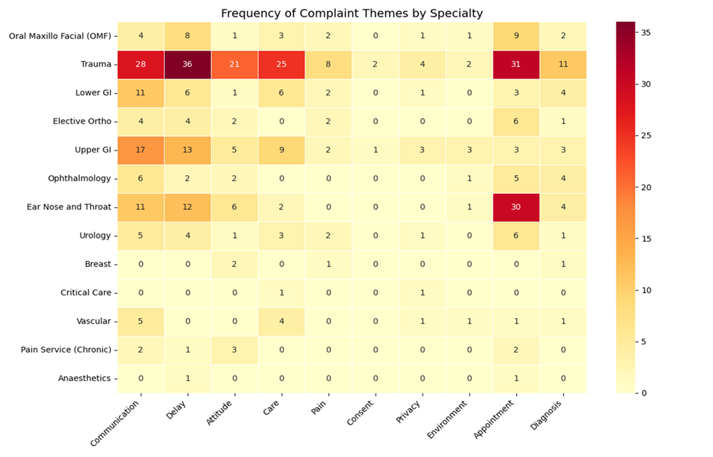
The T&O service have implemented a comprehensive set of improvement initiatives for the 2024–2025 period, focusing on three key domains: communication, attitude, and care. These initiatives are part of a locally developed and delivered improvement action plan:
Communication
- Clear escalation protocols have been reinforced, ensuring staff escalate concerns promptly to the Matron in the absence of the Band 7 nurse.
- Emphasis has been placed on timely and transparent communication with patients and their families, particularly around discharge and theatre planning.
- Safety huddles are now fully embedded across all ward areas.
- The Nurse in Charge is responsible for ensuring clarity of care plans during board and ward rounds, and for confirming patient and next-of-kin (NOK) understanding.
- A monthly Matron checklist has been introduced, conducted at random times, which includes direct patient feedback on their care experience.
- Patients in the TAU (Treatment Assessment Unit) are regularly updated regarding waiting times.
- Communication improvements are a core component of the ward’s overarching action plan.
Attitude
- Ongoing work is being undertaken to improve ward culture and staff attitudes.
- Any instances of unprofessional behaviour are promptly investigated and addressed.
- Staff have been reminded—via internal communication channels—of the Trust’s and Matron’s expectations regarding professionalism, kindness, and teamwork.
- A Trauma and Orthopaedics (T&O) Nursing Conference is scheduled for March 2026, with a focus on embedding positive team culture and expectations.
- The ward management team is committed to leading by example in upholding professional standards
Care
- Appraisal completion rates across all ward areas exceed 94%.
- Quality data is shared with staff on a monthly basis to promote transparency and continuous improvement.
- A clinical training programme is in place with a focus on T&O-specific competencies.
- Updated nurse-led competencies have been introduced to support extended skills in T&O.
- Fundamental care practices have been reinforced

10.2 Maternity

Figure 7 represents a thematic analysis of Complaints received by the Maternity team. This demonstrates that the most commonly cited concerns in maternity relate to communication, clinical treatment and staff attitude during the provision of intra-partum care.
Figure 7
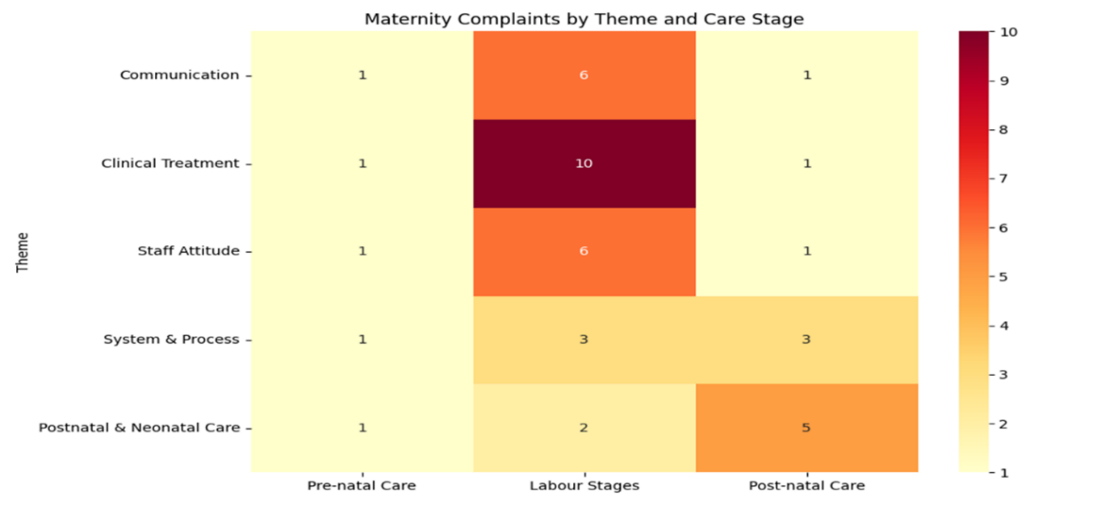

Building on a number of improvement initiatives described in the 2023/2024 annual report, the Maternity Service have initiated:

Improvement | Description
Induction of Labour Pathway Review | Structured review to reduce delays and improve communication during induction, Twice-daily huddles, Bespoke triage training
Discharge Communication Improvements | Staff reminded to clearly explain next steps post-scan or ward transfer
Autism Support | Support offered from autism lead and unit tours to improve inclusive care
Staff Reflection and Learning Logs | Encouraging reflective practice and sharing learning across teams
Radiology Reporting Timeliness | Escalation with external radiology providers and internal review to address delays in newborn X-ray reporting
SBAR Handover and Escalation Training | Relaunched SBAR and RCOG 'Advice, Inform, Do' toolkit
Postpartum Haemorrhage (PPH) Risk Assessment | Booking, 36 weeks, and labour with weekly audits
BadgerNet Documentation and Training | Masterclasses, e-learning, superusers
Infant Feeding and Tongue Tie Pathway | Additional frenulotomy training and annual updates
Communication Awareness Campaign | Awareness month and maternity advice line focus
PROMPT Emergency Training | Mandatory drills for obstetric emergencies

10.3 Communication
The Trust recognise that failings in communication are a common finding in our complaint (and incident) investigations. Effective communication can have a profound impact on how patients and caregivers perceive their care. Research and policy analysis on communication and patient safety has focused on written communication, but safe healthcare also depends heavily on the spoken word. Good spoken communication is about passing on clear and accurate information
Communication throughout a patient’s interaction with the health care system, including during diagnosis, treatment, and transitions to other settings of care including the home, helps to ensure patients and family caregivers can participate effectively in their care and make informed decisions. However, when these communication touchpoints are not optimal or are missed altogether, there is an opportunity for harm.
Communication (between staff and patients/families) features in the Trust’s Patient Safety Incident Response Plan (published March 2024).
In recognition of the challenges faced with communication with service users, the Digital team have introduced the Patient Engagement Portal. Martha’s Rule is also helping to empower patients, families, carers and staff to ensure that their concerns are listened to and acted upon. The introduction of a monthly Experience of Care Meeting in April 2025 will further improve learning from complaints, by the provision of a forum to consider real time issues, concerns, themes and trends across both the PALs and Complaints teams. Though the work of this group, Divisional and Service line leaders will be supported with designing and developing SMART actions to improve service user experience, with a specific focus on communication.

11. Looking Forward

Gloucestershire Hospitals NHS Foundation Trust continues to be proactive in its management of its complaints process.
The Complaint Improvement Programme will continue throughout 2025/2026. Through the work of this group, the Trust will continue to improve:
- How we respond to Complaints; offering direct contact with Senior Leaders to resolve concerns through implementation of the New Complaint Handling Framework
- The timeframes within which we respond to Complaints; ensuring a sustained 90% response rate
- The quality of the response provided; ensuring open, transparent, fair and thorough responses
- How we learn from Complaints; real time thematic analysis, monitoring and assurance of actions
- Knowledge, skills and competency of staff involved with complaint handling: providing opportunities to complete the PHSO Complaint Handling Training
- Utilising AI to support complaint handling processes

Author: Jo Mason-Higgins, Acting Associate Director of Safety

Date: 9th September 2025

