SUSTAINABILITY REPORT 2025-26 GLOUCESTERSHIRE HOSPITALS NHS FOUNDATION TRUST

EXECUTIVE SUMMARY

The Trust Green Plan 2021-25 (sustainability strategy) committed the Trust to a range of actions, initially between 2021-2025, but also longer term, which will help move us forward on our pathway to net zero by 2040. Our new Green Plan, to cover 2026-2030, will be published in July.
It will detail our strategy and approach for embedding sustainability across all aspects of health and care delivery. This will enable us to deliver our aim of reducing carbon emissions and helping to address climate change, recognising that the health of people and the health of the planet are deeply connected.

Both our Green Plans focus on practical steps, such as:
- Building sustainability knowledge amongst our staff
- Embedding sustainability into everyday care
- Harnessing digital technology to reduce waste and emissions
- The importance of prevention and community partnerships
- Reducing our energy consumption and increasing on site renewable generation

In November 2025 GHFT published ‘Our five-year strategy 2025-2030’. The four strategic aims - Patient Experience and Voice; People, Culture and Leadership; Quality, Safety and Delivery; and Digital First, are supported by four Golden Threads – these will run through everything we do. Health Inequalities, Continuous Improvement and Brilliant Basics will all have an impact on sustainability, but of particular note is Green Sustainability and the commitment that ‘our actions must be green, fair and affordable’. This golden thread will be used to put sustainability at the core of everything we do, assist with engagement at all levels of the organisation, and enable actions (and hopefully funding) to reduce carbon emissions and meet the agreed target of net zero carbon by 2040.

This annual sustainability report documents some of the achievements we have made in reducing our carbon emissions and taking action on the steps outlined in the Green Plan.

Our carbon emissions for energy 2025-26 are 16,142 tCO₂e. These carbon emissions have decreased by 6% compared to actual emissions in 2024-25 (17,170 tCO₂e).

Our overall carbon emissions are 18,490 tCO₂e. This is for energy, water, waste, anaesthetic gas, fleet and business travel. This is a 5.4% decrease from actual emissions 2024-25 (19,541 tCO₂e).

1 INTRODUCTION

As an NHS organization, we have an obligation to work in a way that has a positive effect on the communities we serve. The three pillars of sustainability – society, environment, and economy are interconnected and reliant on each other. The Trust acknowledges the impact we have on the local economy, society and environment and are therefore committed to continually work to actively integrate sustainable development into our core business.

The links between health and climate change are clear and we have a responsibility to act. The Climate Change Act (2008) and the NHS targets (Delivering a Net Zero NHS, 2020) oblige the Trust to reduce carbon emissions.

Acting now, by embedding sustainability into the organisational culture, making changes to how we operate, how, where and what we procure and upgrading our infrastructure, will be the only way to meet the NHS targets to reach net zero carbon emissions by 2040 on the emissions we directly control, and to reach net zero carbon by 2045 on those we influence.

This report outlines our achievements, actions and carbon emissions for 2025-26 and outlines some of the sustainability / climate change actions we will undertake during 2026-27.

2 ENERGY AND WATER

GHNHSFT has spent £6.05 million on gas, electricity, oil and water in 2025/26.

 |  |  |  |  | Reported | Actual | Reported | Actual
Resource |  | 2020/21 | 2021/22 | 2022/23 | 2023/24 | 2023/24 | 2024/25 | 2024/25 | 2025/26
Gas | Use  (kWh) | 90,503,442 | 98,521,058 | 93,954,862 | 87,477,787 | 89,826,134 | 92,314,962 | 89,966,615 | 84,511,888
Gas | tCO2e | 16,641 | 18,045 | 17,151 | 16,002 | 16,429 | 16,884 | 16,455 | 15,462
Oil | Use  (kWh) | 224,560 | 587,947 | 587,610 | 269,010 | 269,010 | 264,790 | 264,790 | 279,262
Oil | tCO2e | 57 | 150 | 150 | 68 | 68 | 67 | 67 | 70
Elec | Use  (kWh) | 3,717,545 | 5,280,452 | 3,703,198 | 3,972,303 | 3,972,303 | 3,132,154 | 3,132,154 | 3,443,400
Elec | tCO2e | 867 | 1,121 | 716 | 823 | 823 | 649 | 649 | 609
Total Energy  tonnes CO2e |  | 17,565 | 19,316 | 18,017 | 16,893 | 17,322 | 17,600 | 17,170 | 16,142

Oil is for the back-up generators (most of which is used in the regular generator system checks) and heating for the estates building at GRH. The severity of the winter, generator use and whether tanks are topped up in March or April all affect the above oil data. Carbon emission factors are calculated by central government and reflect changes in processes, the greening of electricity generation etc.

The above table shows Reported and Actual data for 2023-24 and 2024-25. Reported data is the consumption declared within the formal submission of the annual ERIC (Estates Return Information Collection). This is due to faulty meter reading equipment in Energy Centre B (GRH), which led to a catch-up bill attributing 6 months of 2023-24 gas consumption to 2024-25 when it was billed in June 24. In terms of reporting this gas is 2024-25, but in terms of consumption it is 2023-24 and therefore reported and actual figures for 2023-24 and 2024-25 are listed above.

Energy related carbon emissions have decreased by 6% compared to actual emissions in 2024-25 (17,170 tCO₂e).

Electricity costs for 2025/26 remained on a level with 2024/25 despite an overall increase in consumption. The increase in consumption was due to prolonged period of CHP downtime at CGH due to maintenance works. Changes to the way one of the larger pass through elements is calculated and a reduction in the commodity unit rate kept costs down.

Gas costs and consumption were significantly down on the previous year. The average unit rate for the year was 13% lower than in 2024/25. Generally, 2025/26 was a warmer year than 2024/25, however, after normalising for temperature and CHP run hours the gas consumption for GRH saw a reduction of 9% which can be attributed to the completion of the Tower Block façade works.

Combined Heat and Power (CHP) unit performance
GRH is in year 8 of operation and CGH is in year 12.

The combined heat and power (CHP) engines generate 85% of the electricity consumed on both main sites. Although gas now has a higher carbon factor than electricity generated from the national grid, there are contractual and financial reasons for maintaining the CHPs. Offsetting the gas input and operation and maintenance costs of running the CHPs against the electricity and heat generated, export and capacity market income, and avoided climate change levy they have delivered a positive benefit of £761,766. GMS will provide a fuller analysis of the CHP performance in the 2025-26 annual energy report, due to be published summer 2026.

Water
Water | 2020-21 | 2021-22 | 2022-23 | 2023-24 | 2024-25 | 2025-26
Consumption m3 | 300,845 | 302,109 | 305,887 | 361,798 | 312,118 | 361,331
Treatment tCO₂e | 213 | 214 | 83 | 73 | 58 | 62
Supply tCO₂e | 103 | 104 | 46 | 64 | 48 | 69
Total Water  Tonnes CO₂e | 316 | 318 | 129 | 137 | 106 | 131

Carbon emission factors for supply and treatment of water were greatly reduced in 2022. These factors are calculated by central government and reflect changes in processes, the greening of electricity generation etc.

There was a large increase in water consumption at CGH during 2025, an extra 48,000 litres compared to the year before, this is attributable to the Energy Centre steam leak.

Projects
The Trust was successful in bidding to two phases of the Public Sector Decarbonisation Scheme - PSDS 1 and 3a. The Tower Block works are complete and as previously stated a 9% decrease in gas consumption can be attributed to this project. Air source heat pumps are currently being commissioned and will be operational during winter 2026/27. Battery energy storage due to be commissioned this summer. All solar panels have been commissioned, except Pathology at CGH which has been delayed due to site infrastructure works.

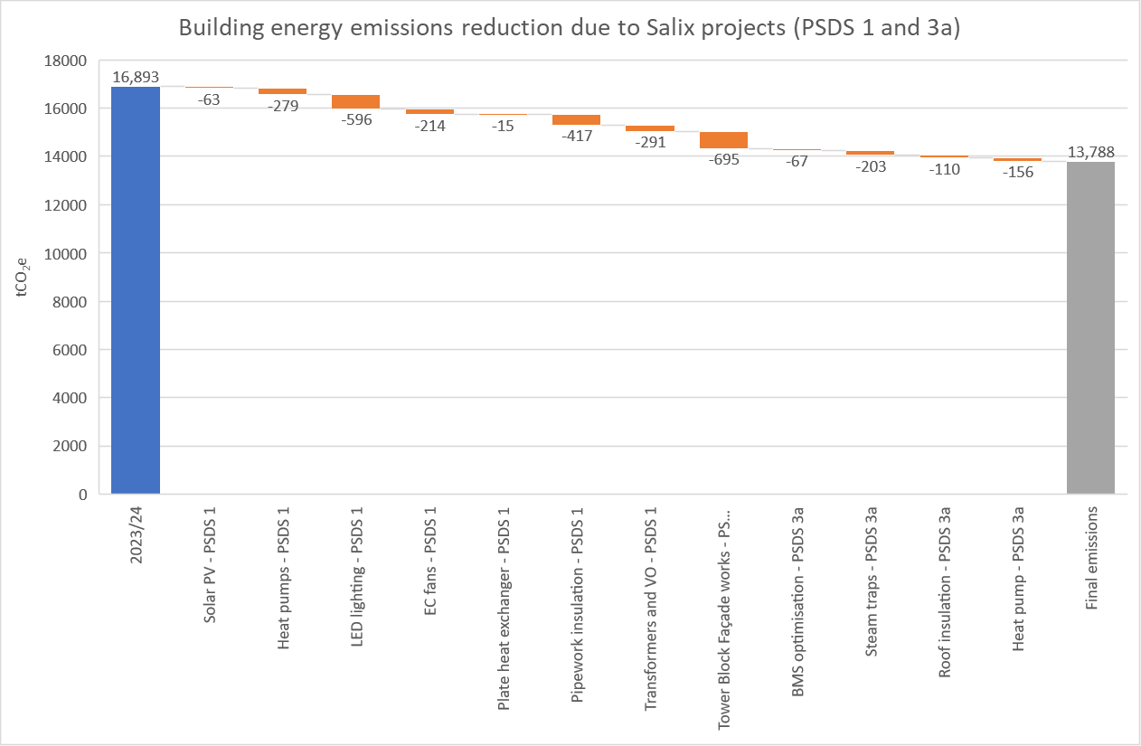
Graph showing the expected carbon emissions reduction from PSDS 1 and 3a projects.

The ongoing Building Management System replacement programme 2025/26 saw several key areas upgraded including CGH Radiopharmacy.

A geothermal pre-feasibility report was supported through the CERL sustainability fund. The report has returned a favourable assessment of both the Gloucester and Cheltenham sites, with Cheltenham likely to have higher temperatures. This links to the ongoing discussions with Cheltenham Borough Council for potential access to a district heat network and the forming of a collaborative pathway for the Trust.

An external water valve survey was undertaken at GRH with no issues found. Water meter data is being used to identify areas of potential wastage.

A review of surface drainage at Sandford Education Centre and Riverside House has led to water volume usage reduction (CO₂e reduction to be calculated).

The Trust was asked to consider use of hydrotreated vegetable oil (HVO) instead of diesel as its choice of back-up fuel. Price is double that of diesel but provides 90% reduction in carbon emissions. However, due to budgetary constraints, filling up new tanks for Energy Centre B with HVO was declined, but HVO may be used for future top-ups as it can be mixed with diesel.

3 ANAESTHETIC GASES

 | Tonnes CO2e
Year | Desflurane | Sevoflurane | Isoflurane | Nitrous Oxide | Entonox | Total  tCO2e
2019/20 | 68 | 100 | 2 | 797 | 1,419 | 2,385
2020/21 | 17 | 58 | 0 | 705 | 1,394 | 2,173
2021/22 | 0 | 64 | 0 | 533 | 1,454 | 2,052
2022/23 | 0 | 59 | 0 | 355 | 1,429 | 1,843
2023/24 | 0 | 47 | 0 | 52 | 1,259 | 1,358
2024/25 | 0 | 40 | 0 | 59 | 1,133 | 1,232
2025/26 | 0 | 41 | 0 | 59 | 1,027 | 1,127

Anaesthetic gas data are taken from purchasing data rather than the number of returned cylinders.

Overall carbon emissions from anaesthetic gas have decreased by 8.5%. This is the equivalent of 75 return flights between London and New York.

A Central Destruction Unit was installed in GRH Birth Unit to capture exhaled Entonox gas from birthing mothers. Entonox = nitrous oxide (N₂O) & oxygen but N₂O has global warming potential 265 times more than CO2 so has an enormous environmental impact. The CDU splits Entonox back to nitrogen and oxygen nullifying environmental impacts and removes the health risk to clinical staff from long term and regular exposure to Entonox. Whilst initial technical faults reduced carbon savings, the system is now fully operational and should save 500 tCO₂e per annum.

4 WASTE

Waste type | Tonnes | tCO2e | Total 2,753 tonnes  Carbon =  total 508 tCO₂e
Recycling | 495 | 2.3 | Total 2,753 tonnes  Carbon =  total 508 tCO₂e
Food waste - anaerobic digestion | 136 | 1.2 | Total 2,753 tonnes  Carbon =  total 508 tCO₂e
Waste to energy - domestic waste | 904 | 4.2 | Total 2,753 tonnes  Carbon =  total 508 tCO₂e
Waste Electrical & Electronic Equipment | 34 | 0.16 | Total 2,753 tonnes  Carbon =  total 508 tCO₂e
Clinical waste - incineration | 248 | 223.5 | Total 2,753 tonnes  Carbon =  total 508 tCO₂e
Clinical waste - alternative treatment | 501 | 180 | Total 2,753 tonnes  Carbon =  total 508 tCO₂e
Clinical waste – offensive | 336 | 7.15 | Total 2,753 tonnes  Carbon =  total 508 tCO₂e
Chemical – incineration | 99 | 90 | Total 2,753 tonnes  Carbon =  total 508 tCO₂e

Overall waste tonnage has increased by 1.8% from 2024-25 levels. However, carbon emissions have decreased by 5.9% compared to 2024-25 (540 tCO₂e) due to the switch of some clinical waste from alternative treatment (hazardous clinical waste) to offensive (non-hazardous clinical waste).

NHS England target (as per Clinical Waste Strategy, 2023) is a ratio of 20:20:60 for Alternative Treatment, Incineration and Offensive waste respectively (based on the tonnage sent for disposal). The sustainability budget has funded further offensive bins in 2025-26, allowing the transfer of more non-hazardous clinical waste from alternative treatment to offensive.

The carbon emissions relating to clinical waste disposal were 516 tCO2e in 2023-24 but in 2025-26 have dropped to 410 tCO2e.

5 SCOPE 1, 2 AND 3 EMISSIONS

Our statutory declaration (reported data) for our Scope 1, 2 and 3 emissions are 18,490 tCO2e.

Area | Type | Unit | Cost £
Greenhouse Gas Emissions | Scope 1 (gas consumption, fleet vehicles, oil and anaesthetic gases) | 16,870 tCO2e | Total Scope 1, 2 and 3 emissions (not including anaesthetic gas)  £7,770,073
Greenhouse Gas Emissions | Scope 2 (electricity consumption) | 609 tCO2e
Greenhouse Gas Emissions | Scope 3 (business travel, water supply and treatment and waste disposal) | 1,011 tCO2e

This is a 5.4% decrease from actual emissions 2024-25 (19,541 tCO₂e).

6 ACTIONS AND ACHIEVEMENTS IN 2025-26

In November 2025 GHFT published ‘Our five year strategy 2025-2030’. The four strategic aims - Patient Experience and Voice; People, Culture and Leadership; Quality, Safety and Delivery; and Digital First, are supported by four Golden Threads – these will run through everything we do.

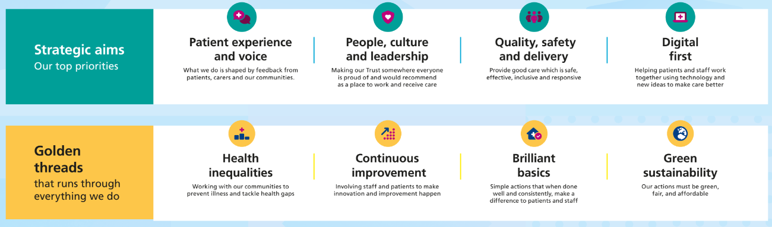

Health Inequalities, Continuous Improvement and Brilliant Basics will all have an impact on sustainability, but of particular note in this report is Green Sustainability and the commitment that ‘our actions must be green, fair and affordable’. This golden thread will be used to put sustainability at the core of everything we do, assist with engagement at all levels of the organisation, and enable actions (and hopefully funding) to reduce carbon emissions and meet the agreed target of net zero carbon by 2040.

In February 2026 the Care Quality Commission audited GHFT in relation to the Well-Led framework. The inspection included an interview on Environmental Sustainability, attended by three members of CERL. Discussions covered strategy, workforce engagement, targets, recent achievements, countywide working and future aspirations. Initial feedback from the inspectors was that the organisation has well-developed plans for green sustainability, and that the team were knowledgeable and engaged with the green agenda.

The Climate Risk and Vulnerability Assessment (CRVA) was commissioned by Climate Leadership Gloucestershire (CLG). The CRVA provides an evidence base to understand the key climate risks across the county, demonstrating the impact, likelihood and overall risk posed by climate change across a variety of climate hazards. The report includes a longlist of potential climate adaptation projects covering sectors such as built environment, infrastructure, health and green space. Many projects will be addressed through CLG, and GHFT will work with the ICS to share resources to address common actions applicable to the NHS.

There are a number of projects which have delivered sustainability benefits during the year. Some of these have benefited from a £50,000 fund for sustainability projects.

Area of focus | Project | Impact and/or benefits include: | Lead
Endoscopy | - 12-month pilot of Penthrox as an alternative to Entonox for analgesia in Endoscopy. Funded from the sustainability budget. | Estimated saving c. 12kg CO2e per procedure and up to 15t CO2e per annum. | GHFT
Telemedicine and video conferencing | From April 2025-March 2026 there were 231,658 telephone and telemedicine appointments, a rise of 28.5% from 2024-25. | Carbon footprint plus savings of 5,073 tCO₂e (when compared to face to face appointments) | GHFT
Greener IPC – Couch roll reduction | Couch roll use reviewed and reduced. Savings c. £14,000 on orders. | 6 tonnes of waste reduction | GHFT
Reusable torniquets | Rolled out across GHFT following a successful pilot scheme in 2024-25. | Reduction in single use items and waste disposal | GHFT
Medicines - Inhalers | Continued work with ICS partners and countywide clinicians to switch patients away from meter-dose inhalers (MDI) where appropriate. | MDI 40% dispensed inhalers, yet national average 50%. Reduction in carbon emissions relating to medicines. | GHFT
IT equipment | Extending life of assets so that kit is not replaced just because it is old – balanced with need to maintain cyber and security risks. | Reduction in waste | GHFT
Procurement | Net zero commitment requirements have been incorporated into lower value procurements above threshold. | Reduction in Scope 3 carbon emissions | GHFT
Models of Care | NHS NetZero InSites grant awarded for Greenhand – the development of a streamlined, greener carpal tunnel pathway. | Better patient outcomes and anticipated 80% reduction in CO2e from each surgery. Results to be shared across NHS. | GHFT
Theatre – sterile gown | Sterile gowns no longer required for spinal anaesthesia. | Saving c. 5000 gowns per year and 2.5 tCO₂e | GHFT
Waste | £20,000 from sustainability fund for additional offensive waste bins which have replace orange hazardous waste bins. | Saving over 50tCO2e and better compliance with waste segregation | GMS/  GHFT
Carbon training | Carbon foot printing and energy training delivered to staff on the Gold Quality Improvement programme. | Education and awareness | GMS/  GHFT
Travel – shuttle bus | From April 2025 to March 2026 there were a total of 254,802 passengers of which 179,309 were NHS staff and the other 75,493 public. The shuttle bus covered 146,851 miles. | Active travel, less traffic congestion, better air quality and reduced pressure on car parks | GMS/  GHFT
Travel - fleet | During 2025-26 GMS and Trust fleet has covered 831,257 miles generating 210 tCO₂e. | Fleet review to be conducted summer 2026 as part of EV feasibility work | GMS/  GHFT
Travel – grey fleet and staff travel expenses | The business mileage was 1,470,447 miles and 372 tCO₂e. Mileage has decreased by 6% compared to 24-25.  Staff expense claims for mileage and other travel (train, bus etc.) £462,735. | Claims for mileage travelled in electric cars increased by 40% from 24-25. | GMS/  GHFT
Recyclable privacy curtains | Fantex IPC (antibacterial) curtains replacing linen curtains. Fantex curtains are recyclable. | 50% carbon reduction when compared to linen curtain laundering. | GMS/  GHFT
Catering | Food waste recycling for in-patient meals and in GMS catering outlets | Compliance with regulations on segregation and recycling of food waste. | GMS
Energy | Continuation of 5 year programme of upgrades to Building Management Systems at CGH and GRH | Better controls over heating and ventilation. Improvements in efficiency and reduction of gas consumption. | GMS

7 TARGETS

Our Green Plan 2021-25, and the forthcoming Green Plan 2026-2030, outline the steps we will take to reduce carbon emissions and improve sustainability as we support the NHS target to achieve net zero carbon emissions by 2040 (on the emissions we control directly) (NHS Net Zero report, October 2021).

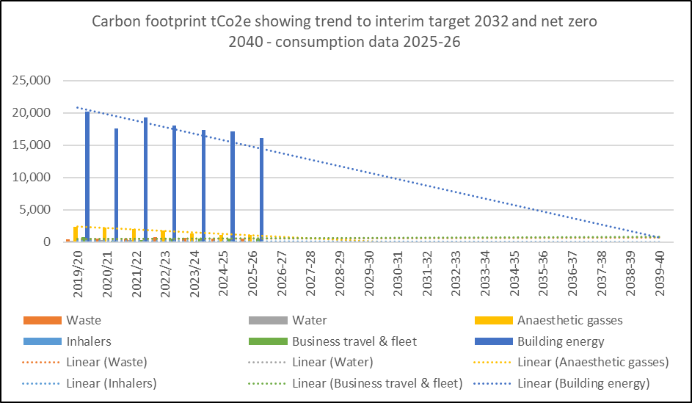

The Greener NHS has calculated an estimated carbon footprint for every hospital trust using a baseline of 2019/20. To reach net zero by 2040 on the Carbon Footprint (emissions we control directly) trusts must reduce their emissions by 47% by 2028-32. To reach net zero by 2045 on the Carbon Footprint Plus (emissions we influence) trusts must reduce their emissions by 73% by 2036-38. Much of their data is from expenditure-based estimates, with some data from our annual Estates Return Information Collection and this has all been used to generate an estimate of total carbon emissions. Their data does differ from ours in some areas, but their data is very useful in showing the scale and overall carbon emission reductions that we must achieve.

 |  | GHFT | GHFT | GHFT | GHFT | GHFT | GHFT | Target by | Target by | Target by | Target by
 |  | 2019/20 | 2020/21 | 2021/22 | 2022/23 | 2023/  24 | 2024/25 | 2028-32 | 2036-38 | 2040 | 2045
NHS Carbon Footprint | See note 1 | 24,433 | 24,313 | 27,441 | 25,554 | 23,535 | 24,403 | 11,484 |  | 0
NHS Carbon Footprint Plus | Medicines and prescribing | 21,768 | 17,805 | 21,307 | 21,096 | 20,493 | 19,701 |  | 15,891 |  | 0
NHS Carbon Footprint Plus | Medical Supply Chain | 26,015 | 26,663 | 43,171 | 46,178 | 32,368 | 36,867 |  | 18,991 |  | 0
NHS Carbon Footprint Plus | Other supply chain | 35,313 | 44,467 | 41,220 | 33,307 | 36,991 | 35,985 |  | 25,778 |  | 0
NHS Carbon Footprint Plus | NHS Commissioned services | 0 | 0 | 0 | 32 | 182 | 3 |  | 0 |  | 0
NHS Carbon Footprint Plus | Non-NHS Commissioned services | 1,047 | 842 | 1,077 | 937 | 802 | 546 |  | 764 |  | 0
NHS Carbon Footprint Plus | Personal travel | 15,974 | 14,877 | 15,087 | 13,912 | 14,347 | 13,928 |  | 11,661 |  | 0
 | Totals | 124,550 | 128,967 | 149,303 | 141,016 | 128,718 | 131,433 |  |  |  | 0

Note 1: NHS Carbon Footprint is building energy, business travel, fleet, water, waste, anaesthetic gas and inhalers.
All figures are tCO₂e.

The bars for 2036/39 show where the Carbon Footprint Plus emissions need to be in order to meet NHS Net Zero Carbon Plus emissions by 2045. This is very likely to require investment in carbon off sets.

8 PROJECTS FOR 2026-2027
There are a large number of projects planned in 2026-27. These include:

Green Plan
Our Green Plan is being updated and will be launched in September 2026. The introduction of Green Sustainability as a Golden Thread (GHFT Strategy 2025-30) will be reflected in the Green Plan, together with future projects and commitments from the new clinical, digital and estates strategies (all to be launched spring/summer 2026).

Annual green sustainability improvement objectives
We have agreed to set two annual improvement objectives for the whole Trust, one strategic and one operational / cross-cutting. These will be managed by the Climate Emergency Response Leadership group, but all areas of the Trust will participate, especially in the operational / cross cutting objective. For 2026-27 we will focus on:
Strategic: development of electric vehicle charging infrastructure to enable the transition of the fleet to 90% low or zero carbon emission vehicles by 2027/28
Operational / cross-cutting: paper reduction, focusing on reduction in printers, postage and paper, and increasing use of digital channels.

Area of Focus | Project | Benefits include: | Lead
Theatres | Reduction in single use items e.g. by use of reusable warmed blankets and UV light decontamination unit | Reduction in single use items and associated waste | GHFT
Medicines | Improve medicine reconciliation at admission and discharge, to improve use of patient’s own medication | Reduce medicine use | GHFT
Energy reduction for IT services | 80% GHFT Data Centres to be relocated to external colocation data centres that are highly efficient and more sustainable | Reduction in carbon emissions relating to IT | GHFT
Procurement | Deepening supplier engagement to prepare the market for NHS Roadmap milestones in 2027 and 2028 | More sustainable procurement | GHFT
Procurement – working in partnership | Collaborating with the ICS, NHS Supply Chain and regional partners to align sustainability standards and reduce duplication | Community working. Share ideas & resources across system | GHFT
Working in partnership on shared goals | Greener ICP group (Infection Control teams from all three organisations) to develop collaborative approach to green projects | Reduce plastic and waste. Share ideas & resources across organisations | GMS/  GHFT
Linen Use – Greener IPC Council initiative | Development of shared policy (acute and community sites) to reduce bed sheet changing frequency (where appropriate) | Reduce volumes sent to laundry and associated carbon | GMS/  GHFT
Glove Reduction – Greener IPC Council initiative | Development of shared ‘Gloves Off’ campaign across county. Aligning ‘top 10 priority behaviour’ to stop unnecessary glove use | Reduction in gloves purchased, waste disposal and related carbon emissions | GMS/  GHFT
Fleet review | Review of all fleet vehicles, routes etc. as part of move to electric vehicles | Introduction for electric vehicles | GMS/  GHFT
Application for funding | Apply for relevant funding opportunities which will assist with carbon reduction especially large-scale heat / energy and carbon saving infrastructure projects | Carbon reduction | GMS
Building Management System (BMS) | Continuation of works to the BMS at GRH and CGH to improve operational resilience. GMS will also develop a proposal for the future direction of the building management systems to ensure that building services are delivered in a responsive and energy efficient manner | Improve energy efficiency and operational resilience | GMS
Decarbonisation of site heating | Continuing discussions with Cheltenham Borough Council about a potential District Heating System | Reduce carbon emissions and a community collaboration | GMS
Decarbonisation of heat | Further review of geothermal feasibility to investigate potential, technical and economic viability of a geothermal heat system. Possible solution for decarbonised heat at CGH/GRH. | Potential savings of 15,303 tCO2e p.a. | GMS
Energy review | Review of energy billing as part of NHS Utilities Review. | Expected to deliver cost savings | GMS
Environmental Management System (EMS) | Development of an EMS as part of regulatory requirements (Medium Combustion Plant Directive) for new back-up generators at GRH and CGH. | Compliance and assurance, better environmental management | GMS
Catering - Reduce waste and improve recycling | Roll-out of Electronic Meal Ordering System across all wards. Will improve patient satisfaction, order accuracy and inventory control. | Reduce food waste by 15% pa, cost and carbon savings from not printing meal cards | GMS
Reduce waste | Business case to fund move of clinical waste from orange to offensive waste stream. Complete installation of offensive bins across Trust. | Carbon savings and compliance with NHS waste strategy | GMS
Sustainability audits | GMS have developed their own carbon footprint and will use this to inform environmental audits of their service. | Reduce carbon emission, cost savings | GMS
Reduction of building energy | Apleona works including upgrade AHU motor, decontamination machines in Endoscopy and lift replacement. | Reduce energy related carbon | Apleona

9 ACHIEVING NET ZERO BY 2040

Despite the above projects, it is not yet clear how the Trust will achieve net zero carbon footprint by 2040. There are a number of issues which need resolving including:

- Trust has no Heat Decarbonisation Plan. This would determine how the GHFT current fossil fuelled heating systems can be replaced by low carbon alternatives. Previous grant applications for funding have been unsuccessful and there were no available grants in 2025-26. Therefore the Head of Energy will formulate a plan during 2026.
- We are in the process of gaining HR/OD, Digital and Pharmacy representation on the Climate Emergency Response Leadership group.
- Greater clinical and operational involvement is required at senior level and divisional level.
- The Trust declared a Climate Emergency in 2019. Climate risk is scored at 12 on the Board Assurance Framework. There are gaps in the proposed control measures for this risk – including funding for projects, the age and condition of the estate and a requirement for staff resources.
- GMS and Trust resources are limited and there is a need for increased dedicated resources to take on sustainability projects. At the moment there is much reliance on the goodwill of staff to take action / lead on climate issues.
- Development of more sustainable travel options requires further investment and improved infrastructure. This includes the provision of EV charging for patients, visitors, staff and fleet.
- Trust likely to struggle to achieve the NHS Net Zero Travel and Transport Strategy (2023) requirement that all new vehicles owned or leased by NHS will be zero emission by 2027, due to electrical infrastructure and funding restrictions.
- There is a lack of recurring investment to support green initiatives. Capital funding is limited but there is a need to retrofit existing buildings and/or construct new buildings to required energy performance standards.

10 ENGAGEMENT

Working with staff, suppliers and local partners is essential action in reducing carbon emissions across the Trust. This year:
- we have Green Champions and some areas have established sustainability groups to take action in their specific departments to help reduce carbon emissions
- as a member of Climate Leadership Gloucestershire, we are leading on the Behaviour Change aspect (in collaboration with Gloucestershire County Council) and are a key stakeholder in the strategic planning and decisions for climate action
- we are working with the Gloucestershire ICB, Gloucestershire County Council and Gloucestershire Health and Care Foundation Trust (GHC) on a number of projects including adaptation and mitigation to climate change, electric vehicle charging and infection prevention programmes e.g. glove use and linen reduction
- we contribute at regional level to the South West Greener NHS.

11 TASK FORCE ON CLIMATE-RELATED FINANCIAL DISCLOSURES (TFCD)

NHS England’s NHS foundation trust annual reporting manual has adopted a phased approach to incorporating the TCFD recommended disclosures as part of sustainability annual reporting requirements for NHS bodies, stemming from HM Treasury’s TCFD aligned disclosure guidance for public sector annual reports. TCFD recommended disclosures are interpreted and adapted for the public sector by the HM Treasury TCFD aligned disclosure application guidance and will be implemented in sustainability reporting requirements on a phased basis up to the 2024/26 financial year.

The phased approach incorporates the disclosure requirements of the governance, risk management and metrics and targets pillars for 2024/25. These disclosures are provided below with appropriate cross-referencing to relevant information elsewhere in the annual report and in other external publications.

The Board’s oversight of climate-related issues:
- The Director of Improvement and Delivery is the board lead for climate-related issues.
- The Finance and Resources Committee is a formal committee of the board and receives assurance of the Trusts delivery of its sustainability plan through regular reports and briefings.
- The Chair of the Climate Emergency Response Leadership (CERL) Group can also draw the attention of the Finance and Resources Committee to any sustainability related issues that require disclosure to the full Board or require executive action.
- The Board receives an annual sustainability report as part of Trust reporting. This report includes progress against goals and targets, highlights achievements and notes actions for the following year.
- The board also has an established sustainability group (CERL) with cross organisation representation which hold responsibilities for developing and actioning the sustainability work plan.
- GHFT works in partnership and collaboration as part of One Gloucestershire and is a formal member of the Climate Action Group across Gloucestershire working with other NHS organisations including the ICB, other NHS Trusts and the County Council.

Trust processes for assessing and managing climate-related issues:
- As part of the Green Plan, the Trust has established the Climate Emergency Response Leadership Group with specific responsibilities to:
  - Understand the impact of climate emergency on the Trust
  - Lead and develop Trust strategy and policies on climate and carbon
  - Monitor progress on the Green Action Plan and all projects contributing to carbon reduction
  - Ensure national and local reporting requirements are met and produce an annual sustainability report
  - Embed sustainability culture throughout the Trust
  - Develop and deliver sustainability cost improvement programme
  - CERL reports to Finance and Resources Committee
- Six monthly energy reports to Gloucestershire Managed Services Board
- An annual energy report to Trust Board
- The Trust has established a £50k sustainability fund held by the Director of Improvement and Delivery and managed through the Climate Emergency Response Leadership Group.
- The Trust is also considering how it can strengthen this through addition sustainability to the focus and delivery of its well-established Quality Improvement Approach via the QI Academy and Equality, Health Inequality Assessment.
- The Trust Strategy (November 2025) has Green Sustainability as a Golden Thread, with the commitment that ‘our actions must be green, fair and affordable’. This golden thread will be used to put sustainability at the core of everything that is done, assist with engagement at all levels of the organisation, and enable actions to reduce carbon emissions and meet the agreed target of net zero carbon by 2040.

Trust process for identifying, assessing and managing climate-related risks:
- The Trust declared a climate emergency in November 2019.
- The Trust has three climate-related risks on the Corporate Speciality Risk Register
  - Risk 121 = The risk that extreme weather events (heat, cold, flooding, fire) and poor air quality, lead to increased demand on urgent and emergency care without corresponding increase in Gloucestershire Integrated Care System health resources. This is noted as a Business risk.
  - Risk 127 = The risk that the Trust does not meet net zero carbon emissions by 2040. This is noted as an Environmental risk.
  - Risk 130 = The risk that the Trust does not progress actions defined in the Green Plan due to a reliance on goodwill and out of hours working from colleagues in order to progress actions at local level. This is noted as an Environmental risk.
- The Board Assurance Framework includes a strategic risk related to “Failure to meet statutory and regulatory standards and targets enroute to becoming a net-zero carbon footprint organisation by 2040”. This is rated 12. This is reported to the Board at every meeting as part of the Board Assurance Framework. This risk is also considered and reviewed by the Finance and Resources Committee ahead of the update to the Board. The risk and actions are reviewed and updated on a monthly basis.
- The three climate-related risks, and the BAF risk SR11 Sustainable Healthcare, are reviewed regularly by Climate Emergency Response Leadership group. This group is responsible for many of the actions outlined and for monitoring reporting of sustainability / climate related issues.
- Climate Emergency Response Leadership group members are able to propose new risks or changes to existing risks.
- Risks are discussed by the Trust at regular intervals and are reported to the Risk Management Group, divisional Boards and the Audit and Assurance Committee.

Trust processes for identifying, assessing and managing climate-related risks are integrated into the organisation’s overall risk management approach:
- The BAF risk SR11 Sustainable Healthcare is linked to BAF risk SR09 Failure to Deliver Recurrent Financial Sustainability and BAF risk SR10 Condition of the Estate.
- Climate related risks are evaluated, managed and monitored in the same way as all other Trust risks, following the Trust Risk Management Framework.
- Climate-related risks are considered under KIER at Finance and Resources Committee

Material metrics and targets used to assess and manage relevant climate-related issues:
- The Trust has adopted NHS national targets for the reduction of carbon emissions
  - For the emissions we control directly (the NHS Carbon Footprint), net zero by 2040, with an ambition to reach 80% reduction by 2028 to 2033
  - For the emissions we can influence (the NHS Carbon Footprint Plus), net zero by 2045, with an ambition to reach 80% reduction by 2036 to 2039.
- Carbon emissions for scope 1 and 2, and part of scope 3 (waste, water and business travel), are calculated annually and included in the sustainability annual report. These have been reported annually since 2017-18.
- Data used for energy, water and waste is also reported within the annual ERIC (Estates Return Information Collection) submission.
- The Green Action Plan details projects which aim to reduce carbon emissions and enable the Trust to achieve net zero targets.

Jen Cleary – Head of Sustainability, GMS
June 2026

