
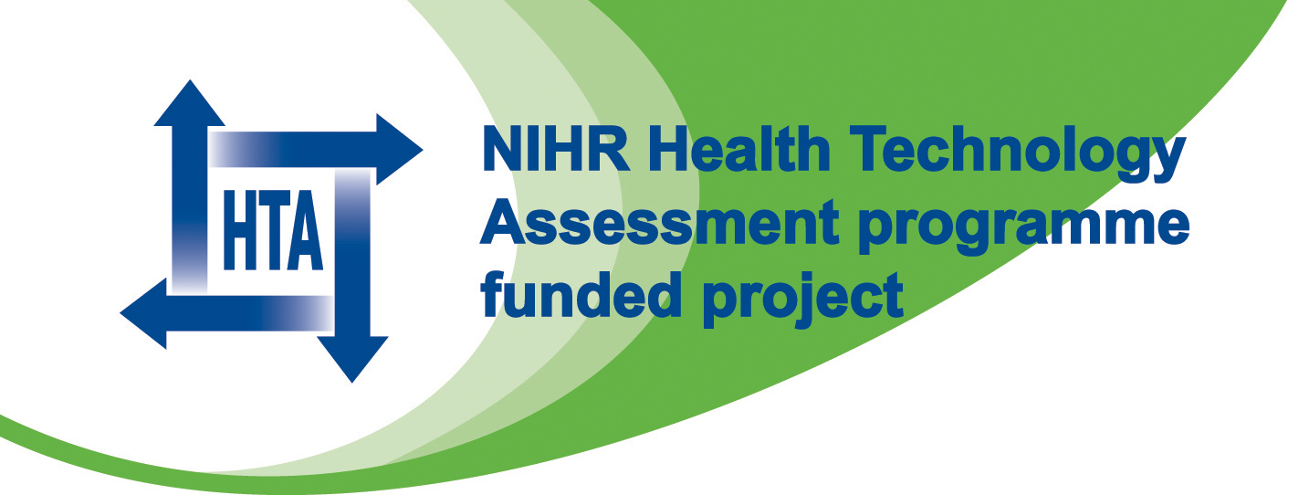
Trust Headed Paper

BOSS Study
c/o Name of Department / Organisation

TO BE PRINTED ON LOCAL HEADED PAPER ALONG WITH NIHR and HTA LOGO

The BOSS study
(Barrett’s Oesophagus Surveillance Study)
A randomised controlled trial of surveillance for patients with Barrett’s oesophagus

You are being invited to take part in a research study. Before you decide it is important for you to understand why the research is being done and what it will involve. Please take time to read the following information carefully and discuss it with others if you wish, for example family and friends or your family doctor (GP). Ask us if there is anything that is not clear or if you would like more information. Take time to decide whether or not you wish to take part.

What is the purpose of the study?
Barrett’s oesophagus is a change in the lower gullet (oesophagus) brought about by the frequent reflux of gastric juice from the stomach into the oesophagus. The lining of the lower oesophagus has changed to become like the lining of the small intestine.

You have had an endoscopy that has diagnosed Barrett’s oesophagus and for most people it is not a life threatening condition but it can cause troublesome indigestion-like symptoms. It occurs in about 1% of the adult population and can lead to oesophageal cancer in some people. Once you have Barrett’s oesophagus the life-time risk of it developing into cancer is about 5%.

The best method of detecting this cancer and early changes and thus preventing its progress is not clear. Some have recommended and developed guidelines that recommend that patients with Barrett’s oesophagus have an endoscopy every 2-3 years to detect cancer. Others suggest that endoscopy should be in response to patient symptoms and performed at the time of need or change in the patient’s condition after consultation with their physician.

The use of regular endoscopy to review the progress of Barrett’s oesophagus commonly causes minor complications in between 1-10% of patients. These include discomfort, pain and/or breathing difficulties, which should settle down in a few days. Endoscopy is also inconvenient for patients and may causes anxiety for some patients and their families. On very rare occasions it can result in perforation of the oesophagus (1 in 3,000 endoscopies), or death (1 in 100,000 endoscopies).

Recent analysis acknowledges that the information to support endoscopy surveillance is relatively weak and the value of planned, regular endoscopy is still subject to considerable debate. A randomised trial is the best way of determining whether regular endoscopy allows for earlier detection and treatment of oesophageal cancer, leading to a better outcome. At the moment there are no other trials published or being conducted in this area.

We are conducting this study because we are not sure whether regular endoscopy, with the risks described, is beneficial to patients with Barrett’s oesophagus or whether using patients’ symptoms could be just as good. It should be important to find out if regular endoscopy benefits patients before routinely offering it.

Why have I been invited?
As a patient with Barrett’s oesophagus you have been invited because you have been diagnosed with Barrett’s oesophagus. A total of 3,400 patients with Barrett’s oesophagus will be recruited from across the UK during a 3 year period and followed up for a further 10 years.

What will happen to me if I take part?
Since we do not know the best way of managing patients with Barrett’s oesophagus we need to make comparisons. If you agree to go into the study you will be randomly allocated to one of two groups:

- You will be invited for a planned endoscopy every two years or in between times if you need one

OR

- You will only be offered an endoscopy if you need one.

For some of you, this may mean that you will no longer receive regular invitations for endoscopy although you did in the past. Regardless of which group you are in you can still be referred back to the hospital consultant for further tests and investigations if necessary.

The groups are selected by a computer, i.e. allocation is by chance, like tossing a coin. Patients in each group then have different management and these are compared. The Trial is much fairer if people are assigned to groups by chance, not by choice.

You will also be registered with the Medical Research Information Service (MRIS) or Information Service Division (ISD) to follow your health outcome in the longer term, even if you have moved away and we haven’t got your address.

What do I have to do?
Everyone taking part in the study will receive a questionnaire every two years for up to ten years. The questionnaire will ask you about the medicines you currently take for your Barrett’s oesophagus and your general well-being. If you are not in the group who are having regular endoscopies this will be sent to you by the BOSS study office. You will also be asked to complete a questionnaire after each endoscopy that you have during the period of the study.

Any additional information we might need about your condition will be provided by your local hospital doctor.

What are the possible benefits of taking part?
We cannot promise that taking part will benefit you. However, the information we get from this study may help us to treat future patients with Barrett’s oesophagus more effectively and given the long term nature of the condition this might include you.

What if I don’t want to take part?
Your hospital doctor will discuss the most appropriate way of monitoring your Barrett’s oesophagus and treating the symptoms.

If you decide not to take part we would like to collect some information about you and your condition. This will help us to find out if the people who choose to take part in the study are any different than those who do not. This may be important information to consider at the end of the study. The information will not identify you. You do not have to agree to this.

What if new information becomes available?
Sometimes during the course of a research project, new information becomes available about what is being studied. If this happens, your research doctor will tell you about it and discuss with you whether you want to continue in the study. If you decide to withdraw your research doctor will make arrangements for your care to continue. If you decide to continue in the study you will be asked to sign an updated consent form.
Also, on receiving new information your research doctor might consider it to be in your best interests to withdraw you from the study. He/she will explain the reasons and arrange for your care to continue.

What happens when the research study stops?

If the project were to stop early then your care will return to the best available at that time. At the end of the project we will look at the findings and then make recommendations about what changes in care there should be.

What if something goes wrong?
We believe that this study is basically safe and do not expect you to suffer any harm or injury because of your participation in it. The NHS indemnity scheme will compensate you if you are harmed due to someone’s negligence but there is no compensation scheme for harm that was not caused by negligence.

Will my taking part in this study be kept confidential?
If you decide to participate in BOSS, the information collected about you during the course of the study will be kept strictly confidential. This information will be securely stored at the BOSS Trial Office at Gloucestershire Royal Hospital on paper and electronically, under the provisions of the 1998 Data Protection Act. Your name and address will also be given to dedicated staff at the BOSS Trial Office when you first enter the study, so that they can send Quality of Life questionnaires to your home address. This information will not be accessed by any other personnel. Any further information about you that leaves the hospital will have your name and address removed so that you cannot be recognised from it. You will be allocated a study number, which will be used as a code to identify you on all study forms. Only the BOSS Trial Office and your hospital will be able to identify you from this number. With your permission, your GP and the other doctors involved in your clinical care will be kept informed, but otherwise all information about you and your treatment will remain confidential.

With your permission, your relevant medical records may be inspected by authorised individuals from the research team or the Gloucestershire Hospitals NHS Foundation Trust (the study Sponsor). They may also be looked at by the regulatory authorities. The purpose of this is to check that the study is being carried out correctly.

What will happen to the results of the research study?
The results of the research will be published in one or more papers in medical journals so that they are available to all doctors. At the end of the study you can request a copy of the results from your research doctor. No individual patients will be identified in any publication or report.

Who is organising and funding the research?
The trial has been organised by Prof Hugh Barr, a surgeon specialising in Barrett’s oesophagus at Gloucestershire Hospitals NHS Foundation Trust. The study is funded by the NHS Health Technology Assessment Programme. The doctor conducting the research is not paid for including patients in the study and for looking after them. These costs are borne by the NHS.

Do I have to take part?
No, it is up to you to decide whether or not to take part. If you do decide to take part you will be given this information sheet to keep and be asked to sign a consent form. Once you have decided to take part you are still free to withdraw at any time and without giving a reason. Your decision to withdraw at any time, or a decision not to take part, will not affect the standard of care you receive.

What if I have any further questions?
Please contact the doctor who is conducting the study in your local hospital:

<insert name and contact details here>
Name of Consultant
Job Title
Address

Telephone Number

Thank you for reading this.

