
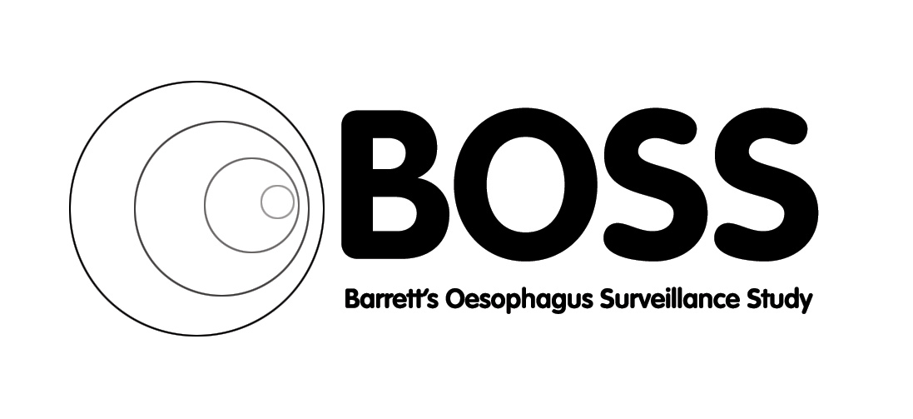
BOSS TRIALS OFFICE – CONTACT LIST

BOSS CLINICAL TRIALS OFFICE:
c/o BOSS Trial Team
Chestnut House
Gloucestershire Royal Hospital
Great Western Road
Gloucester
GL1 3NN
BOSS@glos.nhs.uk
Fax: 03004 225486

MAIN CONTACTS / GENERAL ENQUIRIES:
Name Professor Hugh Barr (Chief Investigator)
Job Title: Consultant Surgeon
Telephone No.: 03004 226679
E-mail: hugh.barr@glos.nhs.uk

Name: Clive Stokes
Job Title: BOSS Clinical Trial Coordinator
Telephone No.: 03004 225477
Email: clive.stokes@glos.nhs.uk

DATA QUERIES:
Name Sue Walton
Job Title Data Officer
Telephone No. 03004 225474
E-mail: susan.walton@glos.nhs.uk
Name: Helen Sainsbury
Job Title: Data Officer
Telephone No.: 03004 225482
E-mail: helen.sainsbury@glos.nhs.uk

Name: Cathryn Rasdell
Job Title: Data Officer
Telephone No.: 03004 225475
E-mail: Cathryn.Rasdell@glos.nhs.uk

All based at Leadon house are for other enquiries:

Name: Catherine Kendall Name: Chris Foy
Job Title BOSS Trial Manager Job Title: BOSS Data Manager
Telephone No.: 03004 225484 Telephone No.: 03004 225461
E-mail: catherine.kendall@glos.nhs.uk E-mail: chris.foy@glos.nhs.uk

Name: Allison Bates
Job Title: Administrator
Telephone No.: 03004 225484
E-mail: allison.bates@glos.nhs.uk

