 Trust Headed Paper

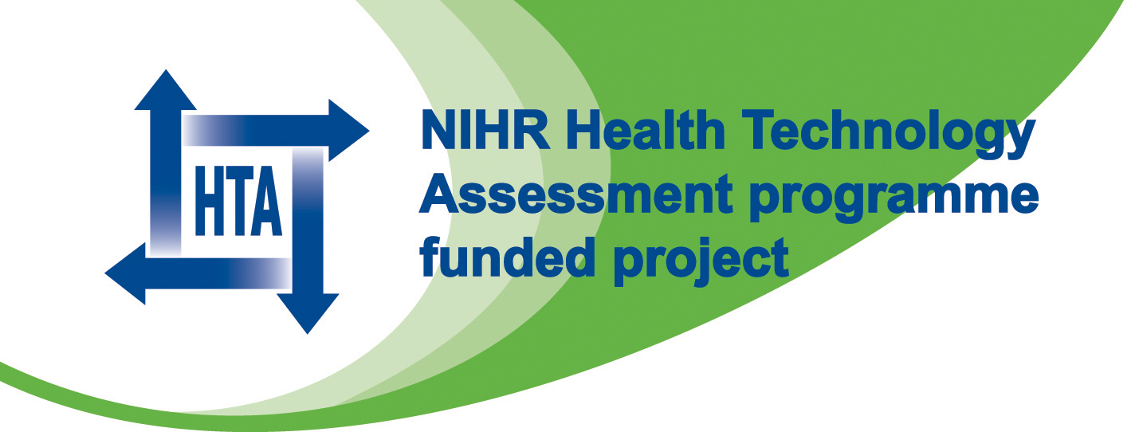
BOSS Study
c/o Name of Department / Organisation

TO BE PRINTED ON LOCAL HEADED PAPER ALONG WITH NIHR and HTA LOGO

The BOSS study
(Barrett’s Oesophagus Surveillance Study)
Consent form for data collection ONLY
Title: | A randomised controlled trial of surveillance for patients with Barrett’s oesophagus

Study Doctor | Name: |  | Trial Number: | BS
Study Site:

Patient Statement and Signature To be completed by the patient
Please initial the boxes below if you agree

- I have received and read a copy of the BOSS Patient Information Sheet (version 10a or 10b*, dated July 2011) and have had an opportunity to ask questions, and all of my questions have been answered.

- I do not wish to participate in the study but agree that the study team can use information about me and my condition providing that it does not identify me.

- I understand that I will not be identified in any reports or publications resulting from the study.

My signature confirms that I have had an opportunity to ask questions, and all of my questions have been answered.

I freely agree to the use of my anonymised information in the study.
Signature | ______________ | Name (print): | ____________________ | Date Signed: | / /
You will be given a signed and dated copy of this consent form to take away with you

Investigator Statement and Signature
To be completed by the person taking consent
I have discussed this clinical research study with the patient and/or his or her authorised representative, using a language that is understandable and appropriate. I believe the participant understood this explanation.
Signature | ______________ | Name (print): | ____________________ | Date Signed: | / /

1 copy for patient, 1 for patient’s notes and 1 for investigator’s file

