 Trust Headed Paper

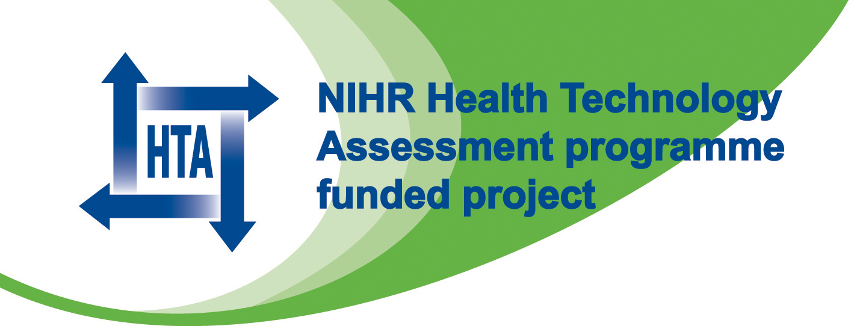
BOSS Study
c/o Name of Department / Organisation

TO BE PRINTED ON LOCAL HEADED PAPER ALONG WITH NIHR and HTA LOGO

The BOSS study
(Barrett’s Oesophagus Surveillance Study)
Consent form for randomised study
Title: | A randomised controlled trial of surveillance for patients with Barrett’s oesophagus

Study Doctor | Name: |  | Study Site:

Patient | Name: |  | Trial No.:

Patient Statement and Signature To be completed by the patient
Please initial the boxes below if you agree

- I have received and read a copy of the BOSS Patient Information Sheet (version 10a or 10b*, dated July 2011) and have had an opportunity to ask questions, and all of my questions have been answered.

- I understand that my participation is voluntary and that I am free to withdraw from the study at any time without giving a reason, without my medical care or other legal rights being affected

- I give my permission for information held by the NHS and records maintained by the Medical Research Information Service (MRIS) or Information Service Division (ISD) to be used to keep in touch with me and follow up my health status.

- I also understand that sections of any of my medical notes may be looked at by responsible individuals from the BOSS Trial Office (Gloucestershire Hospitals NHS Foundation Trust - sponsor) and regulatory agencies where it is relevant to my taking part in this research study. I give permission for these individuals to have access to my records that identify me by name.

- I understand that I will not be identified in any reports or publications resulting from the study.

Yes No
- I give my permission for a letter and information about the BOSS
study to be sent to my GP, which tells them that I have decided to
take part in the study

My signature confirms that I have had an opportunity to ask questions, and all of my questions have been answered.

I freely agree to participate in this study.
Signature | ______________ | Name (print): | ____________________ | Date Signed: | / /
You will be sent a signed and dated copy of this consent form along with a letter that will inform you to which study group you have been allocated in the next few weeks.

Investigator Statement and Signature
To be completed by the person taking consent
I have discussed this clinical research study with the patient and/or his or her authorised representative, using a language that is understandable and appropriate. I believe that I have fully informed the participant of the nature of this study and its possible benefits and risks and I believe the participant understood this explanation.

Signature | ______________ | Name (print): | ____________________ | Date Signed: | / /

1 copy for patient, 1 for patient’s notes and 1 for investigator’s file

