
Trust Headed Paper

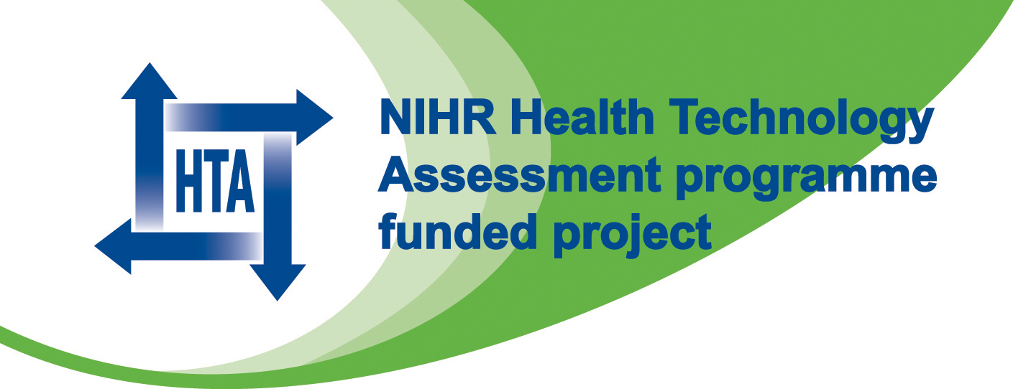
BOSS Study
c/o Name of Department / Organisation

TO BE PRINTED ON LOCAL HEADED PAPER ALONG WITH NIHR and HTA LOGO

Date

Name of General Practitioner
Address

Dear Name of General Practitioner

Patient:
DoB:

Your patient has kindly agreed to take part in this national UK trial, funded by the National Health Service Health Technology assessment Programme, and run by the Research and Development Support Unit based at Gloucestershire Hospitals NHS Foundation Trust.

The aim of the study is to see whether a protocol of endoscopic surveillance is better than endoscopic surveillance if needed for the prevention of early mortality in patients diagnosed with Barrett’s oesophagus.

The study randomises patients to receive a standard upper gastrointestinal endoscopy with biopsy every two years for 10 years or no endoscopic surveillance. All patients will receive a biannual postal questionnaire to record their medication and other health related data.

*please delete as appropriate
Your patient has been randomised to receive:
- endoscopic surveillance
- endoscopy only if required

Please continue to manage this patient as you would have done regardless of their participation in the trial. All patients (including those in the endoscopy at need arm) should be offered an urgent endoscopy if they develop dysphagia, unexplained weight loss of > 7lb, iron deficiency anaemia, recurrent vomiting, or worsening upper gastrointestinal symptoms.

If you need to refer this patient for an endoscopy it would be preferable if you could refer them to [insert name of Principal Investigator].

There are no prescribing restrictions and no bar on other investigations should they become necessary. The patient can receive medication as you feel appropriate for their symptoms and can also be referred for endoscopy should it be clinically indicated if their symptoms change or deteriorate.

Please contact us if you require more information.

Yours sincerely

Name of Principal Investigator

