Recommended Reading - Chronic Pain
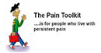 | The Pain Toolkit Book and App  Useful booklet with lots of practical and easy to follow advice. Written in a friendly and accessible manner by someone who has personal experience of chronic pain and can relate to the difficulties. The Toolkit has been developed into an app format. | Available via the Department of Health Choices website www.nhs.uk  Free
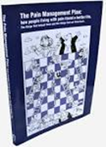 | The Pain Management Plan: How people living with pain found a better life  by Robert Lewin  Step by step guide on how to develop your own pain plan. A plan to get a better life and more control over pain. The Pain Management Plan has been developed into an app format as an alternative to the book. | Available from the Pain Management Department.  Can also be purchased via www.amazon.co.uk  RRP £10
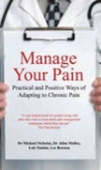 | Manage Your Pain  by Michael Nicholas, Alan Molloy, Lois Tonkin and Lee Beeston.  Easy to dip in and out of. All-round coverage of Pain Self-Management methods. | Gloucestershire &  Herefordshire Library Services  ISBN: 028-5636-790  RRP £14.99
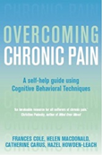 | Overcoming chronic pain: A self-help guide to using cognitive behavioural techniques  by Frances Cole, Helen Macdonald, Catherine Carus, Hazel Howden-Leach.  Practical ways to improve sleep, relaxation, relationships, fitness and pacing of activities. | Gloucestershire &  Herefordshire Library Services  ISBN: 1-84119-970-2  RRP £10.99
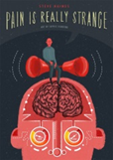 | Pain is Really Strange  By Steve Haines  Research based short book which explains the difference between chronic pain and acute pain, and suggests practical ways to reduce pain. | Gloucestershire &  Herefordshire Library Servies  ISBN: 1848193661  RRP £7.99
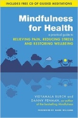 | Mindfulness for Health: A practical guide to relieving pain, reducing stress and restoring wellbeing  By Vidymala Burch and Danny Penman  An excellent 8-week mindfulness course with accompanying meditations on CD. | Gloucestershire & Herefordshire  Library Services  ISBN: 978-0749959241  RRP: £10
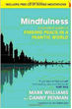 | Mindfulness: A Practical Guide to Finding Peace in a Frantic World (Includes Free CD with Guided Meditations)  by Mark Williams and Danny Penman  Free of jargon. Well-structured book with CD giving an introduction to mindfulness for stress. | Gloucestershire & Herefordshire  Library Services  ISBN: 978-0749953089  RRP £10
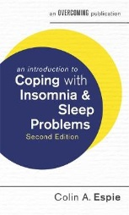 | An introduction to coping with Insomnia and Sleep Problems  by Colin Espie  this book explains why it can be so difficult to break bad sleeping habits and describes the most effective ways of establishing permanently improved sleeping patterns | Gloucestershire &  Herefordshire Library Services  ISBN: 978-1472138545  RRP £4.99
https://www.arthritisresearchuk.org/arthritis-information/conditions/fibromyalgia.aspx
this website has a wide range of helpful booklets about lots of health conditions that cause pain
Services for people with persistent pain in Gloucestershire
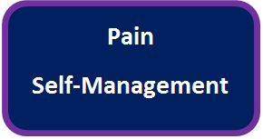 | Pain Self-Management Service Part of our local pain service. Based in Gloucester, Cheltenham, Forest of Dean and Hereford. Helping people to live well with pain. www.gloshospitals.nhs.uk/pmgt Phone: 0300 422 8469
 | Mindfulness Meditation exercises to help with stress and pain. Courses available through Pain Self-Management and Let’s Talk. www.gloshospitals.nhs.uk/mindfulness
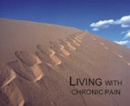 | Living with Pain Self-management CD. Listen online, buy the CD or download for free. Includes guided relaxation session designed for people with persistent pain. www.paincd.org.uk
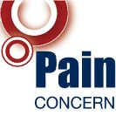 | Pain Concern A UK based charity to help people with persistent pain.  Good magazine, Pain Matters www.painconcern.org.uk Phone: 0300 123 0789 Wonderful online radio programme about pain “Airing Pain”. www.ableradio.com
 | Let’s Talk Help for depression, anxiety, insomnia etc. Refer yourself online or by phone. www.talk2gether.nhs.uk Phone: 0800 0732200
 | Gloucestershire Physiotherapy Healthy Living Links to all the services in your local area to help you get more active, even if you are limited by pain and fatigue. www.gloshospitals.nhs.uk/physio/health
 | Adult Helpdesk For Occupational Therapy, Housing/Social Work enquiries. You can refer yourself. www.gloucestershire.gov.uk/adults Phone: 01452 426868
Citizens Advice Bureau Provides free confidential advice on benefits, legal matters, money and other problems. Phone: 01452 527202
www.gloucestercab.org.uk or www.citizensadvice.org.uk
 | Art Lift Your healthcare professional can refer you to free, friendly community art classes where you can discover a new interest, be creative and meet other people. You do not need to be good at art! Classes all around the county. www.artlift.org Phone: 03000 200 102
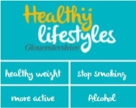 | Samaritans Confidential listening service. Available to take calls 24/7 but you can also visit the local branch or write an email. Phone: 116 123 www.samaritans.org
 | Healthy Lifestyles Gloucestershire Advice and support for lifestyle changes including; healthy weight, stop smoking, more active, alcohol and more. You can refer yourself. www.hlsglos.org Phone: 0800 122 378

ACT Resources
If you’d like to find out more about ACT, you might find the following resources helpful
We would also recommend the following books:
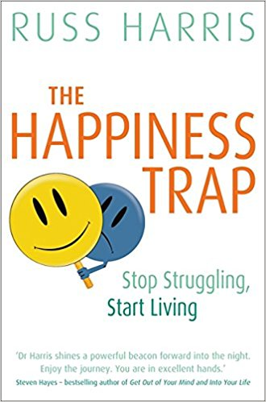
The Happiness Trap (Based on ACT: A revolutionary mindfulness-based programme for overcoming stress, anxiety and depression) by Russ Harris – available from Gloucestershire Library Service or RRP £9.99.

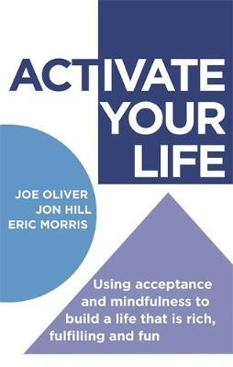
ACTivate Your Life: Using acceptance and mindfulness to build a life that is rich, fulfilling and fun by Joe Oliver, Jon Hill and Eric Morris – RRP £9.99.

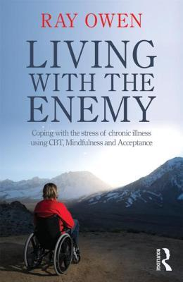

Living with the Enemy: Coping with the stress of illness using CBT, mindfulness and acceptance by Ray Owen – RRP £16.99.

Below are links to videos showing some of the main ideas of ACT:
Passengers on the bus – getting unhooked from unhelpful thoughts - https://www.youtube.com/watch?v=Z29ptSuoWRc
Unwelcome guest – making space for difficult feelings - https://www.youtube.com/watch?v=VYht-guymF4
Values and goals
https://www.youtube.com/watch?v=T-lRbuy4XtA
The struggle switch
https://www.youtube.com/watch?v=rCp1l16GCXI

