**Registered medical practitioner notification form template**

|  |  |
| --- | --- |
| *Health Protection (Notification) Regulations 2010: notification to the proper officer of the local authority* | |
| Registered Medical Practitioner reporting the disease | |
| Name |  |
| Address |  |
| Post code |  |
| Contact number |  |
| Date of notification |  |
| Notifiable disease | |
| Disease, infection or contamination |  |
| Date of onset of symptoms |  |
| Date of diagnosis |  |
| Date of death (if patient died) |  |
| Index case details | |
| First name |  |
| Surname |  |
| Gender (M/F) |  |
| DOB |  |
| Ethnicity |  |
| NHS number |  |
| Home address |  |
|  |
| Post code |  |
| Current residence if not home address |  |
|  |
| Post code |  |
| Contact number |  |
| Occupation (if relevant) |  |
| Work/education address (if relevant) |  |
|  |
| Post code |  |
| Contact number |  |
| Overseas travel, if relevant (destinations & dates) |  |

**Please send completed forms to: Avon, Gloucestershire & Wiltshire HPT:** Public Health England South West, 2

Rivergate, Temple Quay, Bristol, BS1 6EH. **E-mail**: [phe.swhpt@nhs.net](mailto:phe.swhpt@nhs.net) **Tel:** 0300 3038162 (option 1, then option 2)

**For urgent notification & advice**, please contact Health Protection Team on: 0344 257 8195 List of Notifiable Diseases overleaf.

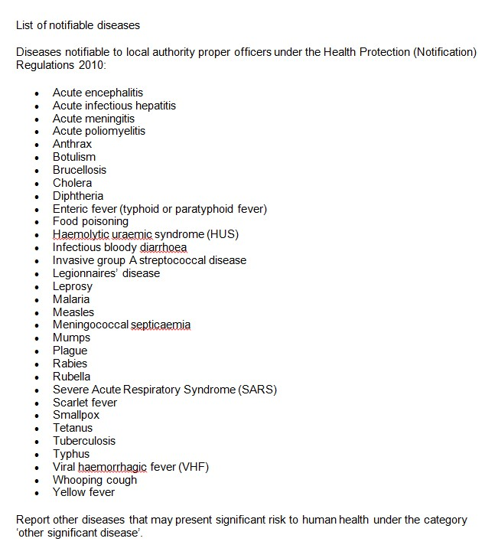

For guidance on whether the infection is likely to be urgent, see Health Protection Legislation (England) Guidance 2010 table 1 (page 25-27) – available at: http://webarchive.nationalarchives.gov.uk/20130107105354[/http://www.dh.gov.uk/prod_consum_dh/groups/dh_digital](http://www.dh.gov.uk/prod_consum_dh/groups/dh_digital) assets/@dh/@en/@ps/documents/digitalasset/dh_114589.pdf