Dermatology Guidelines – Stevens-Johnson Syndrome & Toxic Epidermal Necrolysis

Acute cutaneous drug reactions are common in hospital. These guidelines will help you identify and manage two of the more severe types of cutaneous drug reaction.

Stevens-Johnson Syndrome (SJS):
Acute skin reaction characterised by:
- Mucocutaneous necrosis of at least two mucosal sites (eyes, lips, oesophagus, genitalia, upper respiratory tract)
- Widespread erythematous tender macules
- Flaccid blisters
- Target lesions
Note that in SJS <10% of the total body surface area is affected

Toxic Epidermal Necrolysis (TEN):
Characterised by sheet-like skin loss with >30% of the total body surface area affected.
Please note there is overlap between SJS & TEN (erythema multiforme is a similar condition and is characterised by target lesions on the skin).

Erythema multiforme:
This an acute self-limiting condition, characterised by target lesions on the skin and is usually caused by an infection (commonly HSV) rather than a drug. Occasionally there may be a few oral ulcers. This is a much milder condition and therefore these guidelines are not applicable, but a Dermatology referral should still be made.

Aetiology:
Medications are the most common cause of SJS & TENS, with the following being particularly likely:
- Antibiotics: penicillins, cephalosporins and sulphonamides
- Anti-epileptics: carbamazepine, phenytoin and phenobarbital
- Allopurinol
- NSAIDs
If due to medication the reaction tends to be seen 3 days to 1 month after drug initiation
Infections can also cause the reaction and you should screen for herpes, mycoplasma and legionella if suspected, although this is much less likely than iatrogenic causes.
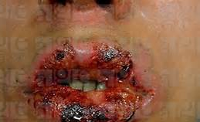
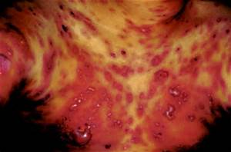

Please note that prophylactic antibiotics and steroids are not indicated

SCORTEN score can be calculated to predict mortality:
Score one point for each of the following:
Mortality predicted by score:
0-1 >3.2%
2 >12.1%
3 >35.3%
4 > 58.3%
5 >90%
- Age >40
- HR >120
- Urea >10
- Glucose >14
- Bicarbonate <20
- Initial percentage of epidermal detachment >10%
- Presence of malignancy

References:
- Creamer, D., Walsh, S. A., Dziewulski, P…. & Smith, C. H. (2016). UK guidelines for the management of Stevens-Johnson syndrome/toxic epidermal necrolysis in adults. BJD.
- British Association of Dermatologists (BAD) guidance:
  - SJS/TEN Summary of Treatment
  - SJS/TEN PIL
  - SJS/TEN discharge letter – on BAD guidelines webpage

