EXAMPLE OF A COMPLETED HISTOLOGY REQUEST FORM
NHS or MRN No, Surname, First name(s) and date of birth constitute the 4 key identifiers see Note 1
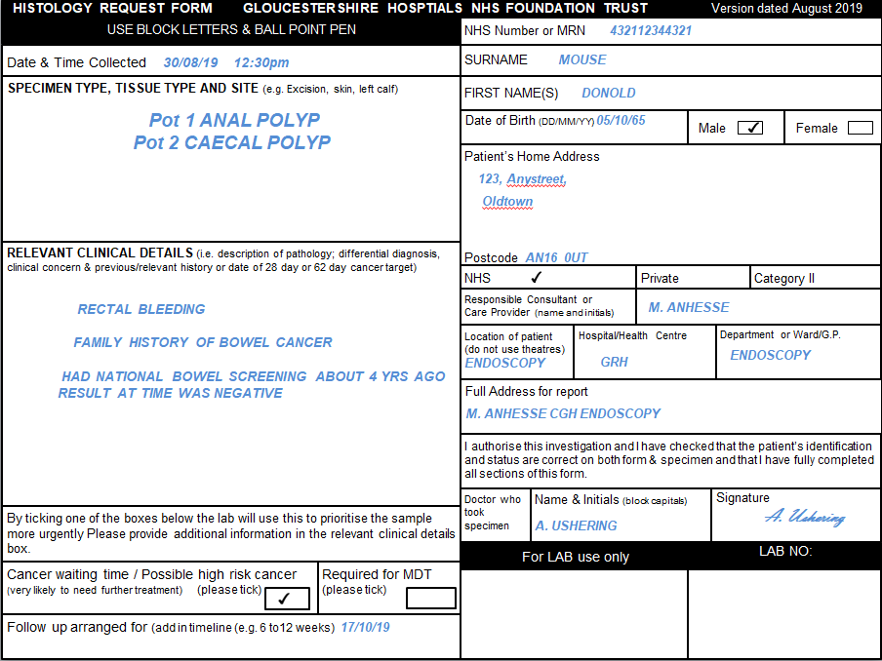

See note 5

See note 6
Used by the lab to confirm patient identity.

Used by the lab for triage and billing.

See note 7
See Note 2

See Note 3

See Note 4
See note 7
See note 8
This must be completed by the practitioner who performed the procedure. Please ensure the full name and signature, are included.

See note 9

Note 1: Pre-printed patient ID labels are acceptable if they include the four key identifiers. Please do not use calling or preferred names as these cannot be accepted. Male/female information is important, particularly where the gender is not identifiable by name, as some, diseases, follow different courses in male and females, affecting prognosis. If a request form arrives without the required four key identifiers or with incorrect information and/or the specimen pot does not match the information on the request form, this will need to be rejected by the lab. This causes delays.

Note 2: The name of the Consultant in charge of the patient.

Note 3: State where the specimen was taken including the Hospital and ward/department, for example; Gloucester Royal Hospital, Endoscopy Unit).

Note 4: This box should indicate where the final clinical report should be sent to. If additional copies are required (i.e. – to a different practitioner or GP) then it is important to include this information here, for example; Dr T Smith’s secretary Endoscopy, at Cheltenham General Hospital.

Note 5: Specimen collection dates and times are an important part of the specimen record, and affect the order of tests displayed in the computer system along with turnaround time calculations.

Note 6: Please state the specimen type, tissue type and site (i.e. Excision, skin, left forearm). Multiple specimens should be clearly labelled and differentiated both on the specimen containers and the request form.

Note 7. Clinical details are vital. If the sample is high risk, e.g. possibility of TB, HIV or Hepatitis this should be clearly displayed here. In addition, previous medical history is useful to clarify the pathway through the laboratory. Specimens from patients with CJD cannot be accepted.

Note 8. Please indicate whether there is a possible cancer risk or if the patient is following a ‘two week wait’ initiative. This allows the laboratory to triage appropriately. Also please tick if there is a scheduled MDT meeting for this patient. You can add a date in the Relevant Clinical Details box.

Note 9. If the patient has a follow up appointment already set, then please indicate here as this supports the appropriate triage within the laboratory.

