Staff Equality Diversity & Inclusion Plan 2019/20 v3
Equality, Diversity, Inclusion and Human Rights (EDIHR) are core components of our new People & OD Strategy 2019-2024. Page 7 of the strategy explains this (screenshot below). In addition the principles of EDIHR are embedded throughout all of our People & OD priorities, as illustrated below:
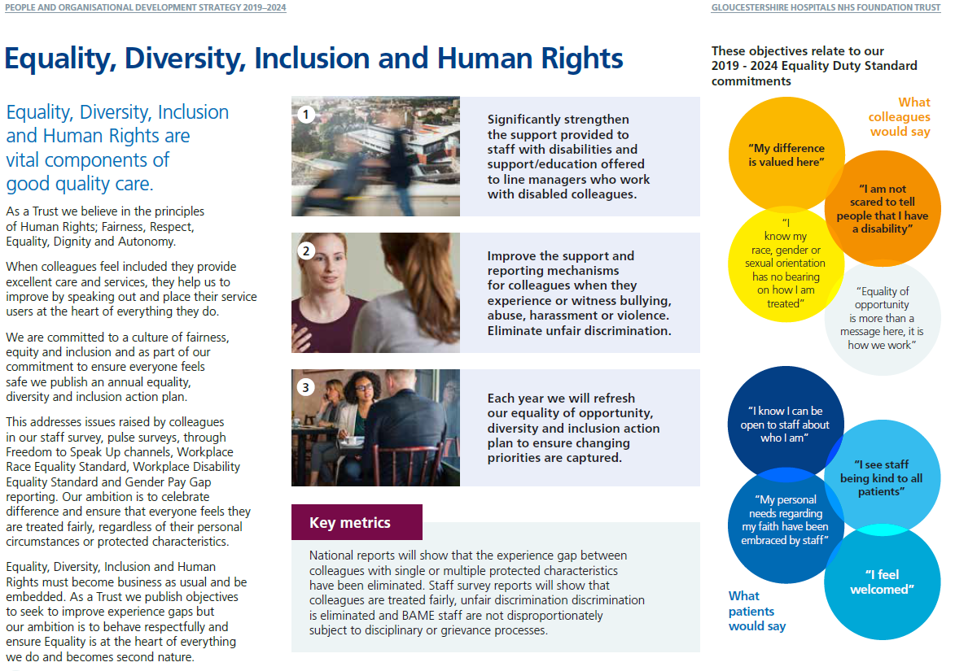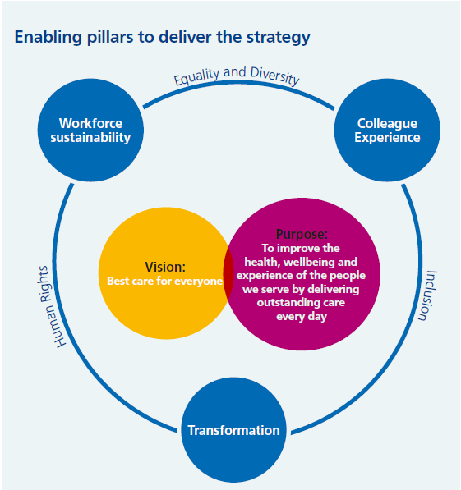

We have identified 4 Equality Objectives for 2019-2023. Objectives 3 and 4 are staff-related and will steer activities each year. Related actions reference the Equality Objectives as a driver.
GHNHSFT Equality Objectives 2019-2023

- Significantly strengthen support provided to staff with disabilities, mental health and long-term health conditions; including implementation of an education/ awareness campaign aimed at managers and staff to enable people with these conditions feel safe, valued and have equal opportunity in the Trust | Staff-related objective
- Improve the support and reporting mechanisms for staff when they experience or witness bullying, abuse, harassment or violence in our Trust to ensure staff feel able to respond effectively and receive the support they need | Staff-related objective

EDI Staff Action Plan 19-20 is overleaf.
Notes:
WRES – Workforce Race Equality Standard
WDES – Workforce Disability Equality Standard
BAME – Black Asian & Minority Ethnicity
LGBTQ+ - Lesbian, Gay, Bisexual, Transgender, Queer, plus (including other identities such as asexual, intersex)

EDI Action Plan 2019-2020
 | Action | Supporting Protected Characteristics | Driver/s | Link to P&OD Strategy Initiatives | Proposed outcome and measures/ indicators of impact | Timescale/ Deadline | Lead Responsible Person/s
1 | Develop the Board Champion role through the following activities:  - Publicity  - Attendance at Network events  - Building relationships between Board Champions and Diversity Network Leads  - Role-modelling desired behaviours  - Leading and promoting activities to address bullying/harassment | All | NHS Staff Survey  Public Sector Equality Duty  Equality Delivery System  WRES  WDES  Gender Pay Gap Report  Stonewall Workplace Equality Index  Equality Objective no.3  Equality Objectives no.4 | Secure equity for all | - Stronger visibility, championing and promotion/support of protected characteristics, at a senior level, that are more vulnerable to discrimination  - Decisions and actions taken at strategic level are considered through protected characteristic lenses  - NHS Staff Survey – specific themes of Equality & Diversity; Staff Engagement  - Improved Stonewall Workplace Equality Index | Ongoing | Emma Wood, Director of People & OD/Deputy CEO  Peter Lachecki, Chair
2 | Review policies and existing support mechanisms in place to support staff who experience bullying & harassment. Define and implement separate action plan to address findings and make improvements | All | Staff Survey  Equality Objective no.4 | Remove violence, aggression, bullying and harassment from colleagues’ working lives | - Revised policy and defined approach to addressing bullying and harassment  - Staff Survey results  - Volume of FTSU cases and HR cases relating to bullying & harassment | Review completed by October 2019  Action plan devised and implementation commences no later than November 2019 | Ali Koeltgen, Deputy Director People & OD  Suzie Cro, Freedom to Speak Up Guardian
3 | Actively illustrate and represent the diversity of our workforce in all recruitment campaigns (virtual and face-to-face) and Trust communications | All, with particular focus on:  - BAME  - Disability  - LGBTQ+  - Age | Staff Survey  WRES  WDES  Stonewall Workplace Equality Index | Embed a strong unique employer brand to attract the best talent and embed values based recruitment | - Visual and written content of recruitment and general communications campaigns  - Recruitment days and fairs have diverse representatives and panels | Ongoing | Holly Kent, Head of Recruitment  Craig MacFarlane, Head of Communications
4 | Alongside continued delivery of mandatory Unconscious Bias training to all new Recruiting Managers, deliver mandatory Unconscious Bias training to all members of the 100 Leaders senior leadership network and the HR Advisory Team | BAME | WRES  Equality Objective no.4 | Develop a culture where our values are well embedded in all our practices and policy.  Embed new leadership and management practice | - Reduction in likelihood of white staff appointed from shortlisting vs. BAME staff | March 2020 | Abigail Hopewell, Head of Leadership & OD
5 | Ensure at least one member of each interview panel has undertaken Unconscious Bias training | BAME | WRES | Secure equity for all  Embed a strong unique employer brand to attract the best talent and embed value based recruitment | - Reduction in likelihood of white staff appointed from shortlisting vs. BAME staff | Implement monitoring system by August 2019  Enforce compliance by October 2019 | Holly Kent, Head of Recruitment
6 | Identify and train BAME volunteers in the Trust who can sit on band 8a+ job interview panels. Establish mechanisms and support needed to ensure volunteers participate | BAME | WRES | Secure equity for all  Recognise the talent of colleagues and retain | - Reduction in likelihood of white staff appointed from shortlisting vs. BAME staff.  - Better representation of BAME staff in senior roles (currently no BAME representation in Band 8c and above) | Implement by November 2019, then ongoing – with regular opportunities advertised for BAME staff to participate | Holly Kent, Head of Recruitment  Abigail Hopewell, Head of Leadership & OD  BAME Diversity Network Lead
7 | Launch the NHS Rainbow Badge scheme | Sexual Orientation  Gender Reassignment  (LGBTQ+) | Stonewall Workplace Equality Index  Equality Objective no.4 | Secure equity for all  Remove violence, aggression, bullying and harassment from colleagues’ working lives  Develop a culture where our values are well embedded in all our practices and policy | - Volume of staff wearing their rainbow badges at work, including Allies  - Patients and staff reporting increased satisfaction, acceptance and safety through staff and patient surveys  - Improved Stonewall Workplace Equality Index score  - Improved confidence in managers to have conversations with colleagues about gender/transgender issues.  - Attendance at LGBTQ+ workshops/diversity network event | Launch Summer 2019 | Steve Hams, Chief Nurse (Board Champion: Sexual Orientation and Gender Reassignment)  LGBTQ+ Diversity Network Leads
8 | Undertake a campaign encouraging staff to access ESR Self-Service to update their personal protected characteristic data, especially sexual orientation and disability which are heavily under-reported | Sexual Orientation  Disability | Stonewall Workplace Equality Index  WDES  Equality Objective no. 3 | Deliver digital and technological efficiencies for people processes  Secure equity for all | - Increased data quality of ESR fields  - Better understanding of our workforce’s makeup | December 2019 | Ali Koeltgen, Deputy Director of People & OD  Craig MacFarlane, Head of COmmunications
9 | Launch the new 2020 Staff Advice and Support Hub, including promotion of this service providing dedicated support to managers and staff regarding reasonable adjustments | Disability | WDES  Staff Survey  Equality Objective no.3 | Promote health, safety and wellbeing | - Staff Survey scores for staff with disabilities  - Access to the 2020 hub regarding Reasonable Adjustment requests  - Timeliness of decision-making and implementation of reasonable adjustments | Launch May 2019 | Abigail Hopewell, Head of Leadership & OD
10 | Recommit to the “Time to Change” mental health pledge, to coincide with World Mental Health Day | Disability (mental health) | WDES  Staff Survey  Equality Objective no.3 | Promote health, safety and wellbeing | - Staff survey results  - Increased awareness and conversations about mental health and wellbeing in the workplace  - As part of our health-wellbeing hub activity, use this day to launch | October 2019 | Abigail Hopewell, Head of Leadership & OD  Kate Jeal, Communications Manager  Mark Pietroni, Medical Director (Board Champion: Disability – mental health and learning)
11 | Complete the Mind Mental Health Workplace Wellbeing Index for the first time.  Complete the Stonewall Workplace Equality Index for the second time. | Disability (mental health)  Sexual Orientation (LGBTQ+) | WDES  Staff Survey  Stonewall Workplace Equality Index  Equality Objective no.3 | Secure equity for all  Promote health, safety and wellbeing | - Benchmarking of our performance in relation to equality against other UK organisations  - Promotion and visibility of disability in the Trust by asking staff to participate in anonymous online survey  - Increased confidence that Trust takes EDI seriously, evidenced by staff survey results | Stonewall – August 2019  Mind - tbc | Abigail Hopewell, Head of Leadership & OD  Disability Diversity Network Leads  LGBTQ+ Diversity Network Leads

All actions to be monitored and delivered through the Equality, Diversity & Inclusion Steering Group which reports to the People & OD Delivery Group.
Abigail Hopewell, Head of Leadership & OD (Vice-Chair, Equality Diversity & Inclusion Steering Group)

