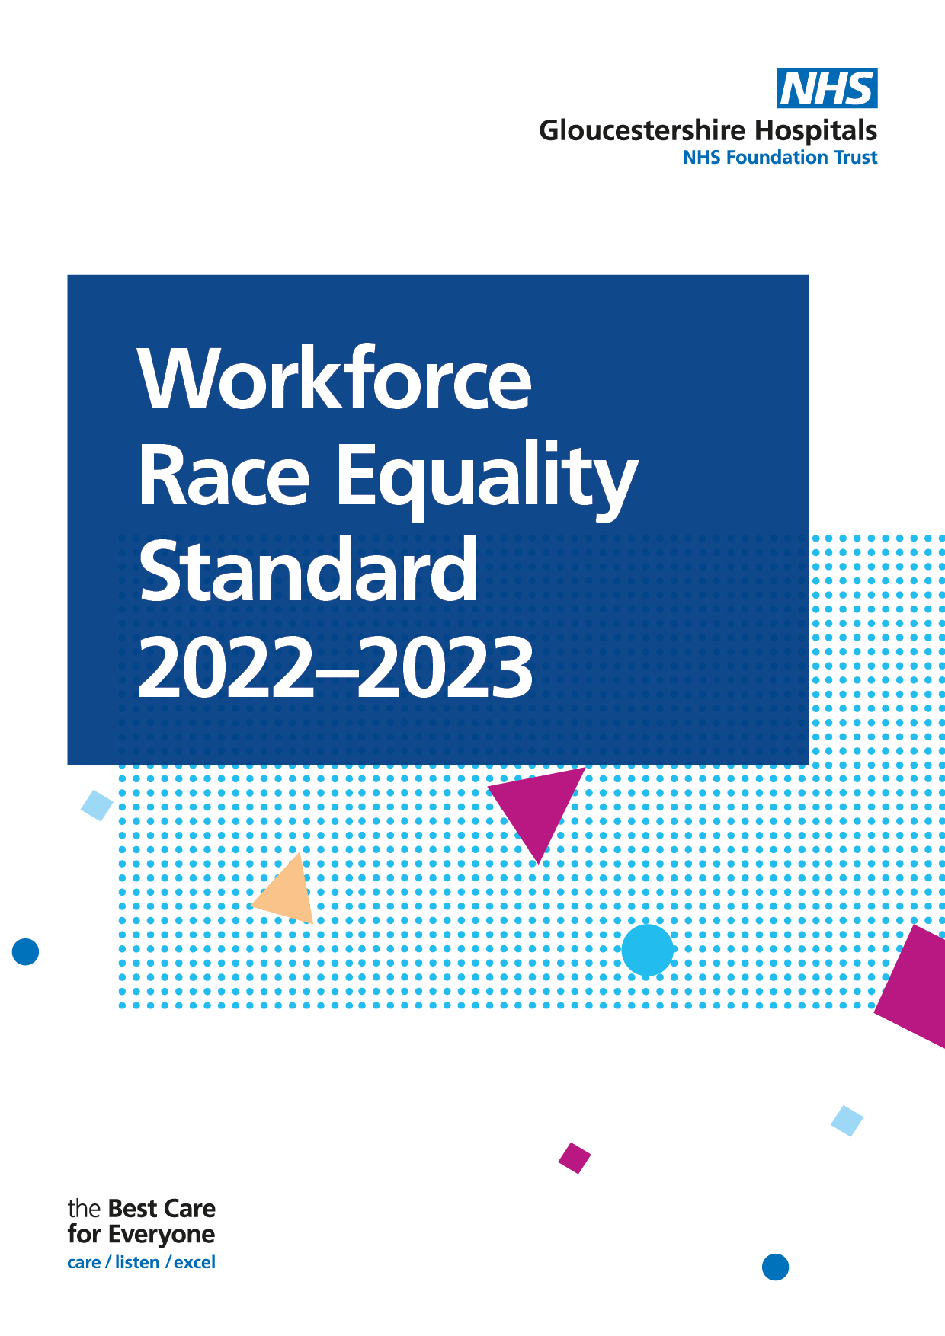

Introduction
Welcome to the 2023 Workforce Race Equality Standard (WRES) Report. The WRES report enables the Trust to publish data on the employment experiences of our Black, and Minority Ethnic (BME) staff compared to those of our white staff.

The WRES was introduced in 2015, designed to demonstrate progress in ensuring colleagues from BME backgrounds have equal access to opportunities and receive fair treatment in the workplace.

Nine measures (metrics) enable NHS organisations to compare the experience of BME and white staff. The information provided within this report includes the data for the nine key WRES metrics and describes the actions taken during 2022 and those planned for 2023/24. These actions are based on areas for further development, identified and informed through the WRES metrics and action plan, and staff survey. Metrics 5 to 8 are based on the staff survey results for 2022.

At Gloucestershire Hospital NHS Foundation Trust (GHNHSFT), as at 31st March 2023, our Electronic Staff Records (ESR) data shows the following:

Workforce Data | 2022/23 Headcount | 2023 | 2021/22 Headcount | 2022 % | % Difference
Total Workforce | 8097 |  | 7740
BME staff | 1466 | 18.1% | 1273 | 16.5 | 1.6% Increase compared to the previous year’s data
White staff | 5730 | 70.8% | 5870 | 75.8% | 5% Lower than the previous year’s data
Ethnicity Unknown | 901 | 11.1% | 597 | 7.7% | Increase of 3.4% have unknown ethnicities on our ESR system

Aims

The aims of this report are to:

  - Compare the workplace and career experiences of the Trusts EM and white staff, using data drawn from WRES reporting in 2023.

  - Present high-level findings and analysis of the WRES metrics data.

  - Highlight trends in NHS staff survey data published, covering the periods of 2022.

  - Suggest actions that will improve the experiences of Ethnic Minority staff against each metric.

  - Raise awareness of race equality within the Trusts workforce and outline some of the challenges that EM staff collectively experience at work.

WRES Metrics

WRES Metric | White, BME & Ethnicity unknown or Null
1 | Percentage of staff in each of the AfC Bands 1-9 OR Medical and Dental subgroups and VSM (including executive Board members) compared with the percentage of staff in the overall workforce
2 | Relative likelihood of staff being appointed from shortlisting across all posts
3 | Relative likelihood of staff entering the formal disciplinary process, as measured by entry into a formal disciplinary investigation
4 | Relative likelihood of staff accessing non-mandatory training and CPD
9 | Percentage difference between the organisations’ Board voting membership and its overall workforce

WRES Data
Non-Clinical Workforce

Indicator 1 | Data Item | White  2022 |  | BME  2022 |  | White  2023 |  | BME  2023 |  | Ethnicity Unknown/Null
1a) Non-Clinical Workforce  Percentage of staff in each of the AfC Bands 1-9 OR Medical and Dental subgroups and VSM (including executive Board members) compared with the percentage of staff in the overall workforce | Under Band 1 | 5 |  | 4 |  | 10 |  | 2 |  | 2
 | Band 1 | 4 |  | 1 |  | 4 |  | 0 |  | 0
 | Band 2 | 391 |  | 35 |  | 177 |  | 22 |  | 20
 | Band 3 | 497 |  | 40 |  | 469 |  | 43 |  | 32
 | Band 4 | 228 |  | 12 |  | 231 |  | 19 |  | 25
 | Band 5 | 140 |  | 17 |  | 143 |  | 14 |  | 10
 | Band 6 | 146 |  | 13 |  | 135 |  | 22 |  | 15
 | Band 7 | 75 |  | 3 |  | 72 |  | 3 |  | 4
 | Band 8a | 43 |  | 4 |  | 46 |  | 5 |  | 4
 | Band 8b | 29 |  | 3 |  | 35 |  | 2 |  | 1
 | Band 8c | 21 | 1 |  | 19 |  | 1 |  | 1
 | Band 8d | 11 | 1 |  | 10 |  | 1 |  | 1
 | Band 9 | 3 | 0 |  | 2 |  | 0 |  | 0
 | VSM | 5 | 1 |  | 5 |  | 1 |  | 0
Clinical Workforce

Indicator 1 |  |  | Data Item | White  2022 | BME  2022 | White  2023 | BME  2023 | Ethnicity Unknown/Null
1a) Clinical Workforce  Percentage of staff in each of the AfC Bands 1-9 OR Medical and Dental subgroups and VSM (including executive Board members) compared with the percentage of staff in the overall workforce |  |  | Under Band 1 | 31 | 2 | 23 | 5 | 20
 |  |  | Band 1 | 0 | 0 | 0 | 0 | 0
 |  |  | Band 2 | 669 | 164 | 811 | 223 | 128
 |  |  | Band 3 | 205 | 39 | 262 | 50 | 17
 |  |  | Band 4 | 188 | 8 | 217 | 22 | 138
 |  |  | Band 5 | 868 | 488 | 781 | 494 | 261
 |  |  | Band 6 | 952 | 149 | 987 | 193 | 63
 |  |  | Band 7 | 488 | 42 | 509 | 62 | 30
 |  |  | Band 8a | 135 | 14 | 138 | 18 | 7
 |  |  | Band 8b | 42 | 2 | 44 | 1 | 1
 |  |  | Band 8c | 11 | 3 | 9 | 4 | 1
 |  |  | Band 8d | 4 | 1 | 5 | 1 | 0
 |  |  | Band 9 | 3 | 0 | 4 | 0 | 1
 |  |  | VSM | 1 | 0 | 3 | 0 | 0
 |  | Of which Medical & Dental
 |  |  | Consultants | 317 | 91 | 325 | 95 | 23
 |  |  | Non-consultant career grade | 80 | 70 | 64 | 81 | 39
 |  |  | Trainee grades | 278 | 65 | 280 | 82 | 57
Non-Clinical
BME representation has remained the same as the previous year but white representation has decreased slightly from 1,598 to 1,358.

Clinical
BME representation has increased from 912 to 1,073, white representation from 3,597 to 3,703.
.
The number of BME senior leaders (8a+) has increased from 30 to 34, with the highest representation in bands 8a and 8c.

There has been a decrease in bands 8b and no change to bands 8d and above.

Total BME representation in Band 8a+

Band | Total BME representation in Band 8a+
B8a | 23 | increase of 4 since 2022.
B8b | 3 | decrease of 2 since 2022
B8c | 5 | increase of 1 since 2022
8d | 2 | No change to the previous year’s data
B9 | 0 | No change to the previous year’s data
VSM | 1 | No change to the previous year’s data

Indicator 2 | Data Item | White | BME | Ethnicity Unknown/Null
2) Relative likelihood of staff being appointed from shortlisting across all posts | Number of shortlisted applicants | 3709 | 1698 | 68
 | Number appointed from shortlisting | 1001 | 313 | 11
 | Relative likelihood of appointment from shortlisting | 26.99% | 18.43% | 16.18%
 | Relative likelihood of White staff being appointed from shortlisting compared to BME staff | 1.46
A figure above 1 indicates that BME staff are more likely to be appointed from shortlisting compared to white staff

Relative likelihood of white candidates being appointed from shortlisting compared to BME applicants, the rate for 2023 is 1.46, this is consistent with last year (1.49)

Likelihood of White staff being appointed from shortlisting compared to BME staff has increased by 0.17 from the previous year.

Indicator 3 | Data Item | White | BME | Ethnicity Unknown/Null
3) Relative likelihood of staff entering the formal disciplinary process, as measured by entry into a formal disciplinary investigation  Note: This indicator will be based on year end data. | Number of staff entering the formal disciplinary process | 7 | 1 | 0
 | Likelihood of staff entering the formal disciplinary process | 0.12% | 0.07% | 0.00%
 | Relative likelihood of BME staff entering the formal disciplinary process compared to White staff |  | 0.58

A figure equal to 1 indicates that BME staff are no more likely to enter the formal disciplinary process over white staff.

The data above indicates that white staff are more likely to enter a formal disciplinary process (0.12%) than BME staff (0.07%). The figure has decreased by 0.1 and shows that white staff are marginally more likely to enter a formal disciplinary process.

Indicator 4 | Data Item | White | BME | Ethnicity Unknown/Null
4) Relative likelihood of staff accessing non-mandatory training and CPD | Number of staff accessing non-mandatory training and CPD | 3150 | 1036 | 527
 | Likelihood of staff accessing non-mandatory training and CPD | 54.97% | 70.67% | 58.49%
 | Relative likelihood of White staff accessing non-mandatory training and CPD compared to BME staff | 0.78

BME staff are more likely to access non – mandatory training and Continued Professional Development compared to white staff, with 70.67% BME and 54.97% white staff.

The gap has decreased since 2022 by 0.5 decimal points, with white staff becoming less likely to access mandatory training/CPD. However, 58.49% of staff whose ethnicity is unknown are likely to complete their mandatory training too.

Indicator 5 |  | 2021 | 2022
Percentage of staff experiencing harassment, bullying or abuse from patients, relatives or the public in last 12 months | White | 29.9% | 28.3%
 | BME | 37.6% | 31.8%

31.8% of BME staff have experienced harassment, bullying or abuse from patients, relatives or the public in the last 12 months, compared to 28.3% of white staff. Since the previous year, the figures have decreased for both ethnic categories, white (1.6%) and BME (5.8%).

Indicator 6 |  | 2021 | 2022
Percentage of staff experiencing harassment, bullying or abuse from staff in last 12 months | White | 26.5% | 16.5%
 | BME | 34.6% | 22.25%

22.25% of BME staff have experienced harassment and bullying abuse from staff in the last 12 months, compared to 16.5% of white staff. The figures have decreased for both ethnic categories White (10%) and BME (12.35%)

Indicator 7 |  | 2021 | 2022
Percentage believing that trust provides equal opportunities for career progression or promotion | White | 56.4% | 51%
 | BME | 35.7% | 41.1%

41.1% of BME staff believe that the trust provides equal opportunities for career progression or promotion, compared with 51% of white staff. The figure for white staff has decreased by 7.7% however has increased by 5.4% for BME.

Indicator 8 |  | 2021 | 2022
In the last 12 months have you personally experienced discrimination at work from any of the following? Manager/team leader or other colleagues | White | 7.7% | 8%
 | BME | 24.9% | 24%

BME staff are much more likely to experience higher levels of discrimination from managers, team leader or other colleagues, than their white colleagues. With 24% and 8% respectively. Since the previous year, there has been a marginal increase of 0.3% for white staff and a decrease of 0.9% for BME.

Indicator 9 | Data Item | White | BME | Ethnicity Unknown/Null
9) Percentage difference between the organisations’ Board voting membership and its overall workforce  Note: Only voting members of the Board should be included when considering this indicator | Total Board Members | 11 | 3 | 4
 | Of which: voting board members | 4 | 2 | 4

 | Board
61.1% | Board members are white
16.7% | Board members are BME. (vs. 18.1% of the overall workforce)
40% | Board voting membership are White, a decrease of 30% compared to the previous year
20% | Board voting membership is BME, which a 10% decrease compared to the previous year.
40% | Overall Board have not declared their ethnicity on ESR
 | Of the Trust Non-voting Board Members 87.5% of its members are white, 12.5% of the board IS BME. 11.5% last year

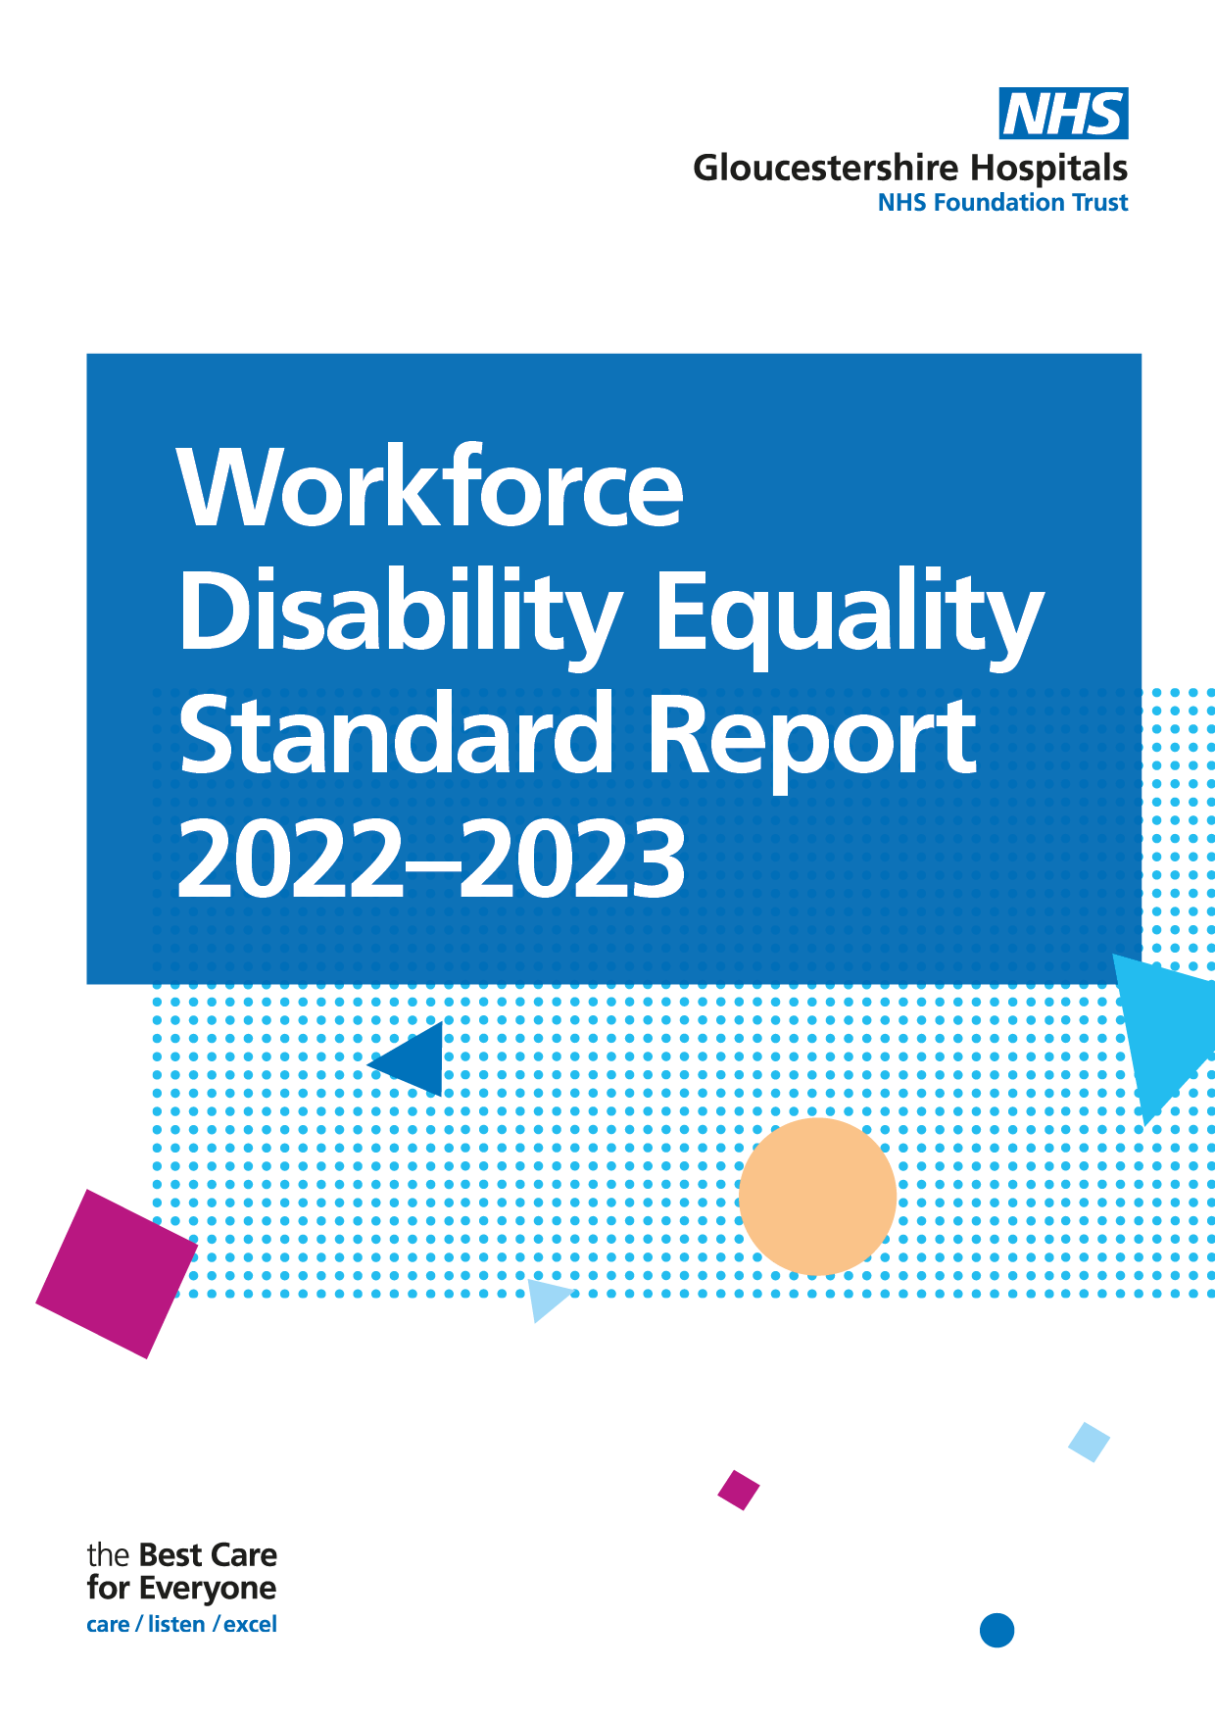

Introduction
Launched in 2019, the Workforce Disability Equality Standard (WDES) requires that all NHS organisations publish data and action plans against ten indicators of workforce disability equality, the aim being to improve the work experience of disabled staff. Each year, comparisons are made to enable the Trust to demonstrate progress against the indicators of disability equality. It also allows the Trust better understand the experiences of its disabled employees and support positive change for all by creating a more inclusive environment.

The data presented in this report will help the Trust create a more inclusive culture, by using a data driven approach to inform organisational change.

Workforce Data | Disabled | Non-Disabled | Unknown
 | 2.94% | 51.24% | 45.82%
Headcount
8095 | 238 | 4148 | 3709

WDES Metrics

WDES Metric | Disabled, Non-disabled & Disability Unknown or Null
1 | Percentage of staff in each of the AfC Bands 1-9 OR Medical and Dental subgroups and VSM (including executive Board members) compared with the percentage of staff in the overall workforce
2 | Relative likelihood of non-Disabled staff compared to Disabled staff being appointed from shortlisting across all posts
3 | Relative likelihood of non-Disabled staff compared to Disabled staff entering the formal capability process, as measured by entry into the formal capability procedure  (Metric based on data from a two-year rolling average)
4-9a | NHS Staff Survey data
9b | Has your organisation taken action to facilitate the voices of your Disabled staff to be heard?
10 | Percentage difference between the organisations’ Board voting membership and its overall workforce

Non-Clinical - Data Submission

Indicator 1 | Data Item | Disabled | Non-Disabled | Unknown/Null
1a) Non-Clinical Workforce  Percentage of staff in each of the AfC Bands 1-9 OR Medical and Dental subgroups and VSM (including executive Board members) compared with the percentage of staff in the overall workforce | Under Band 1 | 0 | 1 | 13
 | Band 1 | 0 | 1 | 3
 | Band 2 | 12 | 84 | 123
 | Band 3 | 24 | 285 | 235
 | Band 4 | 16 | 132 | 127
 | Band 5 | 6 | 88 | 73
 | Band 6 | 3 | 99 | 70
 | Band 7 | 5 | 39 | 35
 | Band 8a | 2 | 24 | 29
 | Band 8b | 4 | 18 | 16
 | Band 8c | 0 | 11 | 10
 | Band 8d | 0 | 6 | 6
 | Band 9 | 0 | 1 | 1
 | VSM | 0 | 5 | 1

Clinical WDES - Data Submission

Indicator 1 | Data Item | Disabled | Non-Disabled | Unknown/Null
1a) Non-Clinical Workforce  Percentage of staff in each of the AfC Bands 1-9 OR Medical and Dental subgroups and VSM (including executive Board members) compared with the percentage of staff in the overall workforce | Under Band 1 | 1 | 1 | 13
 | Band 1 | 0 | 1 | 3
 | Band 2 | 33 | 84 | 123
 | Band 3 | 14 | 285 | 235
 | Band 4 | 14 | 132 | 127
 | Band 5 | 35 | 88 | 73
 | Band 6 | 33 | 99 | 70
 | Band 7 | 13 | 39 | 35
 | Band 8a | 7 | 24 | 29
 | Band 8b | 2 | 18 | 16
 | Band 8c | 0 | 11 | 10
 | Band 8d | 0 | 6 | 6
 | Band 9 | 0 | 1 | 1
 | VSM | 0 | 5 | 1

Indicator 2 | Data Item | Disabled | Non-Disabled | Unknown/Null
2) Relative likelihood of Disabled staff compared to non-disabled staff being appointed from shortlisting across all posts. | Number of shortlisted applicants | 631 | 7719 | 426
 | Number appointed from shortlisting | 100 | 1703 | 204
 | Relative likelihood of non-disabled being appointed from shortlisting compared to disabled staff | 1.39

The relative likelihood of non-disabled staff being appointed from shortlisted compared to disabled staff ratio is 1.39. Disabled applicants are less likely to be appointed from shortlisting than non-disabled candidates.

Indicator 3 | Data Item | Disabled | Non disabled | Unknown/Null
3. Relative likelihood of non-Disabled staff compared to Disabled staff entering the formal capability process, as measured by entry into the formal capability procedure  (Metric based on data from a two-year rolling average). | Average number of staff entering formal capability process over the last 2 years for any reason (Total divided by 2) | 4.5 | 25 | 21.5
 | Of these, how many were on the grounds of ill health | 4.5 | 24.5 | 14
 | Likelihood of staff entering the formal capability process | 0 | 0.000121 | 0.002022

Those with an unknown disability are much more likely to enter the formal capability process.

Indicator 4 | Data Item | Disabled | Non disabled
Percentage of Disabled Staff compared to non-disabled staff experiencing harassment bullying or abuse from: | (1) Patients/Service users, their relatives or other members of the public | 36.2% | 27%
 | Managers | 20.7% | 11.8%
 | Other colleagues | 28.2% | 20.2%
Percentage of Disabled staff compared to non-disabled staff saying that the last time they experienced harassment bullying or abuse at work they or a colleague reported it. |  | 49.3% | 44.3%

Staff with a disability are more likely to have experienced harassment, bullying or abuse at work from there managers and other colleagues.

Disabled staff are more likely to report incidents of harassment, bullying or abuse compared to non-disabled.

Indicator 5 | Disabled | Non disabled
Percentage of Disabled staff compared to non-disabled staff believing that the Trust provides equal opportunities for career progression or promotion. | 44.5% | 51.9%

Equal opportunities for career progression or promotion – 44.5% of disabled staff (4% decrease 2021/22) believed they had equal opportunities for career progression or promotion. This compares to 51.9% of non-disabled staff.

Indicator 6 | Disabled | Non disabled
Percentage of Disabled staff compared to non-disabled staff saying that they have felt pressure from their manager to come to work, despite not feeling well enough to perform their duties. | 35.9% | 24.7%

35.9% of disabled staff say that they have felt pressured to come to work, despite not feeling well enough to perform their duties. This number has decreased compared to the previous year. Whereas the number has increased for non-disabled staff.

Indicator 7 | Disabled | Non disabled
Percentage of Disabled staff compared to non-disabled staff saying that they are satisfied with the extent to which their organisation values their work. | 27.2% | 34.8%

27.2% of colleagues with a disability feel that their work is valued compared with 34.8% of non-disabled colleagues. This is lower than the previous reporting period, where colleagues with disability were 29.4%.

Indicator 8 | Disabled
Percentage of Disabled staff saying that their employer has made adequate adjustment(s) | 72.3%
72.3% of colleagues with disability reported that they feel the Trust provides adequate adjustment(s). This has increased by 0.8% in the previous reporting period.
Indicator 9a | Org Overall | Disabled | Non-Disabled
The staff engagement score for Disabled staff, compared to non-disabled staff and the overall engagement score for the organisation | 6.3 | 5.9 | 6.4

Indicator 9b | Disabled
Has the organisation taken action to facilitate the voices of the disabled staff to be heard | Yes

The Trust’s inclusion network is made up of Ethnic minority, LGTBQ+ and Disabled staff where colleagues can raise concerns and discuss planned actions for its’ disabled colleagues.

The Trust has an established EDI steering group, providing the more senior leadership with time to focus on each strand of inclusion, including disability.

The Disability Network has made significant improvements moving the EDI agenda forward ensuring we continue to engage and evolve colleagues with disabilities and long-term conditions in our key decision making.

Indicator 10 | Data Item | Disabled | Non disabled | Unknown/Null
Board vs Organisational Workforce | Percentage difference between the organisation’s Board voting membership and its organisation’s overall workforce disaggregated. | -2.94% | -31.24% | 34.18%
 | Total Board members percentage by disability | 0% | 38.89% | 61.11%
The total Board members by percentage without disability is 38.89%, however, those who have not recorded their disability status is 61.11%.

