**HEARING AID ON A SLIM/FLEXI TUBE**

**A BASIC GUIDE**

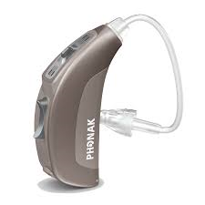

**Dome**

**Hearing aid**

**Tube**

[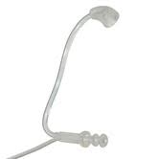](https://www.google.co.uk/imgres?imgurl=https://duxzn84gr6b9u.cloudfront.net/image/166x166/images/siemens_slifetube_red_300.jpg&imgrefurl=https://www.connevans.co.uk/viewCategory.do?id%3D10875781&docid=KGHc4KQ0wEuR_M&tbnid=VLwN_cQF3LVA8M:&vet=10ahUKEwiEm_PLt9vdAhXsBcAKHZ2wCCAQMwhGKBYwFg..i&w=166&h=166&safe=strict&bih=775&biw=1440&q=siemens%20Reflex%20%20hearing%20aids%20uk&ved=0ahUKEwiEm_PLt9vdAhXsBcAKHZ2wCCAQMwhGKBYwFg&iact=mrc&uact=8)

Various types of thin/ flexi tubes exist depending on the type of hearing aid a Pt has.

[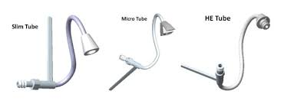](https://www.google.co.uk/imgres?imgurl=https://i.ebayimg.com/images/i/182429533290-0-1/s-l1000.jpg&imgrefurl=https://www.ebay.co.uk/itm/Phonak-Unitron-HE-Thin-Micro-Slim-Tubes-/182429533290&docid=j-8rjsuLDahjQM&tbnid=5esL5v7PC8QaBM:&vet=10ahUKEwj32PKyydvdAhULBcAKHVxUB0oQMwhkKCswKw..i&w=600&h=221&safe=strict&bih=775&biw=1440&q=Phonak%20Nathos%20S%2BM%20hearing%20aid%20open%20fit&ved=0ahUKEwj32PKyydvdAhULBcAKHVxUB0oQMwhkKCswKw&iact=mrc&uact=8)

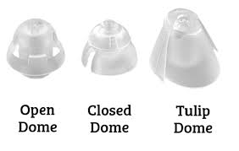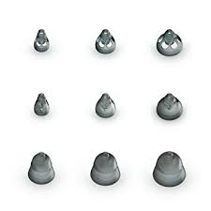

**Various types of dome exist for use depending on the patients hearing.**

**THE DOME PUSHES ONTO THE END OF THE TUBE BUT ONLY A QUALIFIED PERSON SHOULD DO THIS**

[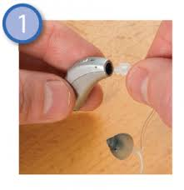](https://www.google.co.uk/imgres?imgurl=http://www.nnuh.nhs.uk/wp-content/uploads/2014/01/Cleaning-Thin-Tube-1-292x300.png&imgrefurl=http://www.nnuh.nhs.uk/departments/audiology/faqs/&docid=yY6epUj8ioiUXM&tbnid=cwfq8iggRz736M:&vet=10ahUKEwjivryzzNvdAhWnCMAKHX_oB_cQMwhYKBQwFA..i&w=292&h=300&safe=strict&bih=775&biw=1440&q=hearing%20aid%20flexi%20tube%20domes&ved=0ahUKEwjivryzzNvdAhWnCMAKHX_oB_cQMwhYKBQwFA&iact=mrc&uact=8)

The tube may push in or screw into the hearing aid.

The tube (and dome) needs replacing at least every 6 months.

**A THIN TUBE/ FLEXI TUBE SAT CORRECTLY IN A PATIENTS EAR.**

[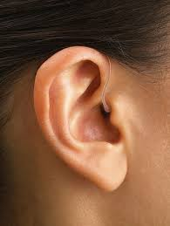](https://www.google.co.uk/imgres?imgurl=http://conchahearing.com/wp-content/uploads/2013/04/BTE-Hearing-Aid2.jpg&imgrefurl=http://conchahearing.com/learn-more/types-of-hearing-aid/&docid=SWp-FWT9TvkceM&tbnid=wlBJmWznej6cEM:&vet=10ahUKEwiP3IOHy9vdAhULXsAKHZuPCDUQMwh3KDkwOQ..i&w=600&h=796&safe=strict&bih=775&biw=1440&q=%20hearing%20aid%20on%20mould&ved=0ahUKEwiP3IOHy9vdAhULXsAKHZuPCDUQMwh3KDkwOQ&iact=mrc&uact=8) [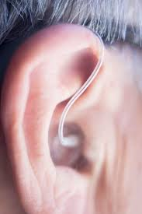](https://www.google.co.uk/imgres?imgurl=https://www.healthyhearing.com/uploads/images/UsedHearingAids.jpg&imgrefurl=https://www.healthyhearing.com/help/hearing-aids/used&docid=-IixFv-NcIPHkM&tbnid=FFh7Q6_fTRaM0M:&vet=10ahUKEwiP3IOHy9vdAhULXsAKHZuPCDUQMwieAShgMGA..i&w=1119&h=1678&safe=strict&bih=775&biw=1440&q=%20hearing%20aid%20on%20mould&ved=0ahUKEwiP3IOHy9vdAhULXsAKHZuPCDUQMwieAShgMGA&iact=mrc&uact=8)